

Johnson Production Group

Press Kit

# One-Liner

# When Maya Alvaro accepts a last minute invite to her company’s corporate retreat, she’s

# under strict instruction to impress the CEO and snag a career making contract. But when the

# team building rafting trip pairs her with a handsome competitor, Maya must learn the value of

# working together or risk getting swept away.

# Synopsis

# Maya Alvaro is a strong but sweet, hard working business woman with a heart of gold. What she is not is a rugged outdoorsy type, so when the CEO of her company invites her to an exclusive white-water rafting retreat in the Rocky Mountains, Maya’s not so sure she’s the woman for the job. Her boss convinces her she can handle anything that comes her way and sends her on the trip under strict instruction: impress the CEO and snag a career making contract. If she can do this, and survive a weekend camping in the woods, the promotion of her dreams will be hers. So Maya packs the closest thing she has to hiking boots and heads out, hoping for the best. Shortly after arriving at The Whitewater Lodge, Maya meets Matt, a man who IS an outdoorsy type. In fact Matt is more at home in the woods than anywhere else. Maya quickly realizes that Matt is also trying to snag the same coveted contract she’s after and once they’re done sizing each other up as the competition, they do not hit it off. But as fate would have it, Maya and Matt are paired as a team to complete a series of team-building exercises together, including zip-lining, high-wire rope walking, and Mays’s most dreaded event (and worst nightmare), whitewater rafting. As Maya lets her guard down to brave the wild wilderness, she and Matt start to form a genuine, romantic connection. What begins as a ferocious competition slowly starts to evolve into something much more. They realize they’re much better as a team, in more ways than one, and devise a plan to combine their efforts so they both get what they need out of the weekend.

# Producers

Executive Producers

TIMOTHY O. JOHNSON

OLIVER DE CAIGNY

BENJAMIN HOLLINGSWORTH

CINDY BUSBY

Co-Executive Producer

JULIANA WIMBLES

JOSEPH WILKA

LISA ALFORD

Producer

NAVID SOOFI

Supervising Producer

TIM MUDD

# Key Cast

|  |  |  |
| --- | --- | --- |
| CHARACTER  Maya Alvaro  Matt  Allegra Adams  Jim  Luis |  | ACTOR  CINDY BUSBY  BENJAMIN HOLLINGSWORTH  KATE TWA  WILLIAM DEVRY  EDWIN PEREZ |

# Key Cast Biographies

# CINDY BUSBY

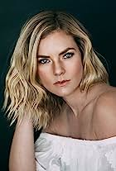Cindy Busbyis best known for her series regular role in Heartland, as “Ashley Stanton,” a rich, self-righteous, competitive horseback rider. The series took off quickly becoming one of the most popular Canadian television shows ever, and has become a fan favourite thanks to Netflix, while also being syndicated in over 81 countries around the world.

Throughout the following years, Cindy has continued having great success booking leading roles in over a dozen films, first landing the lead antagonist in the film Picture This alongside Ashley Tisdale and Kevin Pollack. She can also be seen in Royal Hearts, opposite James Brolin, which brought Cindy to Romania to film the movie. She can also be seen starring in Unleashing Mr. Darcy, alongside Frances Fisher, The Wrong Stepmother, opposite Vivica A Fox, and A Godwink Christmas, with Kathie Lee Gifford. Cindy was also nominated for a LEO Award for her portrayal of Jillian Tatterton in the Lifetime movie series event Web Of Dreams by V.C. Andrews. Most recently, Cindy starred in Netflix Australia’s Romance On The Menu.

Cindy’s resume continues to feature guest starring roles on top network television series, such as Supernatural, Vampire Diaries, La Complex, Psych, and The Secret Circle. She was also seen heavily recurring on Hallmark’s Cedar Cove working closely with Andie MacDowell, and on ABC’s Somewhere Between, as well as a series regular on UpTV’s Date My Dad starring Barry Watson.

Cindy Busby appeared in the Build-A-Bear Productions and Sony Pictures Worldwide feature Honey Girls, starring Grammy award winning singer Ashanti. She filmed alongside Chad Michael Murray in the Christmas movie The Holiday Train. Cindy has had starring roles in Joy For Christmas, Marry Me In Yosemite, Crown Prince Of Christmas, Love In Zion National: A National Park Romance and Everything Christmas.

## BENJAMIN HOLLINGSWORTH

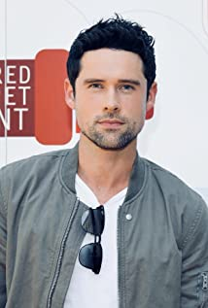Benjamin Hollingsworth is a classically trained actor who was born September 7th, 1984 in Brockville, Ontario, Canada. In 2006, Hollingsworth graduated from the National Theatre School of Canada (NTS), a prestigious three year acting conservatory program in Montréal.

Soon after, in his first professional role under the direction of NTS alumni, Ted Dykstra, Benjamin was nominated for a Robert Merritt Award for his portrayal of Lance Corporal Dawson, in A Few Good Men, by Aaron Sorkin.

Hollingsworth shifted his focus from theater to film and television. He quickly found footing in the Toronto film industry and began guest starring on several popular Canadian TV series including Degrassi, Heartland and HBO Canada's The Line by George F. Walker.

Benjamin's breakout role came when he landed the lead in his feature film debut alongside Demi Moore, David Duchovny and Amber Heard in the highly acclaimed film feature The Joneses (2010).

Following The Joneses, Benjamin was cast in a new CW series called The Beautiful Life (2009) starring Misha Barton, Sara Paxton and Gal Gadot. The series, produced by Ashton Kutcher, cast Hollingsworth in the lead role of "Chris Andrews," a character that was loosely based on Kutcher's own experiences in the industry.

Shortly after, Hollingsworth went on to recur in several TV series including a memorable turn as "Kyle Durant" on the first season of USA's Suits; followed by multiple recurring roles on the CW's The Tomorrow People, Cult and a guest star on ABC's Once Upon a Time.

In 2014, Hollingsworth joined the cast of the Fox series Backstrom starring Rainn Wilson, as Assistant District Attorney "Steven Kines." Later that year he starred in several romantic comedies including Lucky in Love (2014) opposite Gossip Girl's Jessica Szohr, A Wish Come True (2014) starring Megan Park and Can't Buy My Love (2014) with Adelaide Kane. He balanced the year out with lead roles in two action thrillers; 20th Century Fox's Joy Ride 3 (2014) and the Lionsgate feature Vendetta (2014).

Benjamin made his return to network TV as a series regular in CBS' medical drama Code Black (2015) in which Hollingsworth played "Dr. Mario Savetti;" a performance that earned Benjamin a Golden Maple Award nomination for Best Actor in a TV series. Code Black featured an all-star cast made up of Oscar winner Marcia Gay Harden, Luis Guzman and Emmy and Golden Globe nominee Rob Lowe. Code Black concluded its third and final season in 2018. By 2021 he was appearing as a series regular in Joe Pickett, Nancy Drew and as Dan Brady in the immensely popular Virgin River, currently in its fifth season.

In 2019 Benjamin made his return to the big screen with two feature films; Lionsgate's revenge thriller Hard Powder starring Liam Neeson, Laura Dern and Emmy Rossum and the David Cronenberg remake of the 1977 cult classic Rabid from the Soska Twins. He has also starred in several TV Movies including A Godwink Christmas: Meant for Love, Love Under the Olive Tree, A Splash of Love, Romance in Style and The Santa Summit.

## KATE TWA

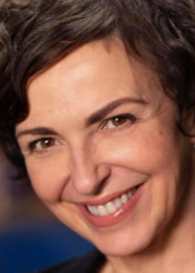Kate began her professional acting career at the age of 17 playing Estella in The Citadel Theater's production of Great Expectations. Shortly after, she travelled over seas to study in London with the British Theatre Association. Training in the classics by day left her evenings open to explore some of London's newest playwrights and explosive productions. At 18 she was developing a taste for the raw, insightful and provocative work she is known for today. Kate was appointed Artistic Director of Gastown Theatre, a 66 seat black box theatre that further fueled her passion for acting and ignited new thirst for directing and writing.

Selected stage performances include Birdbath by Leonard Melfi, No Exit by Jean‐Paul Sartre, Miss Julie by August Strindberg and The Sweetest Swing in Baseball by Diana Son. Kate has .also acted extensively in film and television (X‐Files, Outer Limits, Killer App, DaVinci's Inquest, and Dead Zone.Developing and directing new material has since been a driving passion. Written and directed works include Whatever Happened to What’s Her Name?, Serfing (co-written with Mark Ragan), Joke You! (co-written with Jan Derbyshire) and Torched. In 2011 Kate wrote and directed Gods of Youth, a harrowing exploration of kids and crystal meth. Most recently she completed writing and directing The Orchard, a dark comedy about an unexpected transformation.

Kate won critical and audience acclaim for directing Creeps by David Freeman, Waiting For Lefty by Clifford Odets, The Shape of Things by Neil LaBute, Hope Slide by Joan Macleod, The Curate Shakespeare As You Like It by Don Nigro, Wild Abandon by Daniel MacIvor, Tough! by George F. Walker and A Midsummer Night’s Dream, and Comedy of Errors both by William Shakespeare. Kate has taught for The Canadian College of Performing Arts, The Vancouver Film School, Cineworks, The Company We Keep, and in 2001 she co‐founded The Lyric School of Acting. She moved on to develop Cucumber Satellite Theatre and Film Society, then Co-Founded the renowned Railtown Actors Studio with John Cassini. She currently resides in Naramata, BC and is the Artistic Director of Tempest in Penticton.

## WILLIAM DEVRY SIMARD

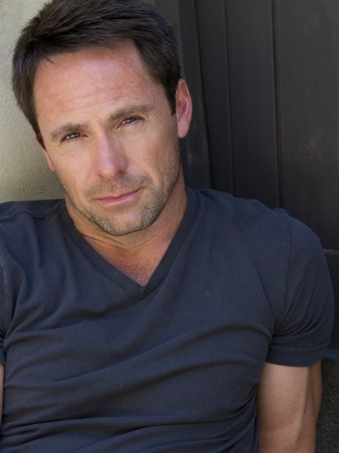William was born and raised in Montreal, Canada. He moved to Florida with his mother when he was 19 and still maintains a residence there. His mother, Diane, is the grand-daughter of Herman DeVry founder of the DeVry Institute. William is an only child and named after his maternal grandfather.

As a child William was fortunate enough to travel to many places, including Guinea Africa, where he lived for several years. As a young boy he dreamed of becoming a major league baseball player, hopefully for his favorite team the Montreal Expos, but while in college a friend of a friend suggested he attend acting classes (for fun) and by doing so William's dream career changed.

William's best known for his roles as Joshua Doors on Earth Final Conflict, Brent Kallus on Beggars and Choosers, Aldwin on StarGate SG-1, and most recently Michael Cambias on All My Children. William currently resides in Vancouver, Canada where most of his work in the Science Fiction genre has been filmed. In 2003 he was nominated for Best Supporting Actor in a Daytime Drama Series for All My Children. He also has won the award for Best Villian in 2003 and 2004 at the AMC Fan Luncheon.

## EDWIN PEREZ

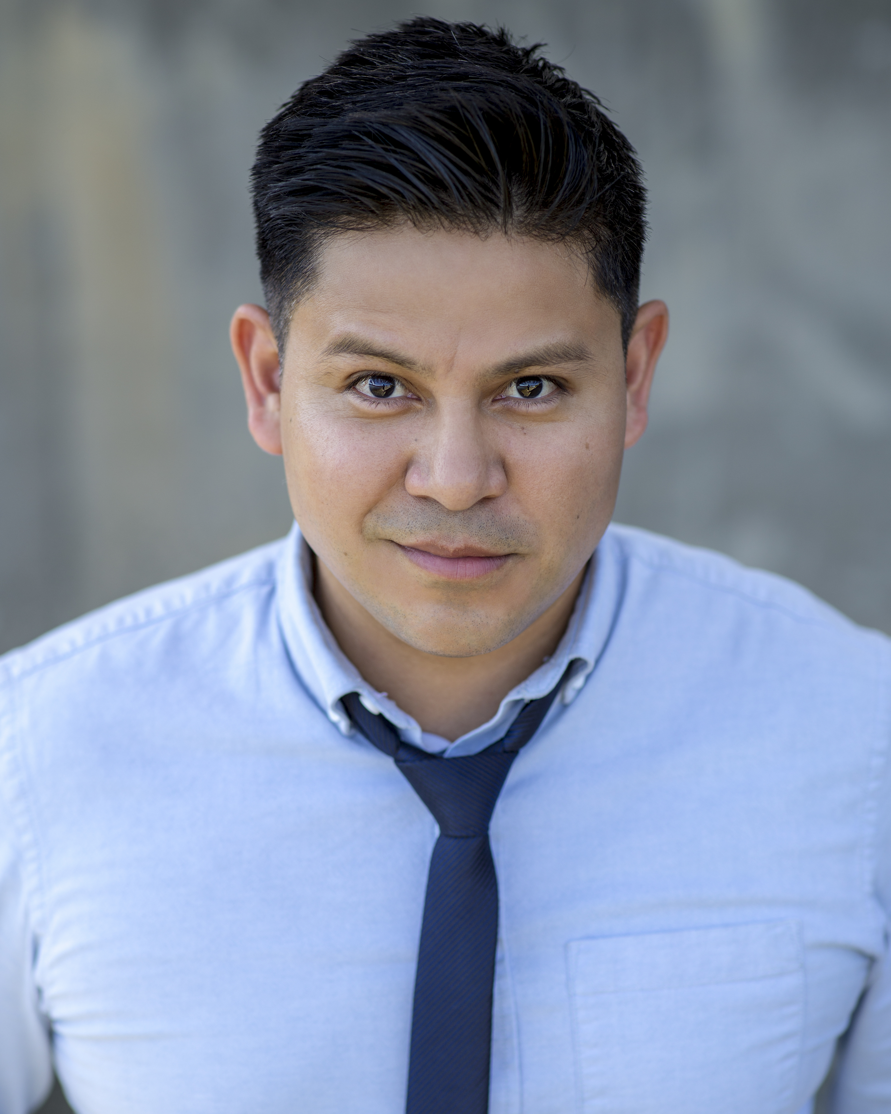Edwin Perez is an American film, TV and voice actor. He is best known for appearing in Supergirl, Arrow, Supernatural and Lucifer, and for voicing a character in Far Cry 6. His recent filmwork has included roles in Love in Wonderland, The Christmas Yule Blog, Butlers in Love, Just One Kiss and Game of Love

He provided character voices in Grand Theft Auto: Vice City Stories, Cats & Dogs 3: Paws Unite, Chip and Potato as well as a 45 episode run as Tio Javier in the very popular Nina’s World.

### Production Credits

### Full Cast

|  |  |
| --- | --- |
| [Actors](http://www.imdb.com/name/nm7589451/?ref_=ttfc_fc_cl_t1)  CINDY BUSBY  BENJAMIN HOLLINGSWORTH  KATE TWA  WILLIAM DEVRY SIMARD  EDWIN PEREZ  ALISHA-MARIE AHAMED  SOPHIA CARRIERE  HEATHER DOERKSEN  SANDRA DOMINGUEZ-SHAPIRO | Role  Maya Alvaro  Matt  Allegra Adams  Jim  Luis  Claire  Carmen Alvaro  Marilyn  Sasha |

### Casting by

JUDY LEE

### Production Designer

HANNAH BLESSIN

### Director of Photography

JUSTIN SEBASTIAN

### Edited by

JASON NIELSEN

### Music by

RUSS HOWARD III

### Written by

JULIANA WIMBLES

### Directed by

JASON BOURQUE

### Full Crew

|  |  |
| --- | --- |
| PARALEE COOK | Associate Producers |
| TIM SPENCE |  |
| CELESTE CROWE |  |
| BROOK JAMES |  |
| CELESTE CROWE | Unit Production Manager |
| NIGEL WILLIAMS | First Assistant Director |
| MICHAEL ALCANTARA | Second Assistant Director |
| JADEN DEVINE | Costume Designers |
| JULIA LOUISE ROSS |  |
| MARIA MARGARITA MARTINEZ GARCIA | Set Decorator |
| MARCELA BUCHER | Props Master |
| LYDIA KUHNERT | Make-Up Artist |
| CASSANDRA KLEINSCHROTH | Hair Stylist |
| ROBIN MACDONALD | Location Manager |
| JULIE ZHU | Script Supervisor |
| BROOK JAMES | Production Coordinator |
| TAD NAZAR | Production Sound Mixer |
| NOVUS ORDO SECLORUM SHOOTING GROUP INC. | Picture Post Production |
| SQUARE MUSIC LAB | Sound Facilities |

# Producer Biographies

## TIMOTHY O. JOHNSON – Executive Producer

Timothy O. Johnson is among the most active and reliable producers in the business thanks to top rate productions and global distribution appeal. He is the managing partner of Johnson Production Group, a Canadian based operation that produces over 100 hours of dramatic television annually with hundreds of programs running internationally. The company is the leader supplier to Lifetime, Hallmark and other international outlets.

A graduate of the Marshall School of Business at the University of Southern California, he served as President of the USC Entertainment Management Association and a member of the Advisory Committee of the Center for Entrepreneurial Studies.

Johnson is also responsible for producing the international hit series, DR. QUINN, MEDICINE WOMAN for CBS for over 5 seasons. During his 100-episode tenure, he also developed and produced the original docu-drama COLD CASE for CBS network, which was the very first program to integrate television with the Internet.

Most recently, Johnson has produced the THE NOEL DIARY, being the #1 Film on Netflix’s Top 10 list in December of 2022. He was also at the helm of the successful GIRL IN THE SHED: THE KIDNAPPING OF ABBY HERNANDEZ, as well as the V.C. Andrews series of films, to date including TWILIGHT’S CHILD, MIDNIGHT WHISPERS, and DAWN, all produced for Lifetime..

Johnson has produced over 400 movies and 15 globally released series for every major US network - including Netflix, Lifetime, Hallmark, ABC, Disney, CBS, NBC, Netfly, FOX and Sony.

## JOHNSON PRODUCTION GROUP

The Johnson Production Group contracts globally to produce television content for international networks, studios and distributors. Based in Los Angeles and Vancouver, British Columbia, the company manages production, facilitates development and financing, procures distribution and guarantees quality and timely execution of its programs. While costs have gone up, so has the demand for quality. No longer is good enough, good enough. Johnson Production Group serves that segment when a show needs to be "A" quality, but produced efficiently enough to meet a locked budget. JPG specializes in value, protection of creative elements, and delivery of a quality finished product.

OLIVER DE CAIGNY – Executive Producer  
Oliver De Caigny is a Canadian producer originally from Belgium, his background in financing, production, and post production makes him a well-rounded producer for any type of production. His experience in financing and production agreements (film and TV series and movies-of-the week), distribution agreements (both domestic and foreign) as well as international co-productions, Canadian tax credit, Telefilm Canada and Canada Media Fund incentives provides him with a well-rounded background in development, production and distribution for motion pictures, television series and productions.

## JOSEPH WILKA – Co-Executive Producer

Joseph Wilka is the Head of Production for Johnson Production Group. Los Angeles-based, Joseph had already produced and directed several feature films before serving as the senior marketing executive for Gravitas Ventures. While at Gravitas, Wilka helped pioneer new distribution models for independent films including day-and-date theatrical releases. It was also at Gravitas where Joseph first worked with Johnson Production Group to facilitate the release of their films to the worldwide Video On Demand audience. After serving as the Director of Distribution and Production for Viva Pictures, where he produced English-language versions of foreign animated titles for DirecTV, Wilka officially joined Johnson Production Group. As Head of Production, he oversees the development, production, and distribution of films from multiple production units for release on broadcast and streaming platforms.

## LISA ALFORD – Co-Executive Producer

Lisa Alford is a development executive at Johnson Production Group. A Massachusetts native, Lisa has lived and worked in Los Angeles for over a decade, always in support of excellent storytelling. Prior to joining Johnson Production Group, Lisa worked as an executive at TriStar television where she specialized in identifying IP that supported TriStar’s mission to feature diverse, authentic characters and champion underrepresented voices. Lisa came up at Sony Pictures Television where she worked as a production coordinator in the Television Movies and Miniseries department and in the writers room on the WGN hit series OUTSIDERS. In her current role, Lisa shepherds projects from the concept phase through story development, production, and post.

## JULIANA WIMBLES – Co-Executive Producer

Canadian-born, Juliana Wimbles has cultivated a career in film and television spanning over 20 years as both an actor and writer. She is a regular on ABC's The Good Doctor (2019) and a familiar face on the Hallmark Channel (2019.) Additional screen credits include Valley Of The Boom (2019), Motive (2015), Restless Spirits (1999), Supernatural (2008) and Fringe (2010.) In 2019 Juliana's wrote the screenplay and appears as a supporting role in MOW Starring Christmas, directed by Ali Liebert, which has just completed principal photography. Juliana also has shared her acting experience as an instructor in Vancouver for 12 years.

NAVID SOOFI – Producer  
Navid is the primary producer for Novus Ordo Seclorum. Navid’s passion for filmmaking along with his business and engineering background plays an important role in creating a successful and transparent business model. Navid has been in the entertainment industry for more than 13 years and has produced over 50 feature films, TV shows and commercials that have been featured on national television, international theatres, and new media platforms. His credits include Over the Moon in Love, The Mistletoe Secret, Random Acts of Christmas, Love Unleashed, Identity Theft of a Cheerleader, and A Mother on the Edge.

JASON BOURQUE – Director  
Over the last decade, award-winning international filmmaker Jason Bourque has written and directed a wide variety of features, television movies, series and documentaries, as well as over 60 commercials, short films and music videos. In 2007 Jason co-wrote and co-directed the theatrical documentary "Shadow Company" narrated by Gerard Butler. An in-depth look into the private military industry, the festival hit (SXSW, Hot Docs) was reviewed favorably in the New York Times, Chicago Tribune, Variety and has been used as a teaching tool for the US Senate. Jason co-directed "Darwin's Brave New World" for CBC and ABC Australia, an award-winning documentary series shot in five countries. "Music For Mandela", his last feature documentary shot throughout South Africa and the UK won the People's Choice Award at the Amnesty International Film Festival.

A prolific genre screenwriter on the west coast, Jason has written twenty-eight produced scripts and has several high-profile projects slated for 2019. Recent releases include "The Fixer", his second television mini-series for Sonar, Muse Entertainment and FOX UK. Jason served as executive story editor and writer (2 episodes) on the new high-octane thriller series "Insomnia" released through Starz International. Jason's theatrical feature "Black Fly" (writer/director) premiered at VIFF and received nominations for Best Canadian Film and Best BC Film as well as 10 Leo Award nominations. It won for Best Male Lead Actor and Best Sound Editing. Recent accolades include Best Feature at the Arizona Underground Film Festival and the UBCP / ACTRA Award for Best Newcomer. Jason's latest award-winning theatrical feature "Drone" is an indie success story. Starring Emmy-award winner Sean Bean, it was released theatrically in the US and internationally in over 25 territories. Upon release, "Drone" was the #1 Indie and #2 thriller on iTunes US. Upcoming releases include the feature "Hotwired in Suburbia", the sequel to the Leo-nominated Netflix Original "Counterfeiting in Suburbia" and two episodes of "Medinah", the world's first Arabic / English science fiction series shot in Qatar.

## Billing Block

Hallmark in association with Johnson Production Group Presents “A WHITEWATER ROMANCE” starring CINDY BUSBY BENJAMIN HOLLINGSWORTH KATE TWA WILLIAM DEVRY SIMARD EDWIN PEREZ Casting by JUDY LEE Production Designer HANNAH BLESSIN Director of Photography JUSTIN SEBASTIAN Edited by JASON NIELSEN Music by RUSS HOWARD III Supervising Producer TIM MUDD Co-Executive Producers JOSEPH WILKA LISA ALFORD JULIANA WIMBLES Executive Producers TIMOTHY O. JOHNSON OLIVER DE CAIGNY BENJAMIN HOLLINGSWORTH CINDY BUSBY Produced by   
NAVID SOOFI Written by JULIANA WIMBLES Directed by JASON BOURQUE

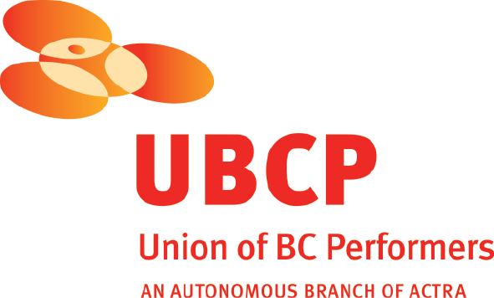 

With the participation of the Province of British Columbia   
Film Incentive BC

The Canadian Film or Video Production Tax Credit  


We acknowledge that this film was recorded on Sḵwx̱wúmesh-ulh temíxw (the land of the Squamish people)

 

© MMXXIV Riveredge Productions Inc. All Rights Reserved





Meta Data

LONG (max 3000 characters) synopsis

Maya Alvaro is a strong but sweet, hard working business woman with a heart of gold. What she is not is a rugged outdoorsy type, so when the CEO of her company invites her to an exclusive white-water rafting retreat in the Rocky Mountains, Maya’s not so sure she’s the woman for the job. Her boss convinces her she can handle anything that comes her way and sends her on the trip under strict instruction: impress the CEO and snag a career making contract. If she can do this, and survive a weekend camping in the woods, the promotion of her dreams will be hers. So Maya packs the closest thing she has to hiking boots and heads out, hoping for the best. Shortly after arriving at The Whitewater Lodge, Maya meets Matt, a man who IS an outdoorsy type. In fact Matt is more at home in the woods than anywhere else. Maya quickly realizes that Matt is also trying to snag the same coveted contract she’s after and once they’re done sizing each other up as the competition, they do not hit it off. But as fate would have it, Maya and Matt are paired as a team to complete a series of team-building exercises together, including zip-lining, high-wire rope walking, and Mays’s most dreaded event (and worst nightmare), whitewater rafting. As Maya lets her guard down to brave the wild wilderness, she and Matt start to form a genuine, romantic connection. What begins as a ferocious competition slowly starts to evolve into something much more. They realize they’re much better as a team, in more ways than one, and devise a plan to combine their efforts so they both get what they need out of the weekend. (1600)

MEDIUM (max 500) synopsis

Maya is a strong, sweet, hard working business woman…and not is an outdoorsy type, but her boss sends her to a white-water rafting retreat in the Rocky Mountains to snag a major contract. There she is paired off with Matt who IS the rugged outdoorsy type and they do not hit it off. As they complete a series of team-building exercises, including zip-lining, high-wire rope walking, and whitewater rafting, what begins as a ferocious competition slowly evolves into a genuine, romantic connection.

(497)

SHORT (max 100 characters) synopsis

At a competitive corporate retreat, Maya and Matt find realize they’re much better as a team.

(97)

5 KEY WORDS

Corporate retreat, competition, outdoors, teamwork