

Johnson Production Group

Press Kit

One-Liner
An entrepreneur gets support from her handsome customer for her budding pet toys and treat business.

Synopsis

Scarlett is a hardworking entrepreneur and inventor, looking to make it big with innovative dog toys and treats. Her latest puppy treat recipe is already all the rage with the dogs on her block, she just needs a distributor to bring her product to the masses. But she can’t land it on the shelves of any local grocers until she meets Alex who runs Paws and Wellness Emporium and is so impressed by her product he puts in an order that quickly sells out. As he and Scarlett work together to keep the supply of puppy treats coming, when a competitor gets a whiff of her product and does everything he can to shut her down. Scarlett doubles down, putting all of her efforts into keeping her business alive. But Alex tries to remind her that there’s more to life than hard work, and what better reminder of the joys of playful love and romance than the adorable puppies that Scarlett works so hard to care for.

Producers
Executive Producers
TIMOTHY O. JOHNSON
ANDREW C. ERIN
OLIVER DE CAIGNY
Co-Executive Producers
JOSEPH WILKA
LISA ALFORD
Producer
JOSIE FITZGERALD

Key Cast
CHARACTER  Scarlet  Alex  Gina  Paul  Michelle |  | ACTOR  PASCAL LAMOTHE-KIPNES  STEPHEN HUSZAR  KATHRYN DAVIS  DARRIN BAKER  VICTORIA MARIA

Key Cast Biographies

Pascal Lamothe-Kipnes

Pascal Lamothe-Kipnes discovered her love of performing during a high school musical. Leaving her hometown of Edmonton, Alberta to attend Vancouver Island’s Shawnigan Lake Boarding School, Pascal is incredibly grateful to have been immersed and involved in a high school drama program. Following her passion, she continued her training at the University of Victoria where she received her BFA in acting. After a brief obligatory post-theatre school stint in Toronto, she returned to British Columbia to pursue a career in film and television in Vancouver, the acclaimed Hollywood North, earning roles on CW's “Charmed” and “DC's Legends of Tomorrow” and lending her voice to the score of VC Andrews “Dawn” series on Lifetime. Pascal has also starred in the feature-length film, Heart of Gold, for which she was nominated for a Leo Award in the Best Lead Performance category.

Stephen Huszar
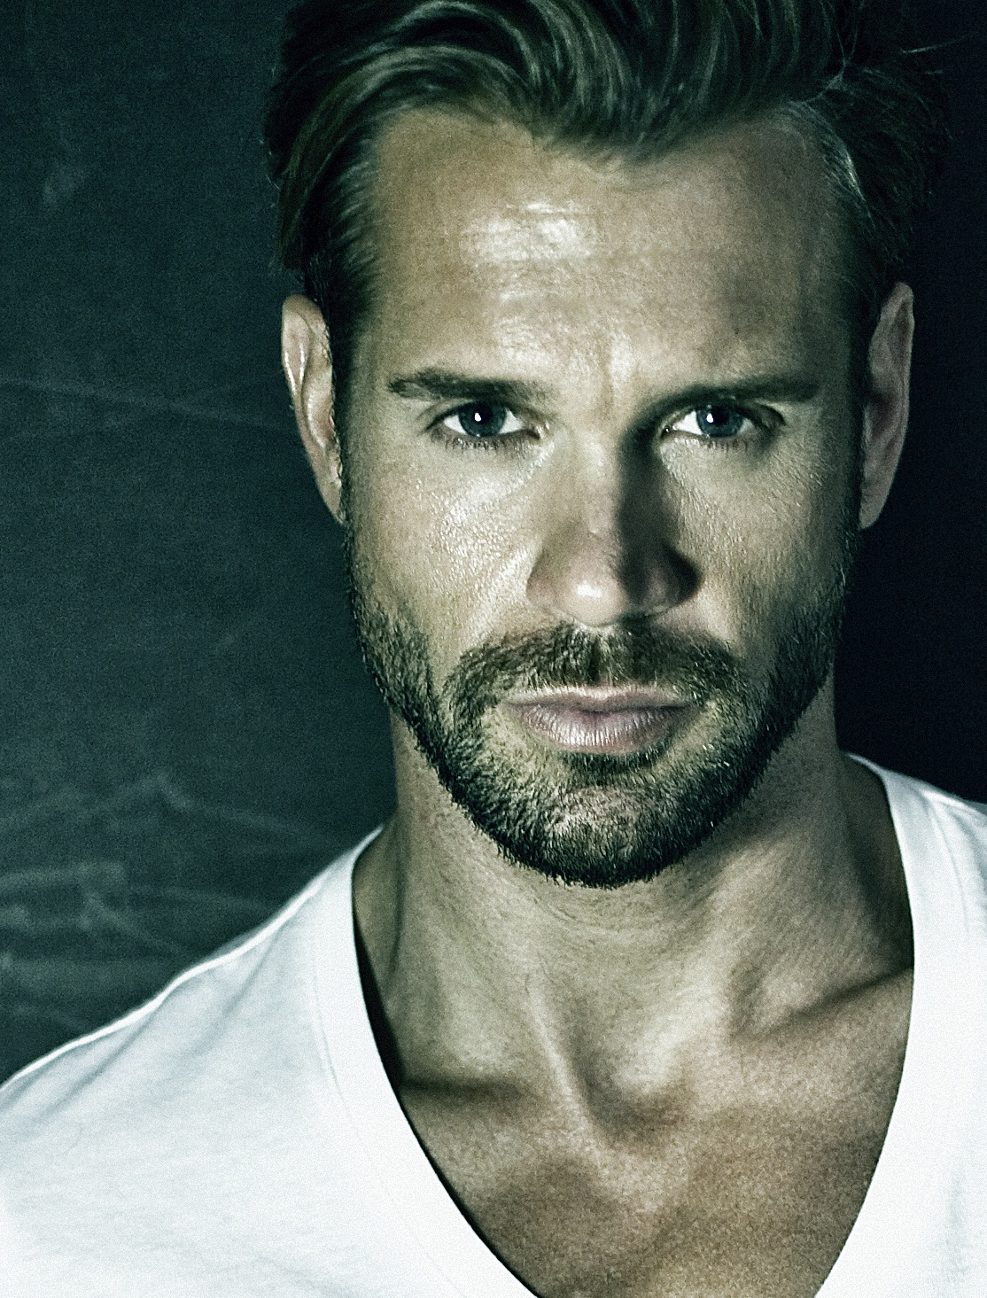
Stephen Huszar is a Canadian actor born in Saskatoon, Saskatchewan, where he graduated from the University of Saskatchewan. Huszar began his acting career in 2004 with a role in the TV movie “The Cradle Will Fall” and shortly after his first lead role starring opposite Kim Coats in the feature film, "Caught in the Headlights". His career took off rapidly and he appeared in recurring roles on popular series such as “Smallville” for The CW, “The Fringe” for FOX, “Corner Gas” for CTV, and “Paradise Falls” for Showcase.
Other notable credits include feature films such as "Milton’s Secret", starring Donald Sutherland and Michelle Rodriguez, (for which he also served as a producer), "30 Days of Night: Dark Days", directed by Ben Ketai, "Faces in the Crowd", opposite Milla Jovovich and “Ferocious", opposite Kim Coates, Dustin Milligan and Amanda Crew.
Selected television credits include his portrayal of comic book super villain Plunder in The CW’s “The Flash,” Showcase’s “Continuum,” The CW’s “Supernatural” a recurring role on Crave TV’s “Letterkenny,” Canada’s top award-winning comedy series.
Most recently Huszar completed production on Season 6 of “Chesapeake Shores” and Season 2 of “Tribal” TV series where he plays a recurring character on both shows.
Other selected releases include his feature film “Rabid", a remake of David Cronenberg’s cult classic, “A Homecoming for the Holidays”, “My One & Only" and “Return to Christmas Creek" for Hallmark Movies & Mysteries and also stars in the network’s original “Ruby Herring Mysteries” franchise. He also starred in the Netflix romantic comedy, “Christmas Wedding Planner”, and Hallmark’s “Undercover Holiday” and “Love in Glacier National Park”, which was the most watched show on all of cable the night of its premiere. Huszar is currently shooting a lead role in the series of “Jane Da Silva Mysteries”, a TV movie for Hallmark.

KATHRYN DAVIS

Born and raised in Bath, England. Kathryn was introduced to theatre at a young age and has always had a great appreciation of all of the arts.
Over the years, Kathryn has accumulated an extensive resume from amateur theatre to professional work in England and Canada in theatre, film, video-games and television. Kathryn is a graduate of Toronto Metropolitan University's prestigious Theatre School program where she has earned her BFA in Performance Acting with Honours. Throughout her training she studied many different styles of theatrical training including Classical Shakespeare, Naturalism (Stella Adler/Uta Hagen), Period Study (Jacobean), Mask, Mime, Clown, Commedia dell'arte, Voice & Speech, Movement (Alexander technique/Laban), Dance (Period/Jazz/Tap) and Musical Theatre.
Kathryn is also trained in Ballet, Tap and Jazz as well as being a strong mezzo-soprano singer. Kathryn has a British RP accent and other accents are very familiar and come easily to her.

DARRIN BAKER
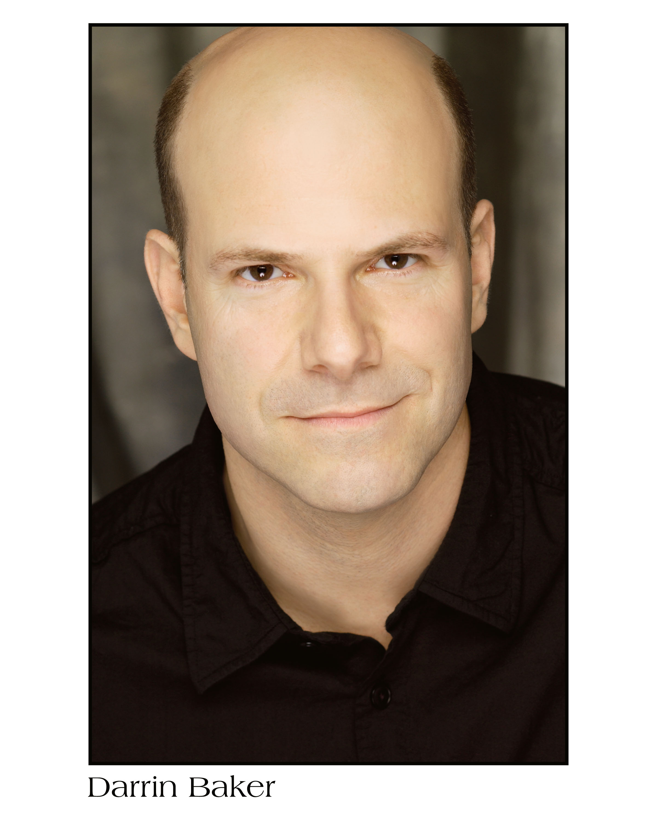
Darrin has been acting professionally for 38 years...in the USA and Canada.
He can be seen in the 2022 TV season recurring as Dr Hartman on Netflix’s Painkiller directed by Peter Berg and as Dr Martin Bisely recurring on Apple TV’s Five Days At Memorial, created and directed by John Ridley. Darrin was also thrilled to appear in the comedy action film The Man From Toronto with Kevin Hart and Woody Harrelson.
His many acting credits include leading roles on TV and film in The Good Doctor, The Man From Toronto, My Spy, Kodachrome, Suits, Designated Survivor, People Of Earth, The Strain, Covert Affairs, The Lottery, Law and Order, The Firm, Law & Order and SVU , Rogue, Dark Matter, The Girlfriend Experience, Flash Point, Warehouse 13, Queer as Folk, King, Murdoch Mysteries and many more. Films include: The Glass Castle, Spotlight, The Man From Toronto, The Good Guy, What Happens Next, A Guide to Recognizing Your Saints and Romance With A Twist.
Broadway credits include: Sunset Blvd, Footloose, The Scarlet Pimpernel, Wonderful Town. Laughing Room Only! and Tarzan.
AWARDS:
2015 SAG Award /Best Ensemble in a motion picture
2013 TORONTO THEATRE CRITICS AWARD (Best Supporting Actor)
2013 DORA AWARD (Nomination) for FEATURED ACTOR in a Musical
2010 CARBONELL AWARD (Nomination) for BEST SUPPORTING ACTOR
DRAMA LOGUE AWARD for BEST DIRECTION /PERSONALS Los Angeles Premiere

VICTORIA MARIA

Victoria Maria was born in Calgary, Alberta, Canada. At nineteen, she moved to New York City to study the Meisner technique at The Neighborhood Playhouse School of the Theatre. After graduating, Victoria worked in indie film in NYC, starring in films that screened at such festivals as SoHo International Film Festival, Calgary International Film Festival and Cannes Film Festival. Victoria has been based out of Toronto, Ontario since 2015. She produced and starred in the short film, March, which was an official selection and nominee at the 2020 Whistler Film Festival.

Production Credits

Full Cast
Actors  PASCAL LAMOTHE-KIPNES  STEPHEN HUSZAR  KATHRYN DAVIS  DARRIN BAKER  VICTORIA MARIA  JASON WEINBERG  KAYLA LAKHANI  ANAS HASAN  RANDY THOMAS  PAULYNE WEI  CURTIS LEGAULT  ZACH EULBERG  NIGEL DOWNER | Role  Scarlett  Alex  Gina  Paul  Michelle  Jack  Secretary  Bennie  Lee  Dr. Mitchell  Assistant  Police Officer  Buyer

Casting
BRIAN LEVY, c.s.a.
JASON STROUD, c.d.c.

Composer
RUSS HOWARD III

Costume Designer
SAGINE CAVÉ

Editor
MITCH LACKIE

Production Designer
GREGORY PHILIP WILSON

Director of Photography
MICHAEL TIEN

Associate Producer
ALEXANDRA WARING

Written by
KEITH HEMSTREET

Directed by
MARNI BANACK

Full Crew
JOHNNY ROSS | First Assistant Director
MARY CROZIER | Second Assistant Director
CIMARRON LANGLOIS | Third Assistant Director
LINDSEY BELANGER | Fourth Assistant Director
MAYA BROWN | Production Assistant
SMYTH CASTING | Extras Casting
ILONA SMYTH
GORAN POBRIĆ | Production Coordinator
NATASHA TREPANIER PANETTA | Assistant Production Coordinator
LOGAN A. WAGNER | Head of Accounting
SARAH CHENIER | Assistant Accountant
MATTHEW CARVELL | Post Production Accountant
ALEXANDRA WARING | Post Production Supervisor
RICHARD FRAZIER | Post Production Coordinator
REZAYAR MEHRPOUR | Post Production Assistant
GREGORY PHILIP WILSON | Production Designer
ELIZABETH FITZPATRICK | Art Director
ANTHONY RANKIN | Set Decorator
GREGORY LOWE | Set Dresser
DANIEL KAUNISVIITA | Graphics Artist
NATHALIE GREGOIRE | Property Master
BEN BELANGER | SFX Supervisor
CAPITAL FILM WRANGLERS | Dog Wranglers
KURTIS BAYFORD
MELISSA MARTIN
AUDREY BROUSSEAU
SAGINE CAVÉ | Costume Designer
RÉNALD JEAN-PIERRE | Costume Truck Supervisor
JESSIE EDWARDS | Costume Set Supervisor
HANNAH LUNDRIGAN | Wardrobe Assistants
CHRYSTINE ST LOUIS
MICHAEL TIEN | Director of Photography
JOSH HENDERSON | B Camera Operator
ABRAHAM ISSA | A Camera - First Assistant Camera
LINDSEY BELANGER | A Camera - Second Assistant Camera
MUNG HATLANG
JILL SKIDMORE
NATHAN YEE
MATT CROSSE | B Camera - First Assistant Camera
DANIEL COSTEA | B Camera - Second Assistant Camera
PATRICK CAMILLE | Camera Trainee
RICHARD FRAZIER | Digital Imaging Technician
GEGHANI PANOSIAN | EPKBTS Camera Daily
RICHARD FRAZIER | Camera Technicians
GEGHANI PANOSIAN
DARCY RYAN | Stills Photographer
ORIGIN CAMERA RENTAL | Camera Equipment
STEVEN F. S. BRUNI | Gaffer
DANIEL KAUNISVIITA | Best Electric
NICHOLAS HERMIER | Key Grip
GERALD AUSTIN LEPAGE | Best Grip
MATT HAUGHN | Crane Operator
CONNOR DORZEK | Grip / Electric Swings
JOHN HOLMES
ALEXIS MUTOMBO
ROMY RANDEV
MASON THIVIERGE
FRANCESCO FALSETTO | Sound Mixer
ADAM PAUL HINCHLIFFE | Boom Operator
NICK SMITH | Script Supervisor
BRENDAN MCLOUGHLIN | Set PA
NATALIE HONSHORST | Assistant Location Manager & Scout
ALEX ASANJARANI | Location Production Assistants
SAM KITTS
KAT PANOVA
WILLIAM THIBODEAU
ALYSSA "ALY" MORDEN-HAYLEY | Key Makeup Artist
NATASHA TREPANIER PANETTA | Key Hairstylist
MARC-ANDRE LEVAC | Makeup & Hair Assistants
KASSANDRA PEREIRA
STEFANE GREGOIRE | Transport Coordinator
GREG LEWIS | Transport Captain
MICHAEL DICKSON | Drivers
BILAL MAHMOUD
KIM RODGER
ALEXANDRE GREGOIRE | Transport Production Assistants
J.G. GREGOIRE
PERRY MCCONNELL
LYNN SPRACKLIN
ROBERT STRONACH
JAY VISNESKIE
KEITH STEFFENSEN | Move Crew
CHRIS SURUJNARAIN
CORNELIA VILLENEUVE
DAN VILLENEUVE
ERIC VILLENEUVE
SEAN VILLENEUVE
TOM WARRELL | Head Chef
GERRY WHALEN | Chef
MATTHEW DUBUC | Caterer
RONDA MACKINNON | Craft Service
PAUL NEEDHAM | Set Medic
THE NO CONFLICT CLEARANCE COMPANY | Script Clearances
HALL WEBER LLP | Legal Services
DANNY WEBBER
ABOVE THE LINE MEDIA SERVICES | Business Affairs
BRENDAN MCNEILL
ARTHUR J. GALLAGHER CANADA LTD. | Insurance
URBAN POST PRODUCTION | Post Production Services
EHREN PFEIFER | ADR Recordist
LUKA TOMA | Sound Editor
DAWN LEWIS | Foley Artists
TESS MOIR
DAVE MERCEL | Foley Recordists
MATTHEW MCKENZIE
COLIN MCLELLAN | Re-Recording Mixer
WARREN CHINN | Colorist
EVAN GRAVES | VFX
KALI RAIGH | Online / Packaging Editor
DIEDRA BAYNE | Assistant Online / Packaging Editor
ASHLEY POUCHING | Project Manager
BRUCE REES | Picture Operations Manager
ROBERTA BRATTI | V.P. of Operations
POND5/ODESIGNS | Stock Footage
POND5/FELIXMIZIOZNIKOV
POND5/FEEDOUGH
POND5/DJMCCLEA
POND5/BLACK BOX GUILD
POND5/JAREDRCOOK
POND5/MANUMATA
POND5/MARKOCONNELL
ISTOCK/JAMESBREY
ISTOCK/PGIAM
ISTOCK/ORLOWSKIDESIGNS
ISTOCK/ODESIGNS
ISTOCK/JEREMYLOPEZFOPPIANI
ISTOCK/IANMCDONNELL
LIBERTY GOLDEN RETRIEVERS | Additional Dog Footage
@HIGHDESERTLABRADORS | Ultrasound footage
"Take Courage"
by Russ Howard III and Barak Shpiez
courtesy of Sweaty Avocado Music and Shpeez Music
"Yellow Funk"
by Russ Howard II and Barak Shpiez
courtesy of Sweaty Avocado Music and Shpeez Music
"Positively Swung"
by Russ Howard III and Benjamin Bromfield
courtesy of Sweaty Avocado Music and Ben Bromfield Music
"Coffee Tweakers"
by Russ Howard III and Benjamin Bromfield
courtesy of Sweaty Avocado Music and Ben Bromfield Music
"Wine O'Clock"
by Russ Howard III and Benjamin Bromfield
courtesy of Sweaty Avocado Music and Ben Bromfield Music

Producer Biographies
TIMOTHY O. JOHNSON – Executive Producer
Timothy O. Johnson is among the most active and reliable producers in the business thanks to top rate productions and global distribution appeal. He is the managing partner of Johnson Production Group, a Canadian based operation that produces over 100 hours of dramatic television annually with hundreds of programs running internationally. The company is the leader supplier to Lifetime, Hallmark and other international outlets.
A graduate of the Marshall School of Business at the University of Southern California, he served as President of the USC Entertainment Management Association and a member of the Advisory Committee of the Center for Entrepreneurial Studies.
Johnson is also responsible for producing the international hit series, DR. QUINN, MEDICINE WOMAN for CBS for over 5 seasons. During his 100-episode tenure, he also developed and produced the original docu-drama COLD CASE for CBS network, which was the very first program to integrate television with the Internet.
Most recently, Johnson has produced the THE NOEL DIARY, being the #1 Film on Netflix’s Top 10 list in December of 2022. He was also at the helm of the successful GIRL IN THE SHED: THE KIDNAPPING OF ABBY HERNANDEZ, as well as the V.C. Andrews series of films, to date including TWILIGHT’S CHILD, MIDNIGHT WHISPERS, and DAWN, all produced for Lifetime..
Johnson has produced over 400 movies and 15 globally released series for every major US network - including Netflix, Lifetime, Hallmark, ABC, Disney, CBS, NBC, Netfly, FOX and Sony.
JOHNSON PRODUCTION GROUP
The Johnson Production Group contracts globally to produce television content for international networks, studios and distributors. Based in Los Angeles and Vancouver, British Columbia, the company manages production, facilitates development and financing, procures distribution and guarantees quality and timely execution of its programs. While costs have gone up, so has the demand for quality. No longer is good enough, good enough. Johnson Production Group serves that segment when a show needs to be "A" quality, but produced efficiently enough to meet a locked budget. JPG specializes in value, protection of creative elements, and delivery of a quality finished product.
ANDREW C. ERIN – Executive Producer
Andrew Erin is a Canadian Writer/Director making a big splash in the US, and has produced, written and directed numerous commercially successful films.
His directorial debut, SAM’S LAKE, was an official selection at the Tribeca Film Festival and did an excellent theatrical run in select theaters around the country; distributed by Lionsgate Films. Andrew also wrote the script for the film.
Andrew’s directorial credits include, SIMPLE THINGS, produced for Screen Media Ventures and Universal Studios. Besides winning The Bob Clark Award for Best Director at the California Independent Film Festival, the film was commercially received.
Andrew has worked continuously as a writer/director, building a strong library of films in the Thriller/Horror genres with: Embrace of The Vampire, The Clinic, Final Sale, Confined and Toxic Skies.
His most recent project, HAVENHURST was recently acquired by Lionsgate, set for release 2016. It was written, directed and produced under his own banner, along with Twisted Pictures.
OLIVER DE CAIGNY – Executive Producer
Oliver De Caigny is a Canadian producer originally from Belgium, his background in financing, production, and post production makes him a well-rounded producer for any type of production. His experience in financing and production agreements (film and TV series and movies-of-the week), distribution agreements (both domestic and foreign) as well as international co-productions, Canadian tax credit, Telefilm Canada and Canada Media Fund incentives provides him with a well-rounded background in development, production and distribution for motion pictures, television series and productions.
JOSEPH WILKA – Co-Executive Producer
Joseph Wilka is the Head of Production for Johnson Production Group. Los Angeles-based, Joseph had already produced and directed several feature films before serving as the senior marketing executive for Gravitas Ventures. While at Gravitas, Wilka helped pioneer new distribution models for independent films including day-and-date theatrical releases. It was also at Gravitas where Joseph first worked with Johnson Production Group to facilitate the release of their films to the worldwide Video On Demand audience. After serving as the Director of Distribution and Production for Viva Pictures, where he produced English-language versions of foreign animated titles for DirecTV, Wilka officially joined Johnson Production Group. As Head of Production, he oversees the development, production, and distribution of films from multiple production units for release on broadcast and streaming platforms.
LISA ALFORD – Co-Executive Producer
Lisa Alford is a development executive at Johnson Production Group. A Massachusetts native, Lisa has lived and worked in Los Angeles for over a decade, always in support of excellent storytelling. Prior to joining Johnson Production Group, Lisa worked as an executive at TriStar television where she specialized in identifying IP that supported TriStar’s mission to feature diverse, authentic characters and champion underrepresented voices. Lisa came up at Sony Pictures Television where she worked as a production coordinator in the Television Movies and Miniseries department and in the writers room on the WGN hit series OUTSIDERS. In her current role, Lisa shepherds projects from the concept phase through story development, production, and post.
JOSIE FITZGERALD - Producer
Josie Fitzgerald is a Canadian born Producer currently residing and working in Ottawa, Ontario. Josie is also a passionate photographer and writer, with an education in Justice Studies and a professional background in Human Resources and Project Management.

Billing Block
HALLMARK MEDIA Presents In Association With JOHNSON PRODUCTION GROUP EVERYTHING PUPPIES starring PASCAL LAMOTHE-KIPNES STEPHEN HUSZAR KATHRYN DAVIS DARRIN BAKER VICTORIA MARIA Casting BRIAN LEVY, c.s.a. JASON STROUD, c.d.c. Composer RUSS HOWARD III Costume Designer SAGINE CAVÉ Editor MITCH LACKIE Production Designer GREGORY PHILIP WILSON Director of Photography MICHAEL TIEN Co-Executive Producers JOSEPH WILKA LISA ALFORD Executive Producers ANDREW C. ERIN OLIVER DE CAIGNY TIMOTHY O. JOHNSON Producer JOSIE FITZGERALD Written by KEITH HEMSTREET Directed by MARNI BANACK

The Canadian Film or Video Production Tax Credit

© MMXXIV Fireside (PE) Films Inc. All Rights Reserved




Meta Data
LONG (max 3000 characters) synopsis
Scarlett is a hardworking entrepreneur and inventor, looking to make it big with innovative dog toys and treats. Her latest puppy treat recipe is already all the rage with the dogs on her block, she just needs a distributor to bring her product to the masses. But she can’t land it on the shelves of any local grocers until she meets Alex who runs Paws and Wellness Emporium and is so impressed by her product he puts in an order that quickly sells out. As he and Scarlett work together to keep the supply of puppy treats coming, when a competitor gets a whiff of her product and does everything he can to shut her down. Scarlett doubles down, putting all of her efforts into keeping her business alive. But Alex tries to remind her that there’s more to life than hard work, and what better reminder of the joys of playful love and romance than the adorable puppies that Scarlett works so hard to care for. (907)
MEDIUM (max 500) synopsis
Scarlett is a hardworking entrepreneur, looking to make it big with innovative dog toys and treats but she can’t land it on local shelves until she meets Alex who runs Paws and Wellness Emporium. While orders quickly sell out, when a competitor gets a whiff of her product and does everything he can to shut her down. Scarlett doubles down putting all of her efforts into keeping her business alive as Alex tries to remind her that there’s more to life than hard work…like puppies and romance. (496)
SHORT (max 100 characters) synopsis
An entrepreneur gets support from her handsome customer for her budding pet treat business. (91)
5 KEY WORDS
Pet treats, romance, dogs, entrepreneur

