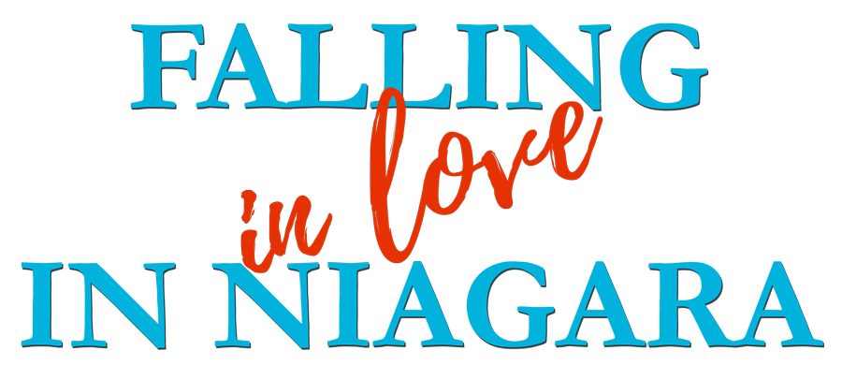

Johnson Production Group

Press Kit

One-Liner

Madeline takes her meticulously planned honeymoon in Niagara Falls even after her fiancé leaves her just before their wedding. There she reconnects with her adventurous side, learns to let go and finds new love.

Synopsis

Madeline has always loved hearing about her grandparent’s inspirational honeymoon in Niagara Falls. As her own wedding approaches she’s planned a similar honeymoon, excited to hit all of the same romantic locales that her grandparents have shared stories about her whole life. When her wedding is shockingly called off only weeks before the big date she makes the bold choice to agree to go on her “honeymoon” anyway with her recently divorced sister on her meticulously planned Niagara Falls trip. When she gets there, the travel guide she booked for the duration of their trip is less than inspiring. He is critical of her plans, he says they’re all just standard tourist traps and she should look for more unique and adventurous outings. She really wants to stick to her itinerary, it’s the same as her grandparent’s after all, but love makes a splash when she follows his lead and they discover the hidden wonders of Niagara Falls together.

Producers
Executive Producers
TIMOTHY O. JOHNSON
ANDREW C. ERIN
OLIVER DE CAIGNY
JOCELYN HUDON

Co-Executive Producers
JOSEPH WILKA
LISA ALFORD
Producer
JOSIE FITZGERALD

Key Cast
CHARACTER  Madeline  Mike  Harley  Emily |  | ACTOR  JOCELYN HUDON  DAN JEANOTTE  MAŠA LIZDEK  JINESEA LEWIS

Key Cast Biographies

JOCELYN HUDON
Jocelyn Hudon was born and raised in Toronto, Canada. Originally a ballerina, she trained and performed at the National Ballet School of Canada since the age of eleven. After completing a degree in communications and a post graduate degree in PR, she began her acting career.
Jocelyn is known for her memorable role of ‘Abby’ on Guillermo Del Toro’s FX Series The Strain, and has also made an impact in the Netflix series The Order, CBS’s Criminal Minds, and FOX’s 911. She recently played the lead role of 'Grace Bennett' in the series, When Hope Calls. She also starred in the TV Movies, Love in the Maldives and One of a Kind Love.
She has starred in Paramount Plus’s feature film V For Vengeance, Netflix’s Sniper, and indie film The Fall. She also appeared in the Apple Plus’s comedy series Acapulco, and FX's Dave.

DAN JEANOTTE
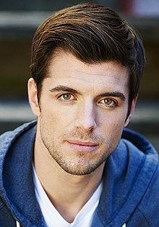
Dan Jeannotte is a Canadian actor, improviser, voice artist and writer. He gained recognition for his roles as Brandon Russell in the American-Canadian fantasy television series Good Witch, and as James Stuart in the CW period drama series Reign. He also portrayed Arno Dorian through performance capture in Assassin's Creed Unity, an action-adventure video game developed by Ubisoft Montreal and published by Ubisoft. In April 2017, Dan joined the Freeform drama series The Bold Type as Ryan Decker, a writer at Pinstripe magazine, who is Jane Sloan's (Katie Stevens) romantic interest. Since 2022, Dan has also played the recurring role of Sam Kirk in Star Trek: Strange New Worlds.
Dan has worked extensively in the comedy and theatre scene in Montreal and Toronto and has toured Canada and the US with his Canadian Comedy Award-nominated comedy troupe, Uncalled For.

MAŠA LIZDEK
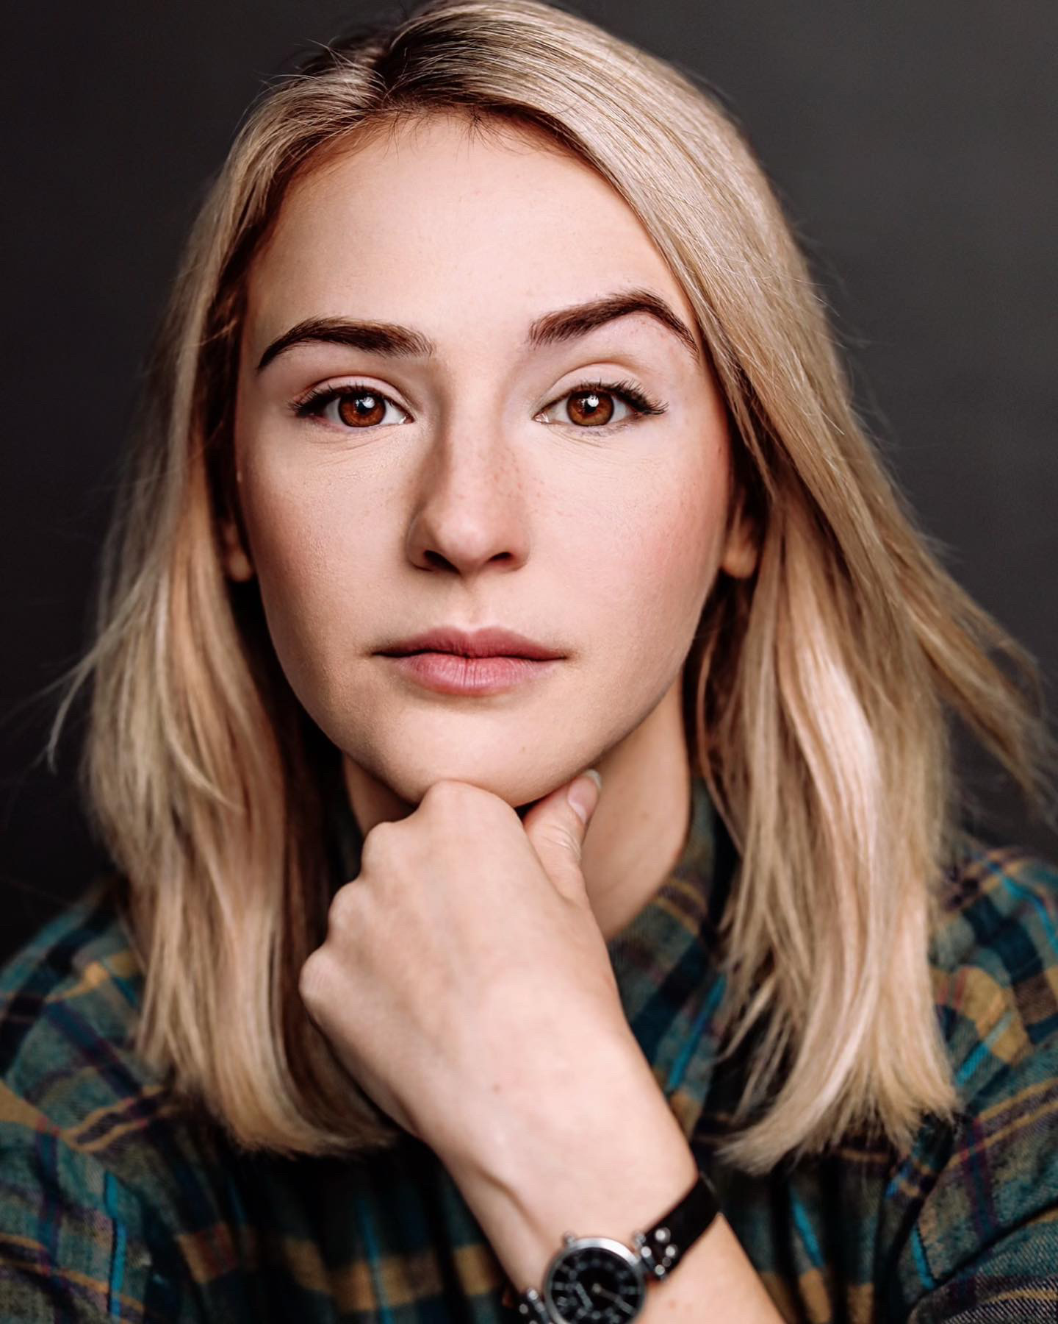
Maša Lizdek is a fast-rising actor who was born in Austria, Vienna, raised in former Yugoslavia, Bosnia and Croatia and currently based in Toronto, Canada.
Maša landed her first professional role in the horror mini television series DARK NET (Super Channel) about a macabre web site whose protagonists face a range of unnamable horrors. The show was an adaptation of the Japanese series Tori Hada. Since then Maša has amassed a growing body of work including The Handmaid’s tale, Unperfect Christmas, Saving Hope, Lucky 7, Man Seeking Woman, Open Heart, and Lost Girl.
Coming up next, Maša is set to take on her biggest role yet as Lisa in the new upcoming sci-fi thriller film Simulant following the story of Faye played by Jordana Brewster, who tries to replace her newly deceased husband, Evan played by Robbie Amell, with an android simulant. The film also stars Sam Worthington and Simu Liu.
Maša can also be seen starring in the new feature Boy in the Woods, a remarkable true-life survival story of a Jewish boy hiding and being hunted in the forests of Nazi-occupied Eastern Europe. Based on the memoir The Boy in the Woods by Maxwell Smart, Maša plays Kasia starring opposite Richard Armitage and Christopher Heyerdahl.
JINESEA LEWIS
Jinesea Bianca Lewis is an enthusiastic actor who brings commitment to the stage and to all roles she undertakes. She has four years of experience as a proven improv actor and has continued her training in stand up and sketch comedy. A consummate professional in all manner of theatre, sh is also a playwright and comedy writer.
Jinesea has appeared in several TV Movies including Unlocking Christmas, Beware of the Midwife, The Great Holiday Bake War, Threats from the Inside, Christmas by Design and An Ice Palace Romance. She also played opposite Mary Walsh in Laughing All the Way.

Production Credits

Full Cast
Actors  JOCELYN HUDON  DAN JEANOTTE  MAŠA LIZDEK  JINESEA LEWIS  MONICA RODRIGUEZ KNOX  DUANE KEOGH  BERT CARDOZO  CHRIS VIOLETTE  TOMAS CHOVANEC  KELLY MCNAMEE  SUKHMAN GILL  GREGORY WILSON | Role  Madeline  Mike  Harley  Emily  Beth  Phil  Keegan  Jason  Concierge  Waiter  Worker  Officiant

Casting
BRIAN LEVY

Composer
RUSS HOWARD III

Costume Designer
SAGINE CAVÉ

Editor
BEN LAWRENCE

Production Designer
GREGORY PHILIP WILSON

Director of Photography
MICHAEL TIEN

Written by
CARLEY SMALE

Directed by
MARITA JANE GRABIAK

Full Crew
ALEXANDRA WARING | Associate Producer
CHRISTOPHER CORDELL | Stunt Coordinator
JOHNNY ROSS | First Assistant Director
VIRGO VELASQUEZ | Second Assistant Director
CIMARRON LANGLOIS | Third Assistant Director
BRIANNA DE AVILA | Fourth Assistant Directors
BRENDAN MCLOUGHLIN
SMYTH CASTING | Extras Casting
ILONA SMYTH
GORAN POBRIC | Production Coordinator
LOGAN A. WAGNER | Head of Accounting
JOSHUA LANGE | Assistant Accountants
VICTORIA BRUNOT
MATTHEW CARVELL | Post Production Accountant
ALEXANDRA WARING | Post Production Supervisor
RICHARD FRAZIER | Post Production Coordinator
NATASHA GABRIELA TREPANIER | Office Production Assistant
GREGORY PHILIP WILSON | Production Designer
ELIZABETH FITZPATRICK | Art Director
TOMAS CHOVANEC | Set Decorators
ANTHONY RANKIN
MORGAN DUNBAR | Graphics
NATHALIE GREGOIRE | Property Master
SAGINE CAVE | Costume Designer
RENALD JEAN-PIERRE | Costume Truck Supervisor
JESSIE EDWARDS | Costume Set Supervisor
HANNAH LUNDRIGAN | Wardrobe Assistants
SARAH OLSEN
MICHAEL TIEN | Director of Photography
JOSH HENDERSON | B Camera Operator
ADAM TESTA | A Camera - First Assistant Camera
ABRAHAM ISSA
MICHAEL POTTS
MUNG HATLANG | A Camera - Second Assistant Camera
MATT CROSSE | B Camera - First Assistant Camera
PATRICIA YOUNG
DANIEL COSTEA | B Camera - Second Assistant Camera
SARA MIHAILESCU | Camera Trainee
RICHARD FRAZIER | Digital Imaging Technician
GEGHANI PANOSIAN | EPKBTS Camera Daily
RICHARD FRAZIER | Camera Technicians
GEGHANI PANOSIAN
RAMZI ESTEPHAN | Drone Operator
DARCY RYAN | Stills Photographer
ORIGIN CAMERA RENTAL | Camera Equipment
STEVEN F. S. BRUNI | Gaffer
YAN SCHNELL | Best Electric
NICHOLAS HERMIER | Key Grips
RJ NADON
CONNOR DORZEK | Best Grips
GERALD AUSTIN LEPAGE
HERVEY CHATEAU | Grip / Electric Swings
DANIEL KAUNISVIITA
BRAEDEN REEVES
FRANCESCO FALSETTO | Sound Mixer
KARLYNE FELIX | Boom Operators
ADAM HINCHLIFFE
NICK SMITH | Script Supervisor
NATALIE HONSHORST | Assistant Location Manager
HOLLY WONG | Location Scout
KEENE IMBLEAU | Key Location Production Assistant
EMMA BOBROVSKIS | Location Production Assistants
MARY CROZIER
ASHLEY GORMAN
SAM KITTS
RICO NICHOLSON
WILLIAM THIBODEAU
ALYSSA "ALY" MORDEN-HAYLEY | Key Makeup Artist
MARC-ANDRE LEVAC | Assistant Makeup Artist
GISELE MATTE | Makeup & Hair Assistants
KASSANDRA PEREIRA
RACHEL WOLFE
NATASHA GABRIELA TREPANIER | Key Hairstylists
CIERA HEARN
CIERA HEARN | Assistant Hairstylists
CAROLINE SCHMITZ
STEFANE GREGOIRE | Transport Coordinator
GREG LEWIS | Transport Captain
MICHAEL DICKSON | Drivers
BILAL MAHMOUD
KIM RODGER
LYNN SPRACKLIN
ROBERT STRONACH
ALEXANDRE GREGOIRE | Transport Production Assistants
JUSTIN GREGOIRE
COOPER HUDSON
PERRY MCCONNELL
LYNN SPRACKLIN
JAY VISNESKIE
KEITH STEFFENSEN | Move Crew
CHRIS SURUJNARAIN
CORNELIA VILLENEUVE
DAN VILLENEUVE
ERIC VILLENEUVE
SEAN VILLENEUVE
TOM WARRELL | Head Chef
GERRY WHALEN | Chef
MATTHEW DUBUC | Caterer
RONDA MACKINNON | Craft Service
THE NO CONFLICT CLEARANCE COMPANY | Script Clearances by
HALL WEBER LLP | Legal Services by
DANNY WEBBER
ABOVE THE LINE MEDIA SERVICES | Business Affairs by
BRENDAN MCNEILL
ARTHUR J. GALLAGHER CANADA LTD. | Insurance by
URBAN POST PRODUCTION | Post Production Services provided by
JOSEPH FACCIUOLO | Dialogue & ADR Editor
EHREN PFEIFER | ADR Recordist
 | Sound FX Editor
 | Foley Artists
 | Foley Recordists
 | Re-Recording Mixers
STEVE LAHEY | Colorist
EVAN GRAVES | VFX
STEVE LAHEY | Online / Packaging Editor
ASHLEY POUCHING | Project Manager
BRUCE REES | Picture Operations Manager
ROBERTA BRATTI | V.P. of Operations
VIAFILMS | ARTGRID/
MAMMADZADARASHAD
PARTICLE FILM CO.
HUGO WILL
ANDRIYSTEFANYSHYN
JMG-VISUALS
BUNCH OF CLIPS
DAN LUDEMAN
ZENSTRATUS | ADOBE/
PD-MEDIA | ISTOCK/
DRONEANDMORE | POND5/
CHARLINEX
JONATHANWILHELMSSON
ATWFILMS
RAWMEDIANETWORK
DENISPRODUCTION
STOCKSELLER
SURPASSPRO
ALEKSTOCK

Producer Biographies

TIMOTHY O. JOHNSON – Executive Producer
Timothy O. Johnson is among the most active and reliable producers in the business thanks to top rate productions and global distribution appeal. He is the managing partner of Johnson Production Group, a Canadian based operation that produces over 100 hours of dramatic television annually with hundreds of programs running internationally. The company is the leader supplier to Lifetime, Hallmark and other international outlets.
A graduate of the Marshall School of Business at the University of Southern California, he served as President of the USC Entertainment Management Association and a member of the Advisory Committee of the Center for Entrepreneurial Studies.
Johnson is also responsible for producing the international hit series, DR. QUINN, MEDICINE WOMAN for CBS for over 5 seasons. During his 100-episode tenure, he also developed and produced the original docu-drama COLD CASE for CBS network, which was the very first program to integrate television with the Internet.
Most recently, Johnson has produced the THE NOEL DIARY, being the #1 Film on Netflix’s Top 10 list in December of 2022. He was also at the helm of the successful GIRL IN THE SHED: THE KIDNAPPING OF ABBY HERNANDEZ, as well as the V.C. Andrews series of films, to date including TWILIGHT’S CHILD, MIDNIGHT WHISPERS, and DAWN, all produced for Lifetime..
Johnson has produced over 400 movies and 15 globally released series for every major US network - including Netflix, Lifetime, Hallmark, ABC, Disney, CBS, NBC, Netfly, FOX and Sony.

JOHNSON PRODUCTION GROUP
The Johnson Production Group contracts globally to produce television content for international networks, studios and distributors. Based in Los Angeles and Vancouver, British Columbia, the company manages production, facilitates development and financing, procures distribution and guarantees quality and timely execution of its programs. While costs have gone up, so has the demand for quality. No longer is good enough, good enough. Johnson Production Group serves that segment when a show needs to be "A" quality, but produced efficiently enough to meet a locked budget. JPG specializes in value, protection of creative elements, and delivery of a quality finished product.
OLIVER DE CAIGNY – Executive Producer
Oliver De Caigny is a Canadian producer originally from Belgium, his background in financing, production, and post production makes him a well-rounded producer for any type of production. His experience in financing and production agreements (film and TV series and movies-of-the week), distribution agreements (both domestic and foreign) as well as international co-productions, Canadian tax credit, Telefilm Canada and Canada Media Fund incentives provides him with a well-rounded background in development, production and distribution for motion pictures, television series and productions.
ANDREW C. ERIN – Executive Producer
Andrew Erin is a Canadian Writer/Director making a big splash in the US, and has produced, written and directed numerous commercially successful films.
His directorial debut, SAM’S LAKE, was an official selection at the Tribeca Film Festival and did an excellent theatrical run in select theaters around the country; distributed by Lionsgate Films. Andrew also wrote the script for the film.
Andrew’s directorial credits include, SIMPLE THINGS, produced for Screen Media Ventures and Universal Studios. Besides winning The Bob Clark Award for Best Director at the California Independent Film Festival, the film was commercially received.
Andrew has worked continuously as a writer/director, building a strong library of films in the Thriller/Horror genres with: Embrace of The Vampire, The Clinic, Final Sale, Confined and Toxic Skies.
His most recent project, HAVENHURST was recently acquired by Lionsgate, set for release 2016. It was written, directed and produced under his own banner, along with Twisted Pictures.

JOSEPH WILKA – Co-Executive Producer
Joseph Wilka is the Head of Production for Johnson Production Group. Los Angeles-based, Joseph had already produced and directed several feature films before serving as the senior marketing executive for Gravitas Ventures. While at Gravitas, Wilka helped pioneer new distribution models for independent films including day-and-date theatrical releases. It was also at Gravitas where Joseph first worked with Johnson Production Group to facilitate the release of their films to the worldwide Video On Demand audience. After serving as the Director of Distribution and Production for Viva Pictures, where he produced English-language versions of foreign animated titles for DirecTV, Wilka officially joined Johnson Production Group. As Head of Production, he oversees the development, production, and distribution of films from multiple production units for release on broadcast and streaming platforms.

LISA ALFORD – Co-Executive Producer
Lisa Alford is a development executive at Johnson Production Group. A Massachusetts native, Lisa has lived and worked in Los Angeles for over a decade, always in support of excellent storytelling. Prior to joining Johnson Production Group, Lisa worked as an executive at TriStar television where she specialized in identifying IP that supported TriStar’s mission to feature diverse, authentic characters and champion underrepresented voices. Lisa came up at Sony Pictures Television where she worked as a production coordinator in the Television Movies and Miniseries department and in the writers room on the WGN hit series OUTSIDERS. In her current role, Lisa shepherds projects from the concept phase through story development, production, and post.

JOSIE FITZGERALD - Producer
Josie Fitzgerald is a Canadian born Producer currently residing and working in Ottawa, Ontario. Josie is also a passionate photographer and writer, with an education in Justice Studies and a professional background in Human Resources and Project Management.

M.J. GRABIAK - Director
M.J. is veteran Television Director/Writer, with 40 credits in episodic television in a wide range of genres, having directed repeatedly for the top producers in the USA; Joss Whedon, J.J. Abrams, and John Wells. She was hired by Ryan Murphy to be one of the first female directors on American Horror Story. Her TV Movies, both Thrillers and Romantic Comedies, have been highly rated on Lifetime and Hallmark Channels.
In addition to averaging at least 3 TV movies per year, in 2018, she directed V Wars for Netflix. A versatile director, as strong with obtaining great performances, as she is technically with camera, she is very adept with the design of action and CGI sequences.
M.J. had thousands of hours of film production experience, before she made the move into Television Directing on the long running series ER in 2001. She has worked successfully with acclaimed actors such as; Lady Gaga, Cuba Gooding Jr., Emma Stone, Kathy Bates, Sarah Paulson, George Clooney, Sally Fields, and is known for elevating performances of young and lesser experienced actors.
A talented global filmmaker, with cameras and drone in hand, she has explored some of the most remote places on earth. Her journeys provide her with rich and fascinating life experiences, which resonate profoundly in her work. In 2017, she undertook an expedition through the jungles and mountains of Papua New Guinea and the Solomon Islands, where she photographed tribal peoples, wildlife, and explored many WWII sites such as Guadalcanal. In 2018 she continued in the Lower Solomon Islands and the countries of Vanautu and New Caledonia, where she interviewed indigenous peoples on small islands, who have never encountered outsiders.
Past adventures include; filming Victoria Falls from every angle, (including White Water Rafting down the Zambezi River), covering Normandy during the 70th Anniversary of D Day, and Road Trips spanning from Europe, Central Asia, to Japan. Her poetical documentary "The Silk Road in Central Asia", (as a one person crew in Uzbekistan & Turkmenistan) is a one of her best writing examples.
Raised in a small town near Pittsburgh, Pennsylvania, she attended Carnegie Mellon University for theater, and graduated from UCLA with a B.A. Major in Motion Picture/Television, and a Minor in Art History. Her experiences include working in NYC Off Broadway Theater, and as a Story Analyst for Independent Feature companies. For a decade, she was one of Hollywood’s top Script Supervisors on high budget features, filmed everywhere in the USA, and as far away as Malaysia.
M.J.'s inspiration comes from the study of theater and film history, art, architecture, ancient civilizations, current cultural anthropology, and classic literature.

Billing Block
HALLMARK MEDIA Presents In Association With JOHNSON PRODUCTION GROUP “FALLING IN LOVE IN NIAGARA” starring JOCELYN HUDON DAN JEANOTTE MAŠA LIZDEK JINESEA LEWIS MONICA RODRIGUEZ KNOX DUANE KEOGH BERT CARDOZO CHRIS VIOLETTE TOMAS CHOVANEC KELLY MCNAMEE SUKHMAN GILL
GREGORY WILSON Casting BRIAN LEVY Composer RUSS HOWARD III Costume Designer SAGINE CAVÉ Editor BEN LAWRENCE Production Designer GREGORY PHILIP WILSON Director of Photography MICHAEL TIEN Co-Executive Producers JOSEPH WILKA
LISA ALFORD Executive Producers TIMOTHY O. JOHNSON ANDREW C. ERIN
OLIVER DE CAIGNY JOCELYN HUDON Producer JOSIE FITZGERALD
Written by CARLEY SMALE Directed by MARITA JANE GRABIAK
The Canadian Film or Video Production Tax Credit
© MMXXIV Fireside (Bee) Films Inc. All Rights Reserved

Meta Data
LONG (max 3000 characters) synopsis
Madeline has always loved hearing about her grandparent’s inspirational honeymoon in Niagara Falls. As her own wedding approaches she’s planned a similar honeymoon, excited to hit all of the same romantic locales that her grandparents have shared stories about her whole life. When her wedding is shockingly called off only weeks before the big date she makes the bold choice to agree to go on her “honeymoon” anyway with her recently divorced sister on her meticulously planned Niagara Falls trip. When she gets there, the travel guide she booked for the duration of their trip is less than inspiring. He is critical of her plans, he says they’re all just standard tourist traps and she should look for more unique and adventurous outings. She really wants to stick to her itinerary, it’s the same as her grandparent’s after all, but love makes a splash when she follows his lead and they discover the hidden wonders of Niagara Falls together. (946)
MEDIUM (max 500) synopsis
Madeline takes her meticulously planned honeymoon in Niagara Falls even after her fiancé leaves her just before their wedding. There she reconnects with her adventurous side, learns to let go and finds new love. (213)
SHORT (max 100 characters) synopsis
Even though the wedding is off, Madeline goes on the Niagara Falls honeymoon anyway, finding love. (99)
5 KEY WORDS
Honeymoon, adventure, fiancé, tourist, romance

