THE MURDAUGH MURDERS
TRUE CRIME MINISERIES
2 X 2 HOUR EPISODES

Johnson Production Group

Press Kit

One-Liner

Based on a true story, the twisted lives of the Murdaugh family culminates in the arrest and conviction of Alex Murdaugh for the murder of his wife and son, exposing a dark history of multiple crimes.

Synopsis

This is the twisted true story of Alex Murdaugh who was found guilty in the double homicide of his wife, Maggie, and his son, Paul Murdaugh. For over 100 years, the Murdaughs, a wealthy and powerful family, were a local, dynasty in the South Carolina low country who oversaw the prosecution of all criminal cases in the state's 14th circuit district. Locals even called the five-county district, "Murdaugh Country." But behind all the power, the black ties, and all the fancy dresses were secrets... Since 2014, Alex and other members of the Murdaugh family were involved in investigations of several murders: including a son’s classmate, their long-time housekeeper, and another son’s close friend. Corruption charges, drug-related charges, and other crimes also followed them. In 2019, Alex's son, Paul was implicated in a fatal boating accident. Subsequently, it is discovered that Alex has been swindling his clients, some of whom live in near poverty, by stealing their insurance settlements while he continues his lavish lifestyle. He even steals from the family of his deceased long-time housekeeper and nanny. Then his own law firm, the very firm his great grandfather founded in 1910, learns he has embezzled several million dollars. In June 2021, Alex Murdaugh's wife and son, Paul, are found murdered near the kennels that housed the dogs Maggie held so dear. As the pressure of all these investigations are mounting, bizarrely Alex is shot along the side of the road. But he isn’t killed - and investigators soon determine Alex attempted to stage his own death so his surviving son could receive a ten-million-dollar life insurance policy. A self-admitted pathological liar, Alex does himself in with one lie after another, leading to ultimate criminal conviction of Alex Murdaugh – the murder of his wife and son.

Producers
Executive Producer
TIMOTHY O. JOHNSON
STACY MANDELBERG
MICHAEL VICKERMAN

Key Cast
CHARACTER  Alex Murdaugh  Maggie Murdaugh  Paul Murdaugh |  | ACTOR  BILL PULLMAN  LAUREN K. ROBEK  CURTIS TWEEDIE

Key Cast Biographies

BILL PULLMAN
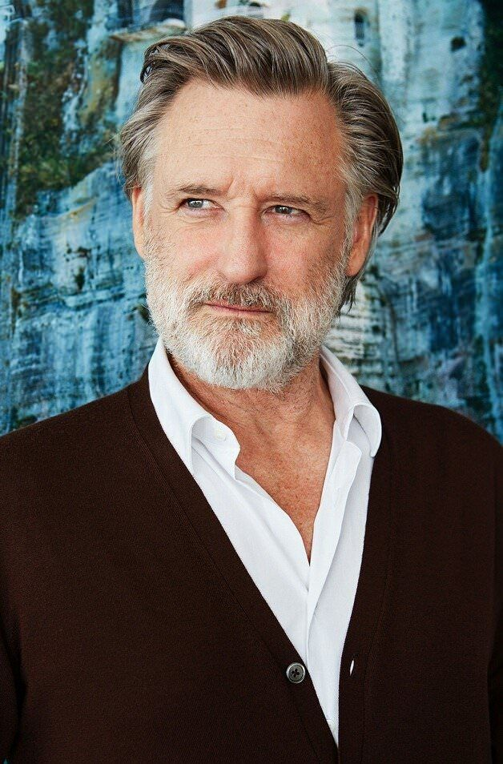
After American actor, Bill Pullman, graduated from Hornell High School in 1971, he attended the State University of New York at Delhi (SUNY Delhi) and the State University of New York at Oneonta (SUNY Oneonta) in the 1970s. He eventually received his Master of Fine Arts degree from the University of Massachusetts Amherst. He taught theater at SUNY Delhi and was an adjunct professor at Montana State University's School of Film and Photography in Bozeman, Montana, where his students persuaded him to pursue film roles.
During the 1980s, Pullman worked primarily with theater companies around New York and Los Angeles. From February 2002 until September 2002, he starred with Mercedes Ruehl in Edward Albee's play The Goat, or Who Is Sylvia? on Broadway. It won the 2002 Tony Award for Best Play, the 2002 Drama Desk Award Outstanding New Play, and the 2003 Pulitzer Prize for Drama. Pullman was nominated for the 2002 Drama Desk Award Outstanding Actor in a Play.
He went on to star as Dr. Richard Massey in the miniseries Revelations and in Albee's play, Peter and Jerry at off-Broadway's Second Stage Theatre in New York for which he received a second Drama Desk Award nomination for Outstanding Actor in a Play in 2008.
Pullman is also a creative writer. His first play, Expedition 6, is about the International Space Station mission Expedition 6, in orbit at the time the Space Shuttle Columbia was destroyed on reentry, grounding the U.S. space shuttle program and requiring the ISS crew to remain in orbit an additional two months. The play opened at San Francisco's Magic Theater in September 2007.
He also appeared in the Broadway production of David Mamet's Oleanna, co-starring Julia Stiles. It opened at the John Golden Theatre October 11, 2009 and closed on December 6, 2009 after 65 performances.
His first prominent film role was in Ruthless People, starring Danny DeVito and Bette Midler. Other notable films included the lead in Spaceballs (1987), The Accidental Tourist (1988), Sleepless in Seattle (1993), The Serpent and the Rainbow (with Zakes Mokae), and While You Were Sleeping (1995). In 1996, he played the President of the United States in the sci-fi film Independence Day. A year later he had a major role in Lost Highway (1997) and voiced Korso in the animated post-apocalyptic film Titan A.E. His more recent films have included The Grudge and Scary Movie 4. He also starred alongside Christian Bale in the musical Newsies.
Starting in the 2000s he has also acted in miniseries and regular series, such as Torchwood (2011), starring roles in 1600 Penn (2012–13) and The Sinner (2017–2021). In 2021, he had a recurring role in the miniseries Halston.
Pullman played Oswald Danes, a pedophile and child killer, in Torchwood: Miracle Day, the fourth series of the BBC/Starz Entertainment television show Torchwood (a spinoff to the BBC series Doctor Who), the former of which began airing in July 2011. For his performance as Danes, he received a Saturn Award nomination for Best Supporting Actor on Television.

LAUREN K. ROBEK
Lauren K. Robek is an award winning Canadian actress and model who has made a name for herself in the entertainment industry. She has her BFA from York University and has worked across Canada and the US in film, television and theatre. Although Lauren began her career as a ballet dancer, she is known for her versatile acting skills and captivating presence on screen and has carved out a successful career in both the film and television industries..
Lauren has played a variety of challenging roles throughout her career and has worked alongside some of the biggest names in the industry. She has appeared in popular TV shows and movies such as "The Vampire Diaries", "Reign", "Suits" and "The 100". Her performances have earned her rave reviews from critics and fans alike.
Apart from her acting career, Lauren K. Robek is also known for her humanitarian work. She has worked with several charities and non-profit organizations, and is actively involved in raising awareness about social issues. She is a role model for aspiring actors and entrepreneurs alike, and continues to inspire people with her passion and dedication to her craft.
CURTIS TWEEDIE
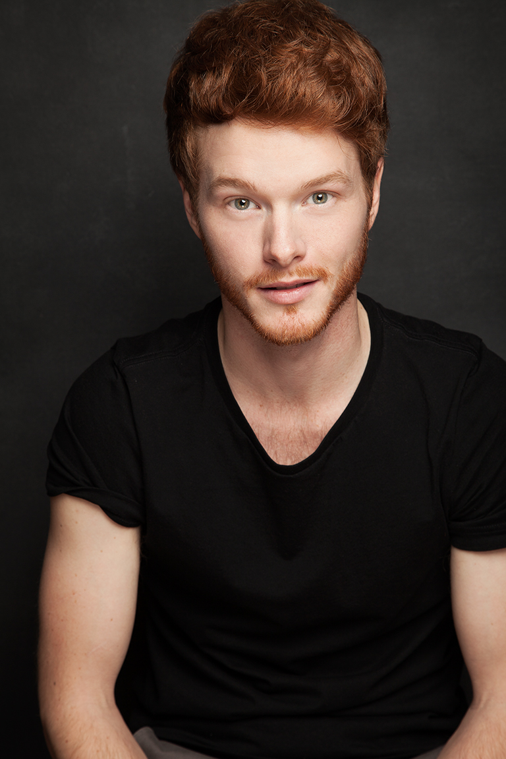
Actor, singer and dancer, Curtis Tweedie, received his diploma from the Canadian College of Performing Arts. He is known for his many stage roles in both Ontario and British Columbia for which he received several award nominations. His roles in television include the TV Series Timeless, Supernatural, iZombie and Aurora Teagarden Mysteries. He has also appeared in the TV Movie A Taste of Christmas.

Producer Biographies

TIMOTHY O. JOHNSON – Executive Producer
Timothy O. Johnson is among the most active and reliable producers in the business thanks to top rate productions and global distribution appeal. He is the managing partner of Johnson Production Group, a Canadian based operation that produces over 100 hours of dramatic television annually with hundreds of programs running internationally. The company is the leader supplier to Lifetime, Hallmark and other international outlets.
A graduate of the Marshall School of Business at the University of Southern California, he served as President of the USC Entertainment Management Association and a member of the Advisory Committee of the Center for Entrepreneurial Studies.
Johnson is also responsible for producing the international hit series, DR. QUINN, MEDICINE WOMAN for CBS for over 5 seasons. During his 100-episode tenure, he also developed and produced the original docu-drama COLD CASE for CBS network, which was the very first program to integrate television with the Internet.
Most recently, Johnson has produced the THE NOEL DIARY, being the #1 Film on Netflix’s Top 10 list in December of 2022. He was also at the helm of the successful GIRL IN THE SHED: THE KIDNAPPING OF ABBY HERNANDEZ, as well as the V.C. Andrews series of films, to date including TWILIGHT’S CHILD, MIDNIGHT WHISPERS, and DAWN, all produced for Lifetime..
Johnson has produced over 400 movies and 15 globally released series for every major US network - including Netflix, Lifetime, Hallmark, ABC, Disney, CBS, NBC, Netfly, FOX and Sony.

JOHNSON PRODUCTION GROUP
The Johnson Production Group contracts globally to produce television content for international networks, studios and distributors. Based in Los Angeles and Vancouver, British Columbia, the company manages production, facilitates development and financing, procures distribution and guarantees quality and timely execution of its programs. While costs have gone up, so has the demand for quality. No longer is good enough, good enough. Johnson Production Group serves that segment when a show needs to be "A" quality, but produced efficiently enough to meet a locked budget. JPG specializes in value, protection of creative elements, and delivery of a quality finished product.

STACY MANDELBERG – Producer
Stacy Mandelberg attended Stanford University’s Mass Media Institute, Northwestern University School of Speech for a BS in Radio, Television and Film, and obtained her Masters of Fine Arts, Film at New York University School of the Arts. She is now the Head of Creative at Johnson Production Group and has had an extensive career in senior executive roles at New World Television, von Zerneck Sertner Films, Wilshire Court Productions, Atmosphere Entertainment, CBS and most recently, Sony/TriStar Television where she oversaw Showtime’s “On Becoming a God in Central Florida”. Stacy is known as a producer of TV movies including Switched Before Birth, Girl Positive, and Haunting Sarah (Lifetime), The Real World Movie (MTV), Sweetwater: A True Rock Story (VH1 Network), Bad to the Bone (ABC) and Crazy Horse (TNT). Additionally she produced several series including The Dovekeepers and The Doris Duke Story (CBS), as well as Robin Cook's Invasion (NBC).

MICHAEL VICKERMAN – Executive Producer
Michael Vickerman is a native of Minneapolis, Minnesota and attended film school at the University of Wisconsin – Milwaukee before transferring to Columbia Film School. Michael began his career writing scenes with Sylvester Stallone for the feature film “Cliffhanger” while still attending film school and working as Mr. Stallone’s assistant. Over the next twenty-five years, Michael went on to write, direct and/or produce over forty feature and television films, including the event limited series “Tut” for Spike TV starring Sir Ben Kingsley. He is currently developing the historical drama “Taj Mahal” for Warner Brothers Television and the historical WWII series “The Doolittle Raiders.”

With the participation of the Province of British Columbia
Film Incentive BC
The Canadian Film or Video Production Tax Credit
© MMXXIII Johnson Production Group Inc. All Rights Reserved

Meta Data
LONG (max 3000 characters) synopsis
This is the twisted true story of Alex Murdaugh who was found guilty in the double homicide of his wife, Maggie, and his son, Paul Murdaugh. For over 100 years, the Murdaughs, a wealthy and powerful family, were a local, dynasty in the South Carolina low country who oversaw the prosecution of all criminal cases in the state's 14th circuit district. Locals even called the five-county district, "Murdaugh Country." But behind all the power, the black ties, and all the fancy dresses were secrets... Since 2014, Alex and other members of the Murdaugh family were involved in investigations of several murders: including a son’s classmate, their long-time housekeeper, and another son’s close friend. Corruption charges, drug-related charges, and other crimes also followed them. In 2019, Alex's son, Paul was implicated in a fatal boating accident. Subsequently, it is discovered that Alex has been swindling his clients, some of whom live in near poverty, by stealing their insurance settlements while he continues his lavish lifestyle. He even steals from the family of his deceased long-time housekeeper and nanny. Then his own law firm, the very firm his great grandfather founded in 1910, learns he has embezzled several million dollars. In June 2021, Alex Murdaugh's wife and son, Paul, are found murdered near the kennels that housed the dogs Maggie held so dear. As the pressure of all these investigations are mounting, bizarrely Alex is shot along the side of the road. But he isn’t killed - and investigators soon determine Alex attempted to stage his own death so his surviving son could receive a ten-million-dollar life insurance policy. A self-admitted pathological liar, Alex does himself in with one lie after another, leading to ultimate criminal conviction of Alex Murdaugh – the murder of his wife and son. (1826)
MEDIUM (max 500) synopsis
This is the twisted true story of Alex Murdaugh who was found guilty in the double homicide of his wife, Maggie, and his son, Paul Murdaugh. For over 100 years, the Murdaughs were a wealthy and powerful family, but behind all the power, the black ties, and all the fancy dresses were secrets…secrets that included murders, corruption, drugs and other crimes. And then in June 2021, Alex Murdaugh's wife and son, Paul, are found murdered and the events that follow become even more twisted. (489)
SHORT (max 100 characters) synopsis
The twisted true story of Alex Murdaugh, who was found guilty in the homicide of his wife and son. (99)
5 KEY WORDS
Murder, weath, power, family, corruption

