Believe In Christmas

Johnson Production Group

Press Kit

# One-Liner

# Grinchy NYC reporter Beatrice is finagled by her best friend Emilia into visiting a small town called “Christmasland”; for the holidays—a place that promises to make all your holiday fantasies come true. The town delivers on Christmas spirit, but is the discovered romance real or just another part of Christmasland’s planned theatrics?

# Synopsis

# When Emilia tells her best friend Beatrice about winning an all-inclusive trip to Christmasland, Beatrice initially thinks it’s a joke. However, with no other plans for Christmas, they decide to go. Christmasland turns out to be a magical holiday extravaganza, making them feel like they’re living in a Hallmark Christmas movie, complete with carols, sledding, cookie decorating, and endless cheer. Despite being assured that it’s all part of the “Christmasland experience”, Beatrice remains skeptical. A whole town dedicated to recreating a Christmas movie? It sounds too good to be true. However, as they start checking off the list of enchanting “happenings”—being rescued by a handsome stranger, encountering an overzealous town busybody, participating in a baking competition, and sharing an interrupted first kiss—Beatrice begins to question what’s real and what’s not. She realizes she has feelings for a dashing local who is home for the holidays but can’t tell if he feels the same. Meanwhile, her best friend Emilia is falling for another charming guest at The North Pole Inn. In a place filled with whimsical realities, Beatrice longs for a genuine Christmas miracle, despite her past disappointments. Through a heartwarming tale of love, hope, and holiday magic, Christmasland leaves viewers believing in miracles, the spirit of Christmas, and new beginnings.

# Producers

Executive Producers

CHRISTIE WILL

OLIVER DE CAIGNY

MEGHAN ORY

JOHN REARDON

MICHAEL BECKER

Co-Executive Producers

DOUG LANDERS

TIM MUDD

Producers

DAVID KEEFE

# Key Cast

|  |  |  |
| --- | --- | --- |
| CHARACTER  Beatrice Thompson  Ethan Crane  Emilia Rhodes  Carol Crane  Porter Bryant |  | ACTOR  MEGHAN ORY  JOHN REARDON  LINDURA  CATHY JONES  KEVIN HANCHARD |

# Key Cast Biographies

# MEGHAN ORY

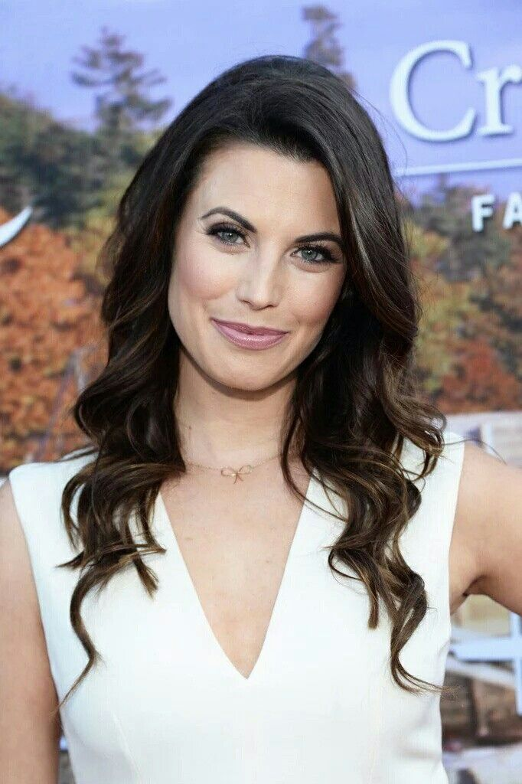Meghan Ory knew she was going to be an actor since her first time on stage, at the age of five. After years of dancing, singing and acting in her hometown of Victoria, BC, Ory began professionally auditioning at age 15. Four months later, she landed a lead role on the Fox Family channel movie-of-the-week “The Darklings,” which led to numerous guest spots, features and movies-of-the-week. In 2012, a small role in the pilot for ABC’s “Once Upon a Time” earned Ory a regular stint as the iconic Red Riding Hood on the series. In 2013, Ory was cast, opposite Josh Holloway, as the lead in the CBS series “Intelligence.” She has starred in the Hallmark Movies & Mysteries originals “The Memory Book” and “Debbie Macomber’s Dashing Through the Snow.” Last year marked Ory’s return to Hallmark originals movies with “The Secret Gift of Christmas” after wrapping 7 seasons of the hit Hallmark channel original series Chesapeake Shores.

# JOHN REARDON

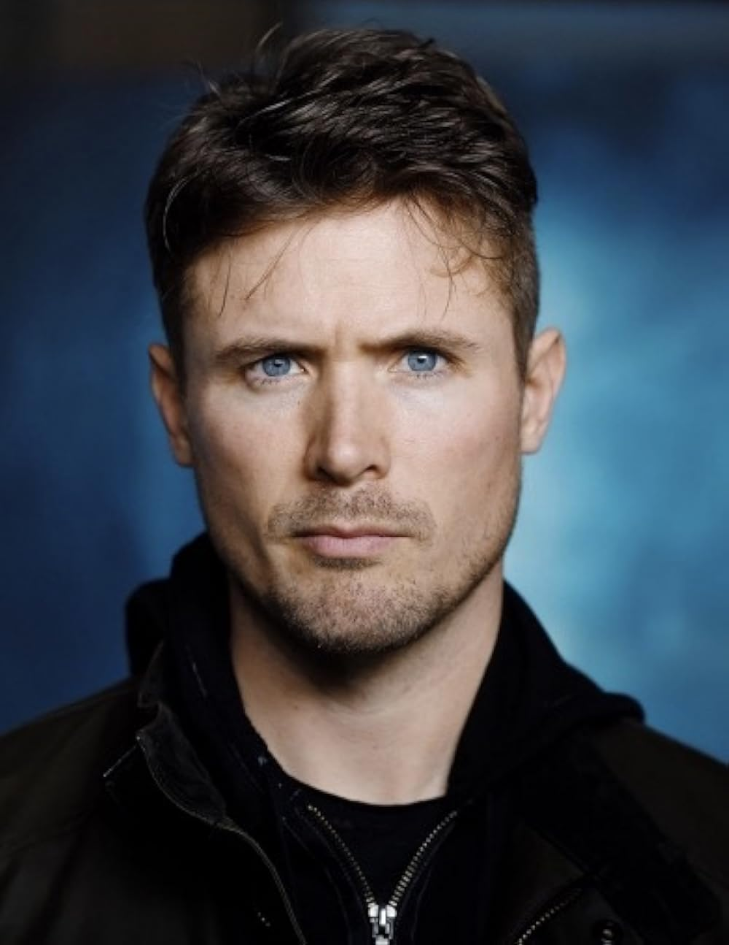John Reardon has accomplished what most actors only dream of, a dynamic and extensive resume of coveted roles in film and television. Born in Halifax, Nova Scotia, Reardon began his time in the spotlight as an all-star football player at Mount Allison University. With his classic good looks and athletic build it wasnʼt long before Hollywood took notice.

Reardonʼs first break came in 2001 when he was cast in an episode of the Showtime series “The Chris Isaak Show.” A slew of recurring roles followed as he was cast on the FOX Family Channel series “Edgemont,” FOXʼs “Tru Calling,” SyFyʼs “Eureka,” Showtimeʼs “The L Word,” CWʼs “Hellcats” and leads in the hit miniseries “Merlinʼs Apprentice” as well as “Son of the Dragon,” which filmed in China.

Reardon became a fan favorite with his supporting roles in the Wayansʼ brothers hit film “White Chicks” and slasher comedy “Scary Movie 4.” He also made his mark in the film world with a role in the blockbuster film “Tron: Legacy” with Jeff Bridges and Olivia Wilde.

Reardon played the role of Blake Laviolette for the three seasons of “Arctic Air” on CBC. Set in Yellowknife, the series portrays renegade bush pilots at work and play in Canada’s north. He also appeared in three seasons of the Showcase sci-fi thriller series “Continuum” in his recurring role of Greg Cameron.

Reardon is now going into his 7th season as the title character in the hit show Hudson and Rex.

With classical training at RADA, Reardon performed in a number of plays on their mainstage. He now splits his time between Vancouver and Los Angeles.

# LINDURA

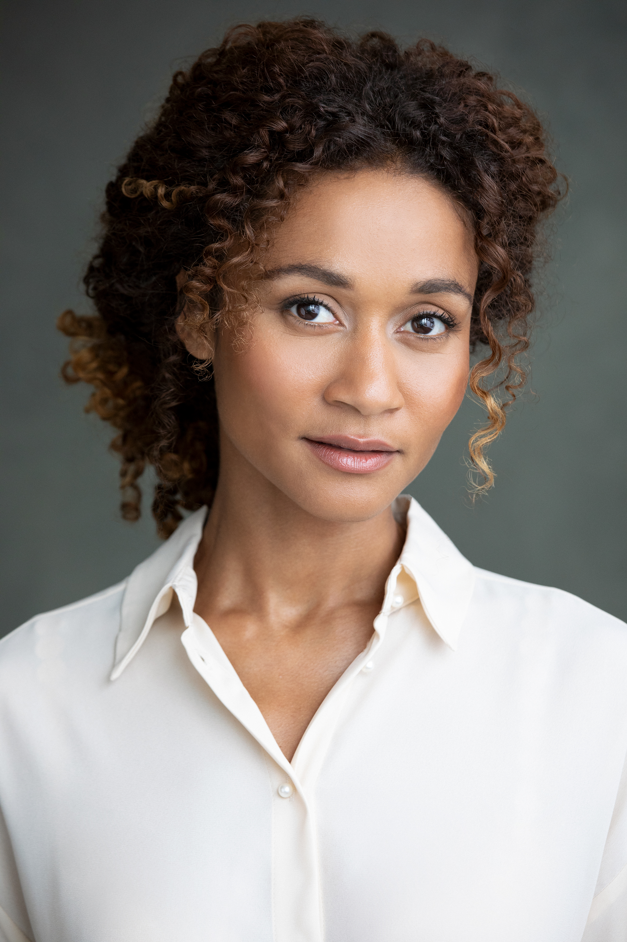Based between Toronto and New York; Lindura may already be a familiar face to some thanks to her highly accomplished work as a model and emerging actor. Lindura has appeared in over 40 television commercials, dozens of campaigns and has recently made her major television debut in the new TV series 'Sullivan's Crossing', based off of the hit book series of the same name. When not in front of the camera, Lindura loves to donate her time to eco-conscious pursuits and social justice initiatives.

# CATHY JONES

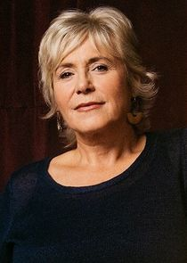Catherine (Cathy) Jones, actor, writer (born at St John's 6 April 1955). Cathy Jones attended Holy Heart of Mary High School and by the age of 17 had joined the Newfoundland Travelling Theatre Company with her brother Andy for a summer of touring the province. She is Newfoundland's comic gift to the rest of Canada, regularly skewering the establishment, politicians and sacred cows. The youngest of a multi-talented family—brother Andy Jones is an actor and writer, and another brother, Mike Jones, is a noted filmmaker—Cathy Jones is one of the funniest women on Canadian television.

In 1973 she joined the Codco comedy troupe in Toronto, whose original members included Mary Walsh, Diane Olsen, Tommy Sexton, Greg Malone and Paul Sametz. Their first production, Cod on a Stick, Another Fun Food Show, was performed at Toronto's legendary Theatre Passe Muraille. It eventually took them back to St John's, where Andy Jones and Robert Joy joined them and they continued to perform together until 1976. For the next 10 years, Cathy Jones and the others worked together in various combinations until they formally regrouped for the CODCO television series, which debuted in 1988 and ran for five seasons on CBC-TV. The Codco series lineup included Cathy, her brother Andy, Greg Malone, Tommy Sexton, and Mary Walsh. Taped in Halifax and produced by Salter Street Films, it was an unqualified hit in the great tradition of Canadian sketch comedies such as "The Wayne and Shuster Show" and SCTV.

Cathy Jones then moved on to This Hour Has 22 Minutes (destined to become one of the longest-running shows in the history of the CBC), a homage to CBC's groundbreaking newsmagazine from the 1960s, This Hour Has Seven Days. Comedians Rick Mercer and Greg Thomey joined Jones and Walsh in the show's original incarnation in 1992. Cathy Jones's memorable characters include sexual-affairs commentator Babe ("I'm just goofin' around") Bennett; Joe Crow, the First Nations sage; and Mrs Enid, an elderly lady with plenty to say. Cathy Jones has also been seen in television episodes of G-Spot and The Republic of Doyle.

She has appeared in several films directed by her brother Mike Jones: The Adventure of Faustus Bidgood (1986), Secret Nation (1992) and the short Congratulations (2000); and in the black comedy Young Triffie (2007), directed by Mary Walsh. In 2002 she had her own television special, Cathy Jones Gets a Special, and she has written for Just for Laughs (2005), The Halifax Comedy Special (2005–05) and The Winnipeg Comedy Festival (2006).

Cathy Jones has shared over 10 Gemini Awards including: in 2003 for best ensemble performance in a comedy program for This Hour; consecutively from 1995 to 2000 for best writing in a comedy series for This Hour; in 1995, 1996 and 1997 for best performance in a comedy series for This Hour; in 1994 for best performance in a comedy series for Codco; and in 1992, 1993 and 1994 for best writing in a comedy series for Codco. By 2011, This Hour had won or been nominated for dozens of Gemini Awards.

In 2000, Cathy Jones received an honorary doctor of letters degree from Memorial University in Newfoundland.

**KEVIN HANCHARD**

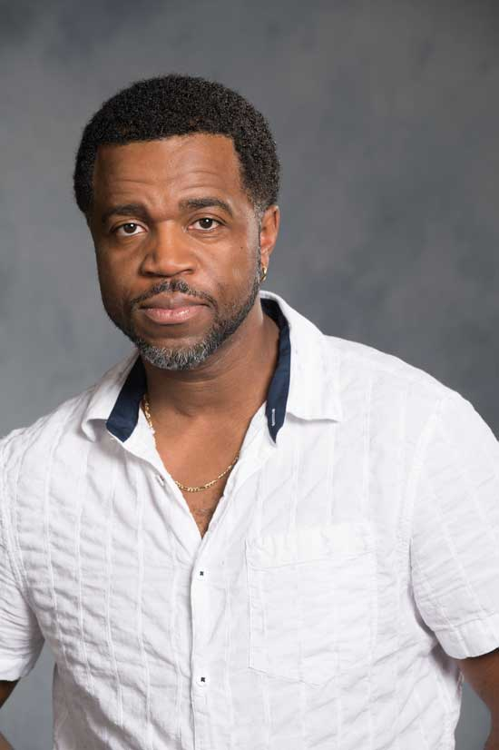Kevin Hanchard is a veteran actor who, in recent years has become one of the nation's most sought after performers. Although no stranger to film and television, this dynamic and versatile actor has made his name in the world of theatre. His knack for bringing a degree of humanity to flawed characters has become the hallmark of his career to date. He has played leading roles in theatres across the nation, including several seasons at both The Shaw and Stratford Festivals and his critically acclaimed 2011 portrayal of Booth in TopDog/Underdog, garnered him one of his two Dora Mavor Moore nominations for outstanding performance by a male.

His film and television work includes the role of Art Bell on the BBC America series Orphan Black and that of Louis Armstrong in The United Stats vs. Billie Holiday. He has had recurring roles in People of the Earth, The Girlfriend Experience, Cardinal, The Porter, Ginny & Georgia, What Odds, Skymed and an impressive 100 episodes to date in the very popular series, Hudson & Rex.

# Production Credits

**Full Cast**

|  |  |
| --- | --- |
| **Actors**  MEGHAN ORY  JOHN REARDON  LINDURA  CATHY JONES  KEVIN HANCHARD  BOB MANN  KIRSTIN HOWELL  ARIA PUBLICOVER  DARCY KEEFE  ASHLEY BROWN  HANK WHITE  BLUE  ZEUS | **Role**  Beatrice Thompson  Ethan Crane  Emilia Rhodes  Carol Crane  Porter Bryant  Mayor Kris  Shelley  Scarlet  Town boy  Worker #2  Vendor  Jingles  Christmasland Cat |

### Casting

CHRISSY KING-LOPES

### Costume Designer

MARTHA CURRY

### Editor

DEVIN TAYLOR

### Production Designer

BILL FLEMING

### Composer

BLAINE MORRIS

### Director of Photography

BECKY PARSONS

### Screenplay by

MAGGIE DALLEN  
CHRISTIE WILL

Based upon the Book Christmasland   
by ANNE-MARIE MEYER

### Directed by

CHRISTIE WILL

**Full Crew**

|  |  |  |  |
| --- | --- | --- | --- |
| CRAIG CAMERON | | Co Producer | |
| BECKY PARSONS | | Associate Producer | |
| TIM SPENCE | | Associate Producer | |
| LAURA RICHTER AND MARK CANO | | Original Song "Stars Align" | |
| CRAIG CAMERON | | Production Manager | |
| ANDREW SUTHERLAND | | First Assistant Director | |
| KATE JOHNSTON | | Second Assistant Director | |
| STEPHANIE MEAGHER | | Third Assistant Director | |
| SEAN HICKEY | | Trainee Assistant Director | |
| CHRISSY KING LOPES | | Casting | |
| ERIN HENNESSEY CASTING | | Background Casting | |
| BRENT MACRAE | | Assistant Production Manager | |
| SARAH COLEMAN | | Production Coordinator | |
| JAMES MILLIGAN | | Production Accountant | |
| BILL FLEMING | | Production Designer | |
| EWEN DICKSON | | Art Director | |
| TREVOR DOHERTY | | 1st Assistant Art Director | |
| CHELSEA MACPHERSON | | Art Department Production Assistant | |
| HELLA LOCKHART | | Key Set Decorator | |
| MADDY TAM | | Lead Person | |
| VALENTIN MOULIAS | | Assistant Set Decorator | |
| SARITA MCNEIL | | Set Dresser | |
| GERRY WILSON | | On-Set Dresser | |
| KEITH CURRIE | | Property Master | |
| MILO VARNER | | Assistant Props | |
| NEIL PURCELL | | Assistant Special Effects | |
| GABE DAVIGNON | |  | |
| KYLE MUNRO | |  | |
| LUKE WILSON | |  | |
| AERIN HACKET | |  | |
| CURRAN LAYDEN | |  | |
| TAYLOR THOMAS | |  | |
| LAWRENCE WILLET | |  | |
| ELLA KEEFE | | Producers Assistants | |
| HENRY KEEFE | |  | |
| MARTHA CURRY | | Costume Designer | |
| JENNIFER ELLIS | | Assistant Costume Designer | |
| DESIRÉE CASIMIR | | Costume Set Supervisor | |
| ALEXANDRA ESPERANZA | | Costume Truck Supervisor | |
| BECKY PARSONS | | Director of Photography | |
| BECKY PARSONS | | Camera Operator | |
| KELSEY SMITH | |  | |
| KELSEY SMITH | | Steadicam Operator | |
| PAUL BEGIN | | A Camera - First Assistant Camera | |
| ASHLEY KARLSEN | | A Camera - Second Assistant Camera | |
| KEVIN KUMAR-MISIR | |  | |
| RICHARD FIANDER | | B Camera - First Assistant Camera | |
| ZHIHAO WANG | | B Camera - Second Assistant Camera | |
| EVAN ELLIOT | | Digital Imaging Technician | |
| NICK HIGHMORE | | Camera Trainees | |
| MARYANNA FRASER | |  | |
| MIKE TOMPKINS | | Stills Photographer | |
| ANDRÉ ST-JULES | | Gaffer | |
| STUART RANKIN | | Best Electric | |
| BAILEY KINNEAR | | 3rd Electric | |
| MATTHEW JEANNOTTE | | Key Grip | |
| LIAM GILES | | Best Grip | |
| DANA PERRY | | Dolly Grip | |
| ADAM DEYARMOND | | 3rd Grip | |
| SAM MACNEIL | | Trainee Grip | |
| IAN THOMSON | | Sound Mixer | |
| ERIK SOUTHEY | | Boom Operator | |
| IAIN BEAIRSTO | | Utility Sound | |
| MARY LOUISE MCCLOSKEY | | Script Supervisor | |
| BILL CHERNIN | | Location Manager | |
| STEVE TABACHNIK | | Location Manager (Mahone Bay) | |
| PAT KING | | Assistant Location Manager | |
| AARON WEBSTER | | Location Production Assistant | |
| ARIANA ROBERTS | | Head of Department Makeup | |
| EMMA-LEIGH “EMMIE” MURPHY | | Head of Department Hair | |
| KALEY WAREHAM | | Daily Hair and Makeup | |
| LIV STEVENS | |  | |
| STEVE MURPHY | | Transport Coordinator | |
| MICHELLE DESNOYERS | | Transport Captain | |
| SHAWN MURPHY | | Head Driver | |
| TONY SMITH | | Drivers | |
| TODD MURPHY | |  | |
| LINDSAY SMITH | |  | |
| LORI BELLEFONTAINE | |  | |
| BRIAN HATFIELD | | Animal Wrangler | |
| TIM WEBBER | | Caterer | |
| BOB ZWICKER | |  | |
| BLAIR SCHADE | | Chef | |
| KENDALL GATES | |  | |
| JACKIE COOLEN | | Key Craft Service | |
| MYLA BACKMAN | | 1st Assistant Craft Service | |
| TIM SPENCE | | Post Production Supervisor | |
| COASTAL CLEARANCES | | Clearances | |
| ROB ASKE, STEWART MCKELVEY | | Legal Services | |
| TIM MUDD | | Head of Business Affairs | |
| FRONT ROW INSURANCE | | Insurance | |
| 902 POST INC. | | Post Production Services | |
| THE HIDEOUT STUDIOS | | Post Audio Services | |
| DOUG WOODS | | Post Coordinator | |
| KYLE CASHEN | | Dialog Mixer | |
| JEREMY VANSLYKE | | Foley Mixer | |
| MELINA COOLEN | | Sound Designer | |
| BRIAN POWER | | Re-recording Mixer | |
| DOUG WOODS | | Colorist-Online Editor | |
| ROBERT CARRIGAN | | Visual Effects Supervisor | |
| GRANT MACINTOSH | | Visual Effects | |
| ALEX WOODS | | Closed Captioning | |
| BLAIN MORRIS | | Composer | |
|  | |  | |
| SPECIAL THANKS TO: | | |
| LAURA REARDON | JANE AND MICHAEL REARDON | | |
| MICHAEL MCNAIR AND ALEXIS MCINTYRE | TOWN OF MAHONE BAY | | |
| SUNNEARA NEOU | LAURIE CARYI | | |
| BONNIE AND NATHAN ORY | KAREN WENTZELL | | |
| ROOT DEVELOPMENTS | JAY FITZGERALD | | |
| HALIFAX GRAMMAR SCHOOL | STEVEN LAFFOLEY | | |
| KITSILANO MOM’S | JOANNE STRONGMAN | | |
| ROD BEZANSON | PATTI DAVISON | | |
| PATRICK KEEFE | ALEXA BAGNELL | | |
| BILLEE HOOPER | YOUNG AVE NEIGHBOURS | | |
| BE GORGEOUS BEAUTY | SARAH YOUNG | | |
| CALVARY CROSSROADS CHURCH | MARISA PALLADO | | |
| ART GALLERY OF NOVA SCOTIA | MARK PATRIQUIN | | |
| AIELENE ANGOLO | CANADA POST CORPORATION | | |
| AMY NAST | DOLLAR THRIFTY AUTOMOTIVE GROUP CANADA INC. | | |
| NAVID SOOFI | MIKE VOLPE | | |
| MANILYN LOWE | ELI + TRIX | | |
| INBAL NEWMAN | NANCY JONES | | |
| MAHONE BAY & DISTRICT FIRE DEPARTMENT | MACQUARRIES PHARMASAVE | | |
| MATT COWAN | GARETH ROBERTS | | |
| CALEB KING | RYAN KINSMAN | | |
| JOHN RAINNIE | T. ERNST FORESTRY PRODUCTS | | |
| WALTER AND JOANNE THOMPSON | CHRIS'S CONVENIENCE | | |
| NICOLE LAFOSSE PARKER | DANIELLE KING | | |
| JENNIFER SKINNER | DLE EQUIPMENT RENTALS LTD. | | |
| THE ARMOUR GROUP LIMITED | EASTWARD PRODUCTION RENTALS INCORPORATED | | |
| ANGUS GRANT | ENCOMPASSING DESIGNS RUG HOOKING STUDIO | | |
| KAREN PINSET | FIREWORKS TEXAS BARBECUE | | |
| SYLVIA JACKSON | FLEUR LAWRENCE | | |
| PHIL LAWSON | HALIFAX REGIONAL MUNICIPALITY | | |
| KELLY MUNROE | KINBURN PHARMASAVE | | |
| MARY SAMUEL | MAHONE BAY B&B | | |
| LIT LIGHTING LTD | MARKET AT MAHONE BAY LTD. | | |
| FATHER CHRISTMAS SOCIETY | MATEUS BISTRO | | |
| VICKI BARDON | OH MY COD! | | |
| DYLAN HEIDE | THE NOSY CROW | | |
| ERIC LEVY | WILIAM F. WHITE | | |
| ANTHONY SCHLEIHAUF | STEPHEN REYNOLDS | | |
| DANI BOWMAN | CURTIS HAMMOND | | |
| GERHARDT PROPERTY IMPROVEMENT | KYLE SCOTT | | |
| RUSSELL WYSE | EAST COAST CINE SERVICES INC. | | |
| JACOB CAVENS | ROUSSEAU CHOCOLATIER | | |
| HISTORIC PROPERTIES LIMITED | NASH AND NASH HOLDINGS INCORPORATED | | |
| EP CANADA FILM SERVICES | OLIVIA LEWIS | | |
| GEORGIA WEST | CAPITAL A HOLDING LIMITED | | |
| HERE NOR THERE BOHEMIAN BOUTIQUE INC. | ENTERPRISE RENT-A-CAR NOVA SCOTIA | | |
| BUDGET CAR RENTAL CANADA | SEAMIST STUDIO | | |
| JUSTIN HARRINS | SHANE MCWHIRTER | | |
| ANGELA LEWIS | SMITH AND SMITH HOLDINGS INCORPORATED | | |
| 3244887 NOVA SCOTIA LTD. | TAKE ONE ATLANTIC INCORPORATED | | |
| MAIN ST. MARKETING PLUS INC. | EVAN GEORGE | | |
| NORTHERN SUN GALLERY AND GIFTS | THE DOG SHOP BATHHOUSE & BOUTIQUE INC. | | |
| ROYAL CANADIAN LEGION BRANCH 49 | HALEY THOMAS | | |
| SCOTT MYERS | CHUAN LE | | |
| STEPHEN DUGAS | SHELLEY BIBBY | | |
| SWEET RIDE CYCLING LTD. | JOANNE CARYI | | |
| WIRED MONK | HATFIELD FARMS | | |
| SARAH TRECARTIN | DANA RUTLEDGE | | |
| SIAN MORRIS ROSS | EASTPORT FINANCIAL GROUP INC | | |
| ANDREW SHERIDAN | MADZ HIGGINS | | |
| BETHANY HOTKE | MORGAN SALTER | | |
| ROWAN CURRIE |  | | |

# Producer Biographies

## JOHNSON PRODUCTION GROUP

The Johnson Production Group contracts globally to produce television content for international networks, studios and distributors. Based in Los Angeles and Vancouver, British Columbia, the company manages production, facilitates development and financing, procures distribution and guarantees quality and timely execution of its programs. While costs have gone up, so has the demand for quality. No longer is good enough, good enough. Johnson Production Group serves that segment when a show needs to be "A" quality, but produced efficiently enough to meet a locked budget. JPG specializes in value, protection of creative elements, and delivery of a quality finished product.

## CHRISTIE WILL – Executive Producer/Director/Writer

Named Best Canadian Female Director, Best Director and winning Best Film and Best Sci-Fi Film in 2020 and 2021 [Her Coming], Christie Will brings an authentic and vulnerable perspective to her work being reviewed in “Integral Women in Film 2022” as having Directed more feature films that any other female in the directors chair worldwide. In July 2022 Christie won a Canadian Leo Award for Best Screenwriting; Television Movie, in addition to garnering a Best Director nomination; Television Movie. In December of 2021, Christie received a Best Director nomination [Five Star Christmas], and in 2020 Will was awarded the Directors Guild of Canada’s Legacy Award, in addition to receiving a Best Screenwriting Leo Award 2019 [Killer Ending]. September 2022 Will was selected (one of 5 new content creators) for Royal Bank of Canada’s Series Fest “Best New Series Creator” at The Toronto International Film Festival [Fishing For Men]. Early in her career, Christie worked as Director/ Producer Peter Berg’s Assistant and later segued into producing and developing films starring Saturday Night Live comedians Chris Kattan, David Spade, Norm McDonald, The Farley Brothers, Patrick Swayze, Tim Curry and more. Christie’s first feature film Slightly Single in L.A. [Simon Rex, Lacey Chabert, Chris Kattan Jenna Dewan and more] was one of the first acquisitions for Netflix in their early days, and her second comedy “Boy Toy” [Dawn Oliveri, Mircea Monroe, Simon Rex, Morgan Fairchild] was bought by Lionsgate. Christie received the Terry Fox Humanitarian Award in 1995, and holds a Master Of Fine Arts in Creative Writing and Film from University of British Columbia as well as a BFA from Emerson College in Boston MA; and a BA College of Charleston, SC. Christie also studied Sanford Mesiner at Playhouse West in Los Angeles for seven years.

OLIVER DE CAIGNY – Executive Producer  
Oliver De Caigny is a Canadian producer originally from Belgium, his background in financing, production, and post production makes him a well-rounded producer for any type of production. His experience in financing and production agreements (film and TV series and movies-of-the week), distribution agreements (both domestic and foreign) as well as international co-productions, Canadian tax credit, Telefilm Canada and Canada Media Fund incentives provides him with a well-rounded background in development, production and distribution for motion pictures, television series and productions.

## ROGUE CIRCUS FILMS

Meghan Ory and John Reardon have now turned their focus to producing with their company ROGUE CIRCUS FILMS, a production company dedicated to creating innovative, fresh content that is commercial, engaging, entertaining and thought provoking. The web series written by Reardon, BLOODHOUNDS was first out of the gate. They have numerous projects in development and are thrilled to bring their first original movie to screen with CHRISTMASLAND

## MICHAEL BECKER – Executive Producer

Michael Becker has over 20 years of experience in the entertainment industry as a driving force behind creative talent and producing distinguished entertainment for film and television.

Michael began his career as a talent agent in 1999, representing writers, directors and producers. He later took over as head of film and television at Datner Dispoto and Associates, where he added cinematographers to his client roster. As an agent, Michael represented his clients in many high profile deals such as Sex and the City, I, Robot, The Notebook, Nip/Tuck, Panic Room, The West Wing and many more. After leaving the agency business, Michael went into management to work with a variety of clients including music artists Soulja Boy, Pitbull, DJ Quik and others.

In 2008, Michael segued into producing and formed Imprint Entertainment, where he is currently CEO. At Imprint, Michael specializes in all aspects of the entertainment business, which include: development, packaging, financing, production, and music publishing for film and television.

## DOUG LANDERS – Co-Executive Producer

Doug Landers holds an MFA in Film and Television Producing from Chapman University. With experience across boutique talent agencies, independent studios, and major productions, Doug is a driving force in the development process. His knack for fostering partnerships with writers and content creators helps shape Imprint's creative vision.

Joining Imprint Entertainment in 2022, Doug champions projects as a Development Executive, transforming ideas into captivating narratives. Beyond work, he's a passionate explorer of bookstores, always seeking fresh voices and creative possibilities.

## TIM MUDD – Co-Executive Producer

Tim Mudd is a highly productive business professional with twenty some years of experience in Canada and the UK in sectors as diverse as Film and Television Production, Hospitality and Food Services, Local Government, Banking and Consumer Finance.

As a skilled and detail-oriented Business Affairs Specialist, Tim has a proven track record of successfully managing various aspects of film and television production, from financing and budgeting to compliance and distribution. He is adept at navigating complex industry regulations and ensuring projects are completed on schedule; proficient in liaising with key stakeholders, including legal teams, producers, broadcasters, and financial institutions and has excellent communication, organizational, and problem-solving skills.

## DAVID KEEFE – Producer

David Keefe makes his debut as a film producer with "Christmasland," leveraging a wealth of experience from a dynamic career in entrepreneurship. With over 25 years of experience in the technology industry, David has a proven track record of founding, operating, and successfully exiting multiple companies. With "Christmasland," David brings his passion for storytelling and business expertise to the screen.

## Billing Block

HALLMARK MEDIA PRESENTS in association with JOHNSON PRODUCTION GROUP and ROGUE CIRCUS FILMS **BELIEVE IN** **CHRISTMAS** Starring MEGHAN ORY JOHN REARDON LINDURA CATHY JONES BOB MANN ARIA PUBLICOVER KIRSTIN HOWELL and KEVIN HANCHARD Casting CHRISSY KING-LOPES Costume Designer MARTHA CURRY Editor DEVIN TAYLOR Production Designer BILL FLEMING Composer BLAINE MORRIS Director of Photography BECKY PARSONS Executive Producers CHRISTIE WILL OLIVER DE CAIGNY JOHN REARDON MEGHAN ORY MICHAEL BECKER Co-Executive Producer DOUG LANDERS TIM MUDD Produced by DAVID KEEFE Screenplay by MAGGIE DALLEN CHRISTIE WILL Based upon the Book Christmasland by ANNE-MARIE MEYER Directed by CHRISTIE WILL

 

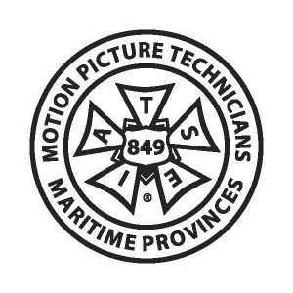  

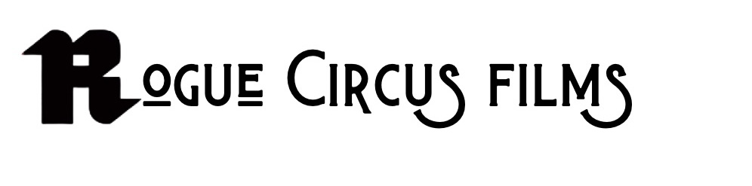  
Produced with the assistance of

THE GOVERNMENT OF NOVA SCOTIA, NOVA SCOTIA FILM AND TELEVISION



The Canadian Film or Video Production Tax Credit  


© MMXXIV Christmasland Production Ltd. All Rights Reserved

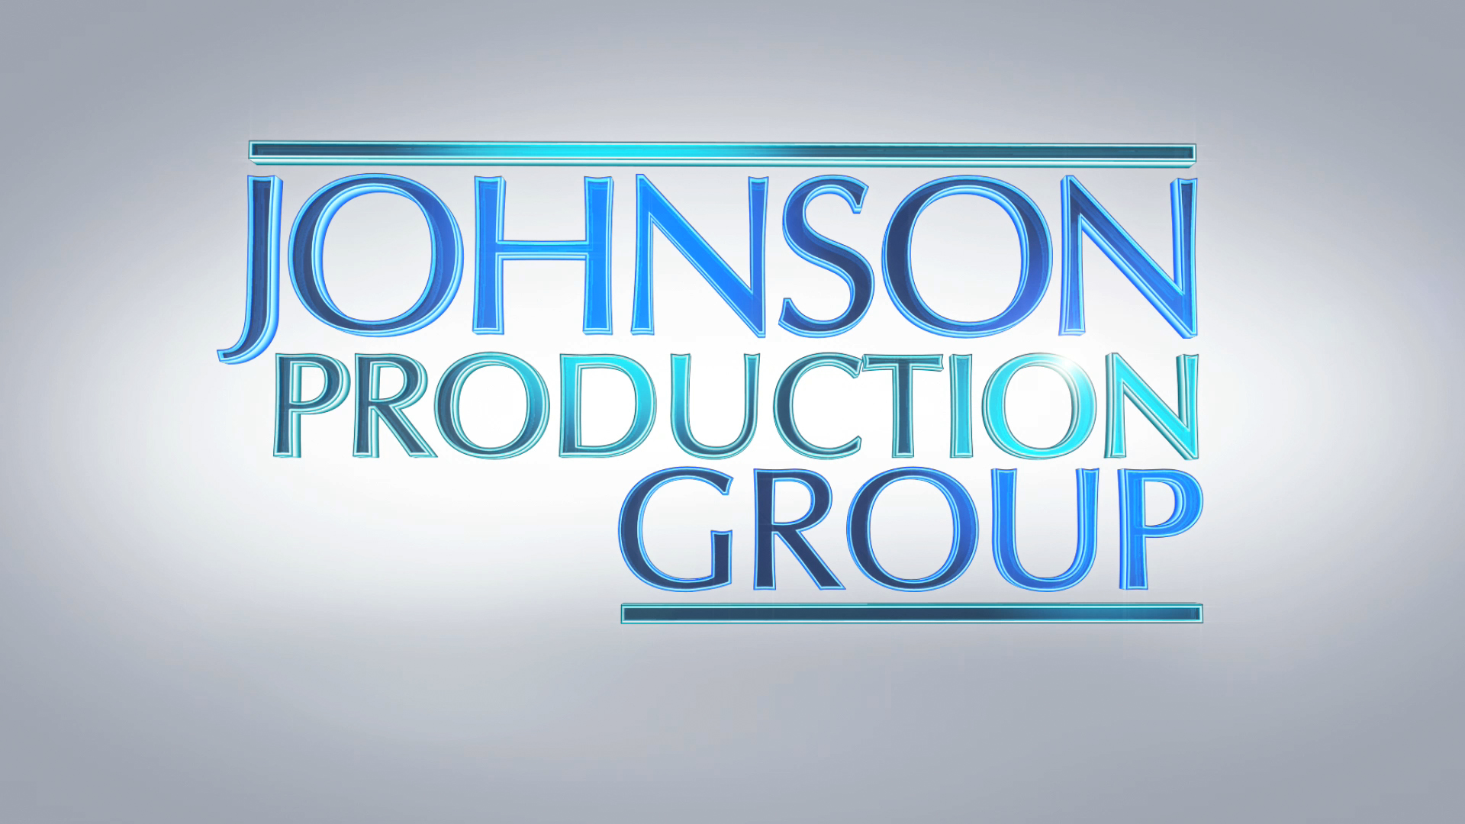

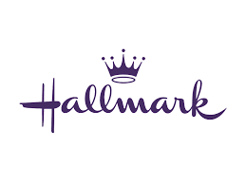

Meta Data

LONG (max 3000 characters) synopsis

When Emilia tells her best friend Beatrice about winning an all-inclusive trip to Christmasland, Beatrice initially thinks it’s a joke. However, with no other plans for Christmas, they decide to go. Christmasland turns out to be a magical holiday extravaganza, making them feel like they’re living in a Hallmark Christmas movie, complete with carols, sledding, cookie decorating, and endless cheer. Despite being assured that it’s all part of the “Christmasland experience”, Beatrice remains skeptical. A whole town dedicated to recreating a Christmas movie? It sounds too good to be true. However, as they start checking off the list of enchanting “happenings”—being rescued by a handsome stranger, encountering an overzealous town busybody, participating in a baking competition, and sharing an interrupted first kiss—Beatrice begins to question what’s real and what’s not. She realizes she has feelings for a dashing local who is home for the holidays but can’t tell if he feels the same. Meanwhile, her best friend Emilia is falling for another charming guest at The North Pole Inn. In a place filled with whimsical realities, Beatrice longs for a genuine Christmas miracle, despite her past disappointments. Through a heartwarming tale of love, hope, and holiday magic, Christmasland leaves viewers believing in miracles, the spirit of Christmas, and new beginnings. (1371)

MEDIUM (max 500) synopsis

Grinchy NYC reporter Beatrice is finagled by her best friend Emilia into visiting a small town called “Christmasland”; for the holidays—a place that promises to make all your holiday fantasies come true. The town delivers on Christmas spirit, but is the discovered romance real or just another part of Christmasland’s planned theatrics? (336)

SHORT (max 100 characters) synopsis

A skeptical woman is won over by the holiday magic of Christmasland, and by one of its residents. (98)

5 KEY WORDS

Holiday magic, sceptical, romance, friends