

# Johnson Production Group

# Press Kit

# One-Liner

# When a determined milliner infiltrates Kentucky’s high society to pitch her Derby hats, she

# unexpectedly captures the attention of an elite horse racing family —particularly its charming heir. As romance blossoms, she must navigate ruthless rivals, deep-seated traditions, and a

# scandal that threatens to upend both her career and the fate of a prized racehorse.

# Synopsis

# Stella Stone, a talented but struggling milliner, dreams of making a name for herself in Louisville’s competitive Derby fashion scene. Desperate for a breakthrough, she sneaks into the suite of Rosalind Fairchild, the grand dame of Kentucky high society, hoping to impress her with a handcrafted fascinator. Instead, she runs into Christian Fairchild, Rosalind’s handsome and skeptical son, who watches in amusement as Stella fumbles her way through an awkward first impression.

# Despite her unconventional approach, Stella’s designs catch Rosalind’s eye, and she is given the opportunity to create custom Derby hats for the Fairchild family—an honor that could launch her career. But Odette Giraud, the imperious designer already working with Rosalind, sees Stella as a threat and subtly undermines her at every turn. Meanwhile, Hannah St. Charles, Rosalind’s jealous assistant, resents Stella’s growing presence and orchestrates an embarrassing social misstep, convincing Stella to attend a prestigious high-society luncheon in casual farm attire. Though humiliated, Stella refuses to be intimidated.

# As she fights to prove herself, Stella grows closer to Christian, who is battling his own doubts about his ability to manage Wildflower Wish (Willa), the Fairchild family’s promising filly. Unlike his late father, Christian is hesitant to race Willa in the Derby against the colts, despite her talent. The arrival of his old friend-turned-rival Davidson Vegh, who is boarding his own aggressive stallion at the Fairchild farm, only adds to Christian’s stress. Davidson, who once managed Willa, pushes Christian to enter her in the weaker race for fillies, but Stella sees something in Willa that Christian doesn’t—unwavering potential.

# As the Derby approaches, Stella juggles the immense pressure of crafting a prize-winning hat while helping Christian restore his confidence. Their mutual support turns into undeniable attraction, though both are wary of how romance might complicate their goals. Just when things seem to be falling into place, Stella overhears Hannah and Odette conspiring to sabotage her career, while Davidson’s motives regarding Willa come into question. With everything on the line, Stella must trust her instincts—not just in fashion, but in love and the world of horse racing.

# In a triumphant finale at Churchill Downs, Christian makes the bold choice to race Willa in the Derby, defying expectations. Meanwhile, Stella’s daring hat design wins the Bradbury Hat Competition, proving she belongs in Kentucky’s elite fashion world. As the race begins, Christian and Willa take off down the track, and Stella realizes she’s not just witnessing history—she’s become a part of it.

# The story ends with Willa making a breathtaking finish, Stella standing on the brink of a career breakthrough, and Christian looking at her with the kind of admiration that suggests their partnership—both personal and professional—is just beginning.

# Producers

Executive Producers

TIMOTHY O. JOHNSON

JOSEPH WILKA

MAURA DUNBAR

JOHN MEHRER

MICHAEL ROTH

Co-Executive Producer

LISA ALFORD

Producer

DANNY ROTH

# Key Cast

|  |  |  |
| --- | --- | --- |
| CHARACTER  Stella  Christian  Odette  Hannah  Annie  Rosiland |  | ACTOR  GINNA CLAIRE MASON  JOHN CLARENCE STEWART  DARLA DELGADO  RENA STROBER  HOLLY WARD  and HOLLY ROBINSON PEETE |

# Key Cast Biographies

# Ginna Claire Mason - IMDbGINNA CLAIRE MASON

Ginna Claire Mason is a Broadway actress best known for playing Glinda in Wicked and starring in several Hallmark movies, including A Holiday Spectacular (2022), A Heidelberg Holiday (2023), and A Carol for Two (2024). A Nashville native, she developed a love for musical theatre early on, influenced by classics such as My Fair Lady, The Sound of Music, Annie Get Your Gun, and Cats. She went on to earn a BFA in Music Theatre from Elon University. In addition to her Broadway success, Mason has performed in touring and regional productions like Newsies, Flashdance, Duck Commander Musical, Thoroughly Modern Millie, Hairspray, and Grease. Now based in New York City, she is married to Eric Willmoffett.

# JOHN CLARENCE STEWART

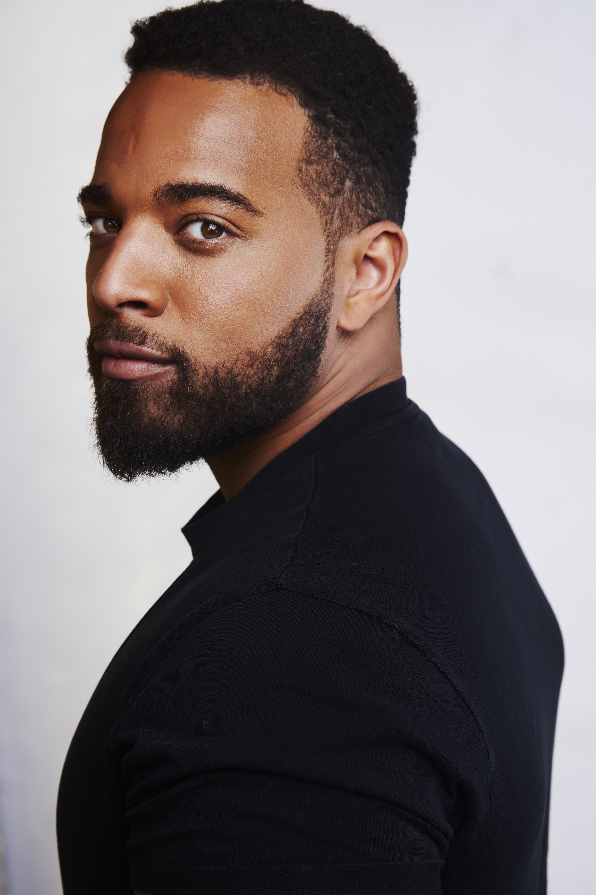John Clarence Stewart is an American actor best known for his role as Simon in NBC’s Zoey’s Extraordinary Playlist, as well as his performances as Alex Wesley in Luke Cage and Lionel in What/If. Born on August 16, 1988, in Stone Mountain, Georgia, Stewart began his acting career in Atlanta, making his professional debut in 2013 with The Whipping Man at the Alliance Theatre. He later moved to New York to further pursue his craft. Throughout his television career, he has appeared in a range of roles, including Zoey’s Extraordinary Christmas (2021), and guest spots on shows like Blue Bloods, The Good Fight, and Hawaii Five-0. Beyond acting, Stewart is a passionate advocate for the growth and education of Black and Brown boys and the broader evolution of Black and Brown men in society.

# DARLA DELGADO

Darla Delgado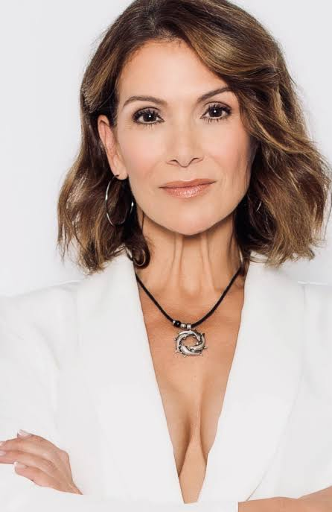 was born in Tampa, Florida, USA, of Hispanic and Italian descent. This actress and producer started modeling at the age of 19, when she became a fan of the Tampa Bay Buccaneers and stayed with them for three years. She has several college credits and classes in broadcasting and advertising, which was her first college major, and she landed a job at a marketing/ad agency two months later. She became one of the top commercial and hosting recipients in the state. In late 2006, she booked a national Super Bowl commercial for Bud Light. After that, her acting teacher at the Performers Studio Workshop in Tampa suggested that she move to Los Angeles. She is known for The Resident (2018-2021), Nashville (2014-2015) and Devious Maids (2016), Cobra Kai (2018), Walker (2021) and Guardians of the Galaxy Vol. 3 (2023).

# RENA STROBER

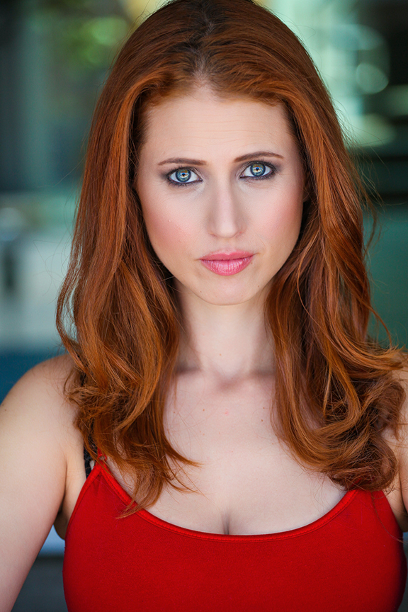From New York to Los Angeles, Rena Strober is praised for her Broadway performances, TV roles, Voice-Over Work and her upcoming short film Spaghetti & Matzo Balls!. She has received multiple awards for her recent Sesame Street album Imagine That: The music of Joe Raposo & Jeff Moss. This magical album features Jason Alexander, French Stewart and the Dotz Blind Children's Choir. www.renastrober.bandcamp.com Proceeds go to Guide Dogs of America

Some favorite New York Credits include appearing on Broadway as Cosette in Les Miserables, starring opposite Betty Buckely, Peter Scolari and Tuc Watkins in the Off-Broadway comedy White's Lies, Belle in Beauty & The Beast among many others. Her 1- woman show, Spaghetti & Matzo Balls! ran Off-Broadway in NY, Los Angeles and in Leeds, England to enlightened and entertained, sold out houses. Rena toured the country with Fiddler on the Roof as Tzeitel playing opposite Topol, Harvey Fierstein & Theo Bikel. Rena originated the role of Tonya in the pre-Broadway production of Zhivago (Directed by Des McNuff) at the La Jolla Playhouse for which she was awarded the Outer Critics Circle Award.

TV audiences know Rena as Becky Bickelhoff on Disney's Liv & Maddie playing, Chuckie's Lawyer Emily Knowland on Shameless, Jonah's successful date on VEEP and multiple wacky roles on Nickelodeon. Rena has also voiced hundreds of characters for DisneyXD, Nickelodeon, Netflix, Nintendo, Sega and many Anime games & Cartoons. Some fan favorites include Ever After High, Penn Zero, Dogs in Space, Sailor Moon and the entire series of Fire Emblem as Azura.

# HOLLY WARD

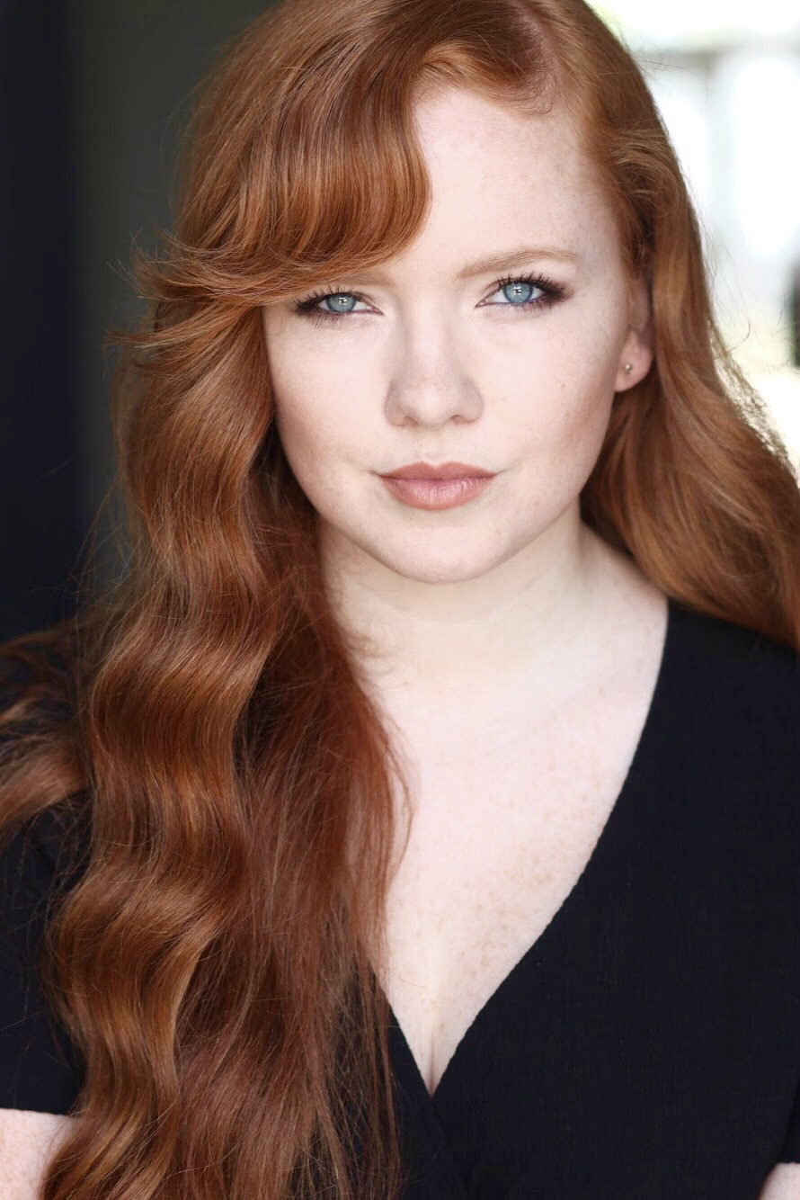Holly Ward is an American actress and model, born in Los Angeles. She appeared in numerous commercials, television series, and independent films and is best known for Black Bird (2022), Agatha All Along (2024) and Queen Sugar (2016).

**and**

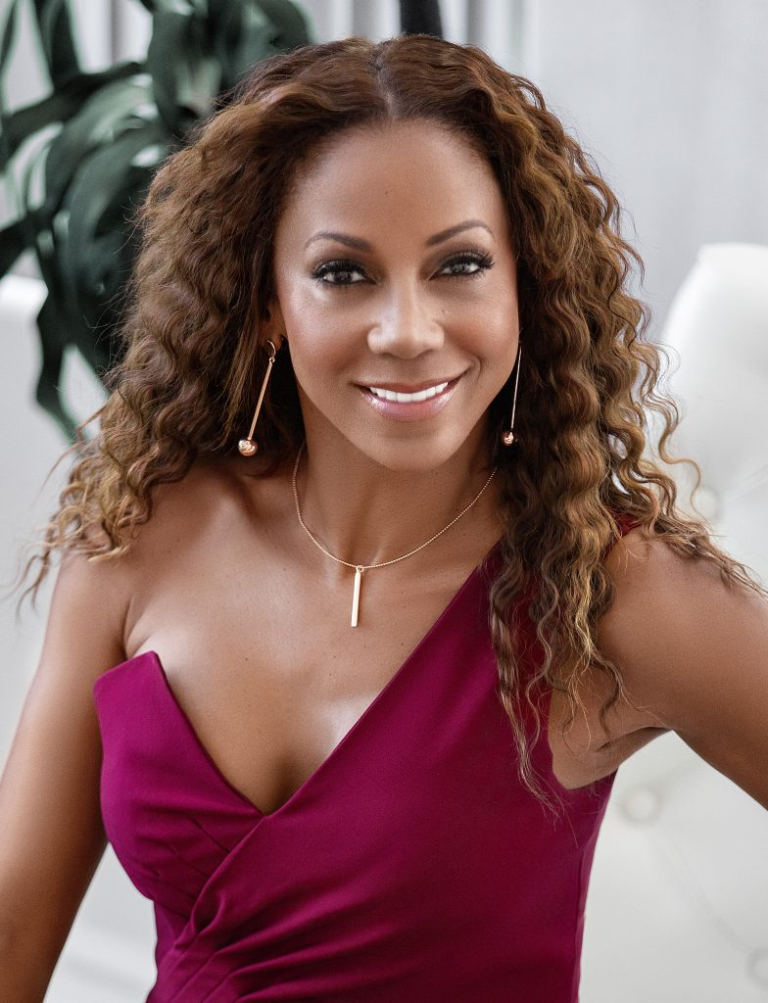**HOLLY ROBINSON PEETE**

Holly Robinson Peete is an American actress, author, talk show host, and activist, best known for her roles in television series such as 21 Jump Street, Hangin’ with Mr. Cooper, and For Your Love. She also gained recognition as a co-host on The Talk and has become a familiar face in numerous Hallmark Channel movies. Born on September 18, 1964, Peete has had a diverse career that spans acting, writing, and public advocacy. She co-founded the HollyRod Foundation with her husband, former NFL quarterback Rodney Peete, to support families affected by autism and Parkinson’s disease—causes close to her heart due to her son RJ’s autism diagnosis and her father’s struggle with Parkinson’s. In addition to her activism, she is an award-winning author of children’s books, including My Brother Charlie, which earned her an NAACP Image Award. She and Rodney Peete have four children and continue to be active in both entertainment and charitable work.

# Production Credits

### Full Cast

|  |  |
| --- | --- |
| [Actors](http://www.imdb.com/name/nm7589451/?ref_=ttfc_fc_cl_t1)  GINNA CLAIRE MASON  HOLLY ROBINSON PEETE  JOHN CLARENCE STEWART  DARLA DELGADO  RENA STROBER  HOLLY WARD  ALEX TRUMBLE  KRISTIN WOLLETT  STEWART SCOTT  JAN NUEBERGER  CINDY KARR  RAYEL  LINDSAY NORTHERN  DEVIN CONWAY  MARTIN MONTANA  SALLIE GLANER  MARGARET REED  ERIC REED  J ALAN DAVIDSON | Role  Stella  Rosiland  Christian  Odette  Hannah  Annie  Davidson  Mandy  Roger  Margaret  Blanche  Mimi  Beth  Brian  Rick  Judge  Woman In Line  Horse Owner  Race Announcer |

### Casting By

JEFF HARDWICK

### Music By

RUSS HOWARD III

### Editor

WENDY ELFORD-ARGENT

### Production Designer

STARLA CHRISTIAN

### Director Of Photography

LARS LINDSTROM

### Written By

UMA INCROCCI  
AUSTIN HIGHSMITH GARCES  
AMY BARRETT  
BRUCE D. JOHNSON

### Directed By

AMY BARRETT

### Full Crew

|  |  |
| --- | --- |
| JOHN MEHRER | Head Of Production |
| CAMERON BRUMBELOW | Line Producer |
| MICHAEL ROTH | Production Supervisor |
| CURTIS ROLAND | Production Managers |
| CHELSEA BUTZ |  |
| MICHAEL HAYWARD | Production Coordinator |
| BORNEO SEED NISHEVIKJ | First Assistant Director |
| ABBY NAN | Second Assistant Director |
| RACHEL DEBICKERO | Second Second Assistant Director |
| KARLIE LOWLAND / KLR CREATIVE GROUP | Additional Casting |
| BECCA EIRIKSON | Art Director / Set Dresser |
| JEROME BOWERS | Additional Set Decorator |
| BRYAN WILLIAMS | Property Master |
| BRIANNA SPEILDENNER | Props Assistant |
| MICHAEL LOEFFLER | Production Assistants |
| LUKE NIEMAN |  |
| JENO BROFCHOSKY |  |
| CIERRA KUTIATA |  |
| CHASE HUANG |  |
| ASHLEIGH ANDERSON |  |
| ADRIAN SPRUNGER |  |
| ROSE CALTRIDER | 1st Assistant Camera |
| JAKE BUTLER |  |
| GONZALO BETANCOR | 2nd Assistant Camera |
| TIGER TAO |  |
| CHELSEA BUTZ | Stills |
| ANTHONY MARINCAS | Gaffers |
| DANIEL NILSSON |  |
| FRANK BIFULCO | Key Grip |
| LUKE PERETTI | Additional Grips |
| ANDREAS DEJESUS |  |
| MIKE BAKER |  |
| BRUCE MURRAY | BB Swing |
| TIM BEDINGHAUS | BB Electric |
| KHRIS COLGATE | BB Grips |
| ROBERT OBED |  |
| DERRICK LESSARD | Sound Mixer/Boom Operators |
| NATHANIEL FENNEL |  |
| KEVIN REGO | Stunt Coordinator |
| CASEY CUBE | Horse Wrangler |
| EVAN WATERS | Costume Designer |
| MARY BETH GRAY | Assistant Costume Designer |
| ALYSSA ROMAN | Key Costumer |
| KELSEY GARCIA | Shopper |
| NICOLE FINCH | Hat Milliner |
| JACKIE CUPPLES | Hair Department Head |
| MONIQUE MCLAUGHLIN | Makeup Department Head |
| JASON HENNARD | Addition HMU |
| MONIQUE AUSTIN |  |
| RICHARD GRANT |  |
| JASMINE STOVAL |  |
| DAVID YATES | Location Scouts |
| MAVERICK GAGLIANO |  |
| KEVIN RILEY | Site Coordinator |
| JOSH CARBUNGCO | Set Medic |
| GREENSLATE | Payroll Services |
|  | Production Accounting |
| J ALAN DAVIDSON | Post Production Supervisor |
| WENDY ALFORD-ARGENT | Editor |
| PURPLE DOG POST | Post Production Services |
|  | Colorist |
|  | Sound Designers |
|  | Re-Recording Mixer |
|  | Dialog Editor |
|  | Additional Voices |
|  | Visual Effects |
| TAMPA BAY DOWNS | Special Thanks |
| QUANTUM LEAP FARMS |  |
| FLORIDA STATE FAIR |  |
| THE FENWAY HOTEL |  |
| PRODUCTION SERVICES AND SYSTEMS, INC |  |
| TRICIA LANIGAN |  |
| THE PATON FAMILY |  |
| MARGO J. FLYNN |  |
| BELLVIEW INN |  |
| SERENDIPITY FARM |  |
| K2 SECOND UNIT STUNTS |  |
| ANGELA BITTAKER |  |
| THE KARNOWSKI FAMILY |  |
| NICK EKONOMOU for the use of The historic Cade Allen home in St. Petersburg, Florida |  |

# Producer Biographies

## TIMOTHY O. JOHNSON – Executive Producer

Timothy O. Johnson is among the most active and reliable producers in the business thanks to top rate productions and global distribution appeal. He is the managing partner of Johnson Production Group, a Canadian based operation that produces over 100 hours of dramatic television annually with hundreds of programs running internationally. The company is the leader supplier to Lifetime, Hallmark and other international outlets.

A graduate of the Marshall School of Business at the University of Southern California, he served as President of the USC Entertainment Management Association and a member of the Advisory Committee of the Center for Entrepreneurial Studies.

Johnson is also responsible for producing the international hit series, DR. QUINN, MEDICINE WOMAN for CBS for over 5 seasons. During his 100-episode tenure, he also developed and produced the original docu-drama COLD CASE for CBS network, which was the very first program to integrate television with the Internet.

Most recently, Johnson has produced the THE NOEL DIARY, being the #1 Film on Netflix’s Top 10 list in December of 2022. He was also at the helm of the successful GIRL IN THE SHED: THE KIDNAPPING OF ABBY HERNANDEZ, as well as the V.C. Andrews series of films, to date including TWILIGHT’S CHILD, MIDNIGHT WHISPERS, and DAWN, all produced for Lifetime..

Johnson has produced over 400 movies and 15 globally released series for every major US network - including Netflix, Lifetime, Hallmark, ABC, Disney, CBS, NBC, Netfly, FOX and Sony.

## JOHNSON PRODUCTION GROUP

Johnson Production Group packages, finances, and distributes television content to networks, studios and streamers. The company specializes in various types of programming including romances, thrillers, holiday and true crime TV movies.

The company has been involved in the production of over 3000 hours of network television, with over $1 billion spent on production. JPG specializes in value, efficiency, protection of creative elements, and delivery of a quality finished product.

## JOSEPH WILKA – Executive Producer

Joseph Wilka is the Head of Production for Johnson Production Group. Los Angeles-based, Joseph had already produced and directed several feature films before serving as the senior marketing executive for Gravitas Ventures. While at Gravitas, Wilka helped pioneer new distribution models for independent films including day-and-date theatrical releases. It was also at Gravitas where Joseph first worked with Johnson Production Group to facilitate the release of their films to the worldwide Video On Demand audience. After serving as the Director of Distribution and Production for Viva Pictures, where he produced English-language versions of foreign animated titles for DirecTV, Wilka officially joined Johnson Production Group. As Head of Production, he oversees the development, production, and distribution of films from multiple production units for release on broadcast and streaming platforms.

## MAURA DUNBAR – Executive Producer

Maura Dunbar is a seasoned entertainment industry professional with over 36 years of experience as a senior-level broadcast/cable executive and producer of Emmy-nominated original programming. Her extensive career has been marked by significant achievements across various platforms, showcasing her expertise in programming strategies, development, packaging, and production.Throughout her career, Dunbar has been responsible for producing over 600 hours of television movies and mini-series, becoming an expert in building communities around programming and marketing platforms. Her work has garnered numerous accolades and industry recognition.

In 2021, Dunbar joined the Johnson Production Group as an Executive Producer, overseeing projects such as "Dog Lover's Guide to Dating" and "Noel Next Door." Prior to this, she served as EVP/Chief Content Officer of Odyssey Networks, where she also headed multiple subsidiary companies as President & CEO of Lightworks Pictures and Engage Entertainment. Under her leadership, these companies developed and produced over 21 films for the Hallmark Channel and UPtv, earning multiple awards including Telly, Camie, and Christopher Awards.

At Lightworks, Dunbar oversaw "The American Bible Challenge," which became one of the highest-rated shows in the history of the Game Show Network, earning her a Daytime Emmy nomination. She also ventured into non-scripted documentary programming, overseeing the production of "Serving Life" for Oprah Winfrey's OWN network, which won numerous awards including the CINE Masters Series Award and the Humanitas Prize.

Before her work with Odyssey Networks, Dunbar served as Senior Vice President of Original Programming for Hallmark Channel. In this role, she launched the channel's franchise of original two-hour movies and helped grow the channel's distribution significantly, from 32 to 57 million homes.

Dunbar's career began at ABC Network, where she worked for 16 years, eventually becoming Vice President of MiniSeries and Special Projects. During her tenure, she developed and produced critically acclaimed and commercially successful content, working with renowned authors and directors such as Stephen King, Larry McMurtry, and Christopher Reeves.

Throughout her career, Dunbar has been actively involved in industry organizations. She served four terms on the Board of Governors for the Academy of Television Arts & Sciences, chairing various committees including the prime-time show committee for the 2008 Primetime Emmy Telecast. She has also been involved with organizations such as GLAAD and the Salvation Army's Entertainment Advisory Committee. Dunbar's contributions to the industry and community have earned her numerous accolades, including an appointment as "Kentucky Colonel" by the Governor. Her commitment to fostering young talent is evident in her involvement with educational institutions and mentorship programs, including serving on the Communication & Fine Arts Council at Loyola Marymount University and participating in the Boyle Heights Elementary Institute Student/Mentor Program.

As a member of the Producers Guild of America, Maura Dunbar continues to be a prominent figure in the entertainment industry, known for her expertise in content creation, production, and industry leadership.

## JOHN MEHRER – Executive Producer

John Mehrer is a producer and the Executive Vice President of Production for RNR Media. Since 2011, John has been on the production staff of over one hundred feature length films and held producing roles on over seventy-five. In the past 5 years, RNR Media has produced over 60 movies in the thriller, romantic comedy and action genres.

## DANNY ROTH – Producer

Danny Roth is a prolific American film and television producer with a career spanning over two decades. He has built a reputation for delivering commercially successful, story-first content across a wide range of genres, including thrillers, holiday features, dramas, and action films. As the owner of RNR MEDIA and producer on more than 130 projects, Roth is recognized for his ability to pair efficient budgets with high production value — often working with top-tier talent and emerging voices alike.

Roth’s work is regularly featured on major platforms including Netflix, Lifetime, Amazon, Hallmark, and Paramount Global. His credits include Altitude, The Hurricane Heist, Christmas Reservations, Arctic Void, and dozens of holiday movies and TV thrillers. Known for his sharp instincts and hands-on producing style, Roth is adept at shepherding projects from development through delivery, maintaining strong relationships with writers, directors, and distributors.

Whether producing independent features or overseeing high-output slates, Danny Roth remains focused on compelling storytelling, market viability, and delivering for audiences worldwide.

## Billing Block

JOHNSON PRODUCTION GROUPPRESENTS An RNR MEDIA Production   
HATS OFF TO LOVE Starring GINNA CLAIRE MASON JOHN CLARENCE STEWART DARLA DELGADO RENA STROBER HOLLY WARD and HOLLY ROBINSON PEETE Production Designer STARLA CHRISTIAN Director Of Photography LARS LINDSTROM Editor WENDY EFLORD-ARGENT Music By RUSS HOWARD Executive Producers TIMOTHY O. JOHNSON JOSEPH WILKA MAURA DUNBAR JOHN MEHRER MICHAEL ROTH Co-Executive Producer LISA ALFORD Produced By DANNY ROTH Written By UMA INCROCCI AUSTIN HIGHSMITH GARCES AMY BARRETT BRUCE D. JOHNSON Directed By AMY BARRETT



Special Thanks to St. Petersburg Clearwater Film Commission and Pinellas, County, Florida, for their invaluable support in the making of this film.

Filmed in Hillsborough County Florida

 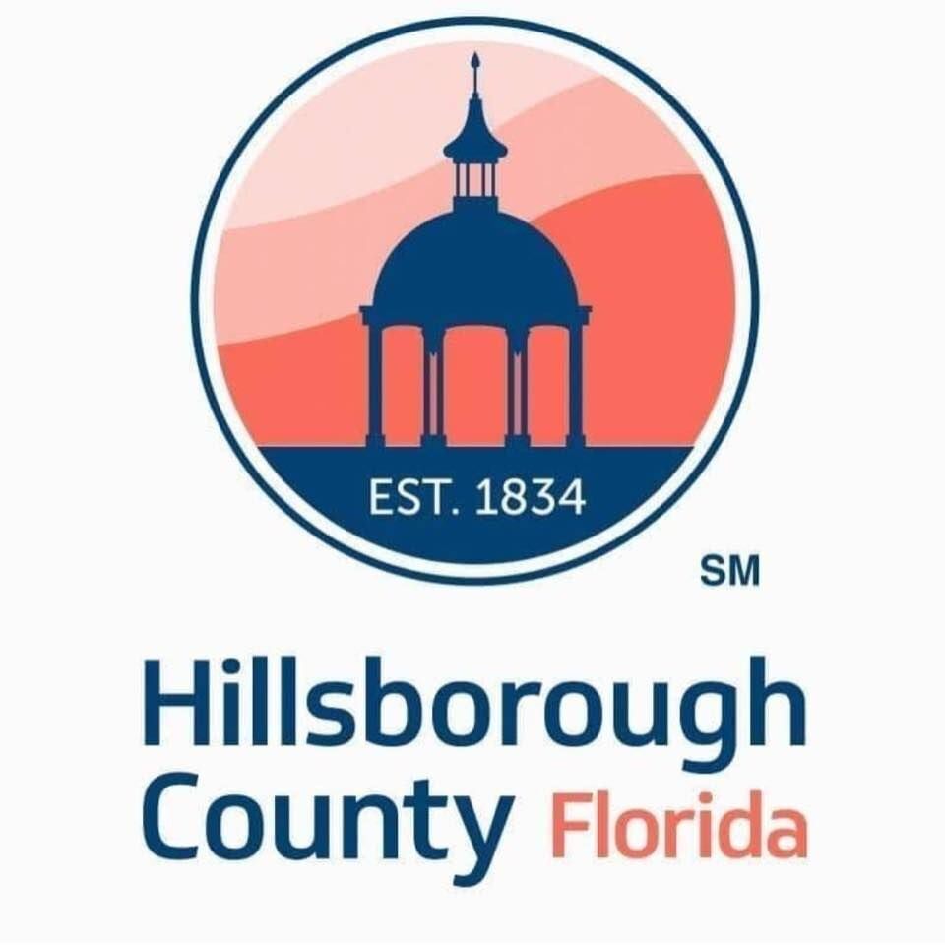  
Thanks to the County and FTB

 



© 2025 PINELLAS PICTURES LLC. ALL RIGHTS RESERVED

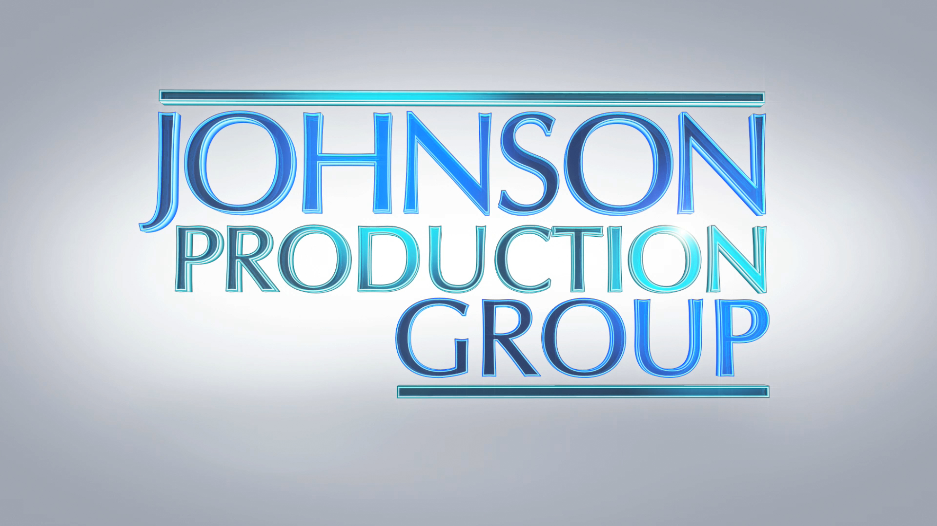

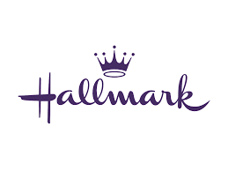

Meta Data

LONG (max 3000 characters) synopsis

Stella Stone, a talented but struggling milliner, dreams of making a name for herself in Louisville’s competitive Derby fashion scene. Desperate for a breakthrough, she sneaks into the suite of Rosalind Fairchild, the grand dame of Kentucky high society, hoping to impress her with a handcrafted fascinator. Instead, she runs into Christian Fairchild, Rosalind’s handsome and skeptical son, who watches in amusement as Stella fumbles her way through an awkward first impression.

Despite her unconventional approach, Stella’s designs catch Rosalind’s eye, and she is given the opportunity to create custom Derby hats for the Fairchild family—an honor that could launch her career. But Odette Giraud, the imperious designer already working with Rosalind, sees Stella as a threat and subtly undermines her at every turn. Meanwhile, Hannah St. Charles, Rosalind’s jealous assistant, resents Stella’s growing presence and orchestrates an embarrassing social misstep, convincing Stella to attend a prestigious high-society luncheon in casual farm attire. Though humiliated, Stella refuses to be intimidated.

As she fights to prove herself, Stella grows closer to Christian, who is battling his own doubts about his ability to manage Wildflower Wish (Willa), the Fairchild family’s promising filly. Unlike his late father, Christian is hesitant to race Willa in the Derby against the colts, despite her talent. The arrival of his old friend-turned-rival Davidson Vegh, who is boarding his own aggressive stallion at the Fairchild farm, only adds to Christian’s stress. Davidson, who once managed Willa, pushes Christian to enter her in the weaker race for fillies, but Stella sees something in Willa that Christian doesn’t—unwavering potential.

As the Derby approaches, Stella juggles the immense pressure of crafting a prize-winning hat while helping Christian restore his confidence. Their mutual support turns into undeniable attraction, though both are wary of how romance might complicate their goals. Just when things seem to be falling into place, Stella overhears Hannah and Odette conspiring to sabotage her career, while Davidson’s motives regarding Willa come into question. With everything on the line, Stella must trust her instincts—not just in fashion, but in love and the world of horse racing.

In a triumphant finale at Churchill Downs, Christian makes the bold choice to race Willa in the Derby, defying expectations. Meanwhile, Stella’s daring hat design wins the Bradbury Hat Competition, proving she belongs in Kentucky’s elite fashion world. As the race begins, Christian and Willa take off down the track, and Stella realizes she’s not just witnessing history—she’s become a part of it.

The story ends with Willa making a breathtaking finish, Stella standing on the brink of a career breakthrough, and Christian looking at her with the kind of admiration that suggests their partnership—both personal and professional—is just beginning. (2947)

MEDIUM (max 500) synopsis

When a determined milliner infiltrates Kentucky’s high society to pitch her Derby hats, she unexpectedly captures the attention of an elite horse racing family —particularly its charming heir. As romance blossoms, she must navigate ruthless rivals, deep-seated traditions, and a scandal that threatens to upend both her career and the fate of a prized racehorse. (362)

SHORT (max 100 characters) synopsis

Stella designs hats for socialite Rosalind but it’s her horse trainer son with whom Stella connects. (100)

5 KEY WORDS

Hats, fascinators, horses, derby, Kentucky