
Johnson Production Group
Press Kit

One-Liner

When an aspiring comedian is placed in charge of the Christmas Variety Show, she worries she might not have what it takes to pull off this make or break moment in her career, until she meets a famous comedian who not only makes her laugh, but makes her see how talented she truly is.

Synopsis

Aubri Callahan is an aspiring comedian and ghost writer for Bella Delmonico, acclaimed stand up comic and owner of the Vista Theater. Performing at the Vista is a key step on the way to stardom and despite her natural talent, Aubri patiently waits for her time to shine, writing jokes for Bella in the shadows of the comedic giants that came before her. When The Vista Theater Variety Show lands in Aubri's lap she must plan the whole event and find a headliner all before Christmas eve, just three weeks away. Aubri worries that the success of the show will be a make or break moment for her career. That is until famous Hollywood comedian Mike Baxter strolls into the theater. On the verge of his own life-changing opportunity, Mike has become nostalgic for the stage that launched his career, and he's immediately charmed by Aubri's quick witted banter. Fate seems to be calling Mike and Aubri up on stage at the Vista. There, Mike rediscovers his stand up roots and Aubri shows the world her inner funny girl, and as their journeys collide they fall hopelessly and hilariously in love, laughing all the way.

Producers
Executive Producers
TIMOTHY O. JOHNSON
DAWN WOLFROM
ANDREW C. ERIN
OLIVER DE CAIGNY
Co-Executive Producers
JOSEPH WILKA
LISA ALFORD
Producer
JOSIE FITZGERALD

Key Cast
CHARACTER  Aubry Wilson  Mike Baxter  Ian Lyles  Bella Deldomino |  | ACTOR  PANIZ ZADE  JAKE EPSTEIN  ISH MORRIS  and MARY WALSH

Key Cast Biographies

PANIZ ZADE

Paniz Zade is a Canadian actress, model, and social media personality. The actress was born to supportive parents in Tehran and later moved to Canada when she was ten. She rose to fame after portraying the character role of Shadee in the TV Series, Run the Burbs. Paniz has been already credited with 24 TV appearances as an actress. She is best recognized for her role as a Salon Receptionist in the romantic drama film, Fifty Shades Darker, directed by James Foley in 2017.
Paniz is known for the TV projects such as Coroner (2019), Blood & Treasure, and The Handmaid's Tale (2019). Some of her recent TV projects are Green Baret's Guide to Surviving the Apocalypse, A Match for the Prince, and Luckless in Love.

JAKE EPSTEIN
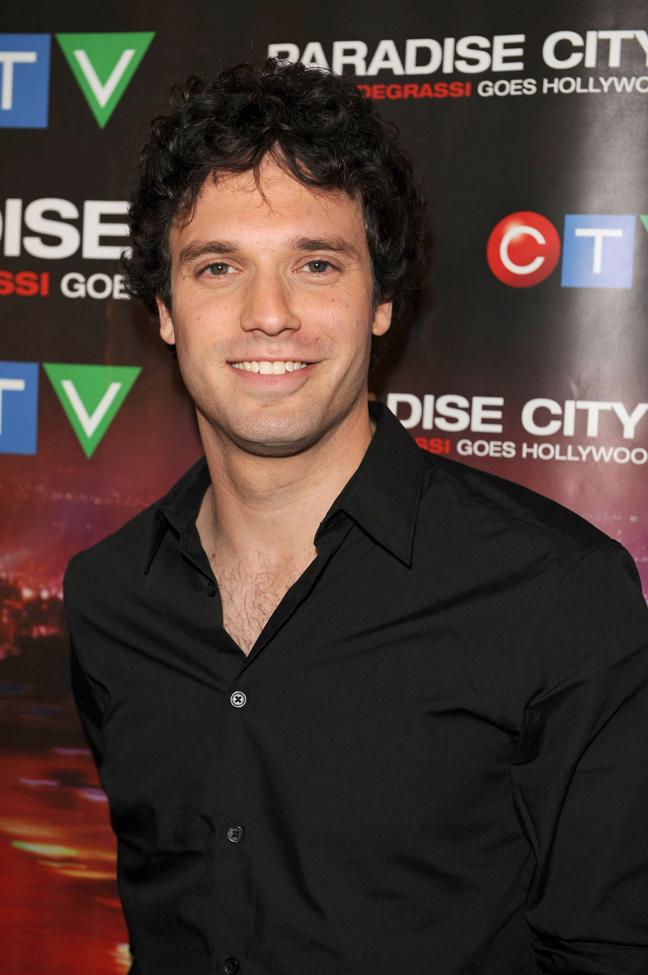
Jake Epstein is a Canadian actor, singer and writer. He is best known for playing Craig in 'Degrassi: The Next Generation' (Gemini Award), Chuck in 'Designated Survivor' and Brian in 'Suits,' along with many other leading roles. On stage, he appeared on Broadway as Peter Parker in 'Spider-Man: Turn Off the Dark,' Gerry Goffin in 'Beautiful: The Carole King Musical' (original Broadway cast), and starred in the US National Tours of Green Day's American Idiot and Spring Awakening. His film work has included roles in A Christmas Village Romance, Terror in the Country, Eight Gifts of Hanukkah, Candy Cane Candidate as well as recurring roles in The Hardy Boys and The Umbrella Academy.

ISH MORRIS
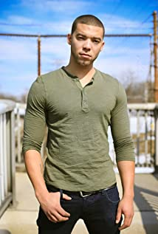
Ish Morris is a successful actor and musician. After graduation, he launched an acting career where he started appearing in commercials, films, and TV shows. He starred in the television series "Soul" alongside Keshia Chante. He also landed a recurring role in The Family Channel's series "Baxter" and had a role in Saw 3D, the last film of the Saw horror franchise. Ish is also known for Suits, Supernatural, Killjoys and Good Witch. His recent TV Movies have included roles in The Evil Twin, Fit for a Prince, Baby It’s Cold Inside, Evil Stepmom, Boyfriends of Christmas Past, UnPerfect Christmas Wish, Feeling Butterflies, Christmas Lucky Charm, Christmas in Wolf Creek and All Aboard for Love.

MARY WALSH
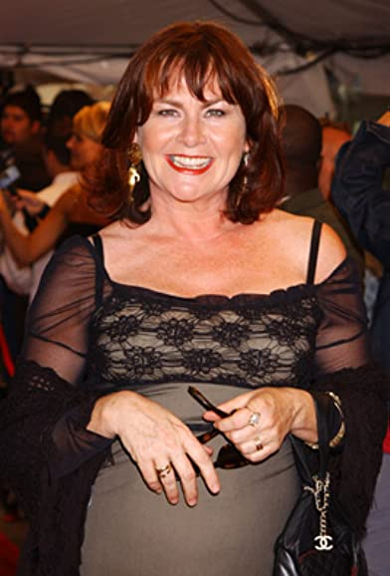
Mary Walsh is a Newfoundland actor, writer, comedian, activist and mother. Among her many awards and doctorates, Mary is also the recipient of The Order of Canada and the Governor General’s Lifetime Achievement Award in the Performing Arts.
No stranger to television audiences, Mary Walsh may be best known for her work on This Hour Has 22 Minutes, CBC’s wildly popular take on current affairs. The series, which she also created, earned her many of her numerous Gemini awards and showcased her dynamic range of characters, including the flagrantly outspoken ‘Marg Delahunty’.
Mary enjoyed 22 years as one of the hosts of This Hour Has 22 Minutes on CBC, a show she also created. The original This Hour Has 22 Minutes cast included Cathy Jones, Rick Mercer, Mary Walsh and Greg Thomey when it debuted in 1993. Hatching Matching and Dispatching aired for two seasons in 2005 and 2006. Mary played Mamie Lou Furey, the matriarch of a family in Cats Gut Cove, Newfoundland and Labrador who owned a combination ambulance, wedding and funeral business Mary had a great time as a recent guest on Chopped Canada on the Food Network.
Walsh wrote, produced and starred in the Gemini award winning Hatching, Matching and Dispatching, and more recent television credits include CBC’s Republic of Doyle, Global's Rookie Blue, and HBO Canada’s Sensitive Skin, for which she was nominated for a 2017 Canadian Screen Award.
Mary Walsh has enjoyed an exciting film career and has played roles in more than 15 films to date. She was nominated for two Genies for her performances in feature films Crackie (Official selection at TIFF) and New Waterford Girl.

Production Credits

Full Cast
Actors  PANIZ ZADE  JAKE EPSTEIN  MARY WALSH  ISH MORRIS  PAUL CONSTABLE  CANDICE LIDSTONE  DERICK AGYEMANG  GREGORY WILSON  TIM PROGOSH  JINESEA LEWIS  MELISSA GERVASI  LUCA CARL THUNBERG | Role  Aubry Wilson  Mike Baxter  Bella Deldomino  Ian Lyles  Robert Busbee  Stephanie  Damon Cardona  Henry  Jeremy  Renee  Mother  Kid

Casting
RON LEACH, c.d.c.

Composer
RUSS HOWARD III

Costume Designer
AMANDA COLLIE

Editor
BEN LAWRENCE

Production Designer
GREGORY PHILIP WILSON

Director of Photography
MICHAEL TIEN

Story by
TATIANA ST. PHARD
MEGAN HOCKING
RICKIE CASTANEDA

Screenplay by
MEGAN HOCKING
RICKIE CASTANEDA
DANE K. BRAUN

Directed by
MARITA JANE GRABIAK

Other Crew
ALEXANDRA WARING | Associate Producers
JOHNNY ROSS
JOHNNY ROSS | Production Manager
SARAH PETKOV | First Assistant Directors
CIMARRON LANGLOIS
CIMARRON LANGLOIS | Second Assistant Director
BORYS SHAPOVALOV | Third Assistant Director
BEN HRKACH | On-Set Third Assistant Director
AIDAN MAZEROLLE | Fourth Assistant Director
REGAL BACKGROUND CASTING | Extras Casting
MARY SAKS
GORAN POBRIĆ | Production Coordinator
LOGAN A. WAGNER | Production Accountant
JOSHUA LANGE | First Assistant Accountant
MATTHEW CARVELL | Assistant Accountant
MATTHEW CARVELL | Post Production Accountant
GREGORY PHILIP WILSON | Production Designer
ELIZABETH FITZPATRICK | Art Director
TOMAS CHOVANEC | Set Decorators
ANTHONY RANKIN
LINDSEY BELANGER
NATHALIE GREGOIRE | Property Master
AMANDA COLLIE | Costume Designer
JESSICA DYKINS | Costume Truck Supervisor
JULIANNE HJARTARSON | Costume Set Supervisor
ERIN MORRISON | Wardrobe Assistant
ALEXANDRA NEUFELDT
ROWAN STEELE
MICHAEL TIEN | Director of Photography
JOSH HENDERSON | B Camera Operator
ADAM TESTA | A Camera - First Assistant Camera
JILLIAN SKIDMORE | A Camera - Second Assistant Camera
NIKKI TUBONGBANUA
MATT CROSSE | B Camera - First Assistant Camera
LINDSEY BELANGER | B Camera - Second Assistant Camera
ADAM SOURGES
GEGHANI PANOSIAN | EPK Camera Operator
RICHARD FRAZIER | Digital Imaging Technician
RICHARD FRAZIER | Camera Utility
GEGHANI PANOSIAN
PETR MAUR | Stills Photographer
STEVEN F. S. BRUNI | Gaffer
NICK LYNCH | Best Electrics
YAN SCHNELL
NICHOLAS HERMIER | Key Grip
RJ NADON | Best Grip
JAMES COWLING | Grip / Electric Swings
CONNOR DORZEK
IAN FRASER
NICK LYNCH
SONIC LIGHTNING & SOUND | Sound by
FRANCESCO FALSETTO | Sound Mixer
ANDREW SUTHERLAND | Boom Operator
NICK SMITH | Script Supervisor
SAGINE CAVÉ | Unit Manager
KIM RODGER | Location Coordinator
JESSICA FERGUSON | Location Consultant
KEENE IMBLEAU | Key Location Production Assistant
NATALIE HONSHORST | Location Production Assistants
AEMON LOPER-GROSS
CAMERON MATHESON
JORDON PALAISY
KAYLA PIETARINEN
ALYSSA "ALY" MORDEN-HAYLEY | Key Makeup Artist
CHANCELLE MULELA | Assistant Makeup Artist
NATASHA GABRIELA TREPANIER | Key Hair Stylist
NAKESHA CHONG | Makeup & Hair Assistants
GISELE MATTE
KASSANDRA PEREIRA
STEFANE GREGOIRE | Transport Coordinator
GREG LEWIS | Transport Captain
MICHAEL DICKSON | Drivers
OLMES LEON
BILAL MAHMOUD
KIM RODGER
ROBERT STRONACH
LYNN SPRACKLIN | Transport Production Assistants
PERRY MCCONNELL
JAY VISNESKIE
JULIANN WRIGHT
STEPHANE BOUSQUET | Move Crew
JOSH GARBY
KEITH STEFFENSEN
CORNELIA VILLENEUVE
DAN VILLENEUVE
ERIC VILLENEUVE
SEAN VILLENEUVE
TOM WARRELL | Head Chef
GERRY WHALEN | Chef
MATTHEW DUBUC | Caterer
RONDA MACKINNON | Craft Service
THE NO CONFLICT CLEARANCE COMPANY | Script Clearances by
HALL WEBER LLP | Legal Services by
DANNY WEBBER
ABOVE THE LINE MEDIA SERVICES | Business Affairs by
BRENDAN MCNEILL
ARTHUR J. GALLAGHER CANADA LTD. | Insurance by
ALEXANDRA WARING | Post Production Supervisor
URBAN POST PRODUCTION | Post Production Services provided by
JOSEPH FACCIUOLO | Dialogue & ADR Editor
EHREN PFEIFER | ADR Recordist
KIRSTY SMITH | Sound FX Editors
LUKA TOMA
MATT THIBIDEAU | Foley Artists
TESS MOIR
DAWN LEWIS
DAVE MERCEL | Foley Recordists
MIKE POISSON
RUDY MICHAEL | Re-Recording Mixer
TYLER HALL | Re-Recording Assistant
ANDREW MANDZIUK | Colorist
EVAN GRAVES | VFX Artist
ANDREW MANDZIUK | Packaging & Online Editor
PETER TOKARSKY | Project Manager
BRUCE REES | Picture Operations Manager
ROBERTA BRATTI | V.P. of Operations
POND5/BLACKBOXGUILD | Stock Footage provided by
POND5/ODESIGNS
POND5/RSTOCK
Music
CHRISTMAS DAY DREAMING
by Tony Osborne
courtesy of Refuel Music and West One Music Group USA
CHRISTMAS WITHOUT YOU
by Alec Wilder and Arthur Jackson
courtesy of Refuel Music and West One Music Group USA
MERRY JAZZMAS
by Russell L. Howard III and Massimo Sammi
courtesy of Sweaty Avocado Music and Astral Avocado Music

Producer Biographies

TIM JOHNSON – Executive Producer
Tim Johnson is among the most active and reliable producers in the business thanks to top rate productions and global distribution appeal.
Johnson is also responsible for producing the international hit series, DR. QUINN, MEDICINE WOMAN for CBS for over 5 seasons. During his 100-episode tenure, he also developed and produced the original docu-drama COLD CASE for CBS network, which was the very first program to integrate television with the Internet.
Johnson has produced over 150 movies, 15 globally released series for every major US network - including ABC, Disney, CBS, NBC, Netfly, FOX and Sony.

JOHNSON PRODUCTION GROUP
The Johnson Production Group contracts globally to produce television content for international networks, studios and distributors. Based in Los Angeles and Vancouver, British Columbia, the company manages production, facilitates development and financing, procures distribution and guarantees quality and timely execution of its programs. While costs have gone up, so has the demand for quality. No longer is good enough, good enough. Johnson Production Group serves that segment when a show needs to be "A" quality, but produced efficiently enough to meet a locked budget. JPG specializes in value, protection of creative elements, and delivery of a quality finished product.

DAWN WOLFROM – Executive Producer
Dawn Wolfrom specializes in developing and producing female driven movies and family friendly content. She has been involved in the film & television industry for 25 years having worked on over a dozen feature films, numerous television projects, shorts, a documentary, and over 250 commercials, promotional spots, industrials and music videos.
Dawn has also served as a panelist for the Austin Film Festival & Conference for several years as well as various panels for The Greater Philadelphia Film Office. She has served as a judge and consultant for the annual Set In Philly Screenwriting Competition, among other nationwide writing competitions.
Dawn was Executive Producer of two award winning short films. THE BOY won the Director's Choice Award at the The Diversity in Cannes Film Showcase 2015, The Award of Excellence at the International Film Festival for Women, Zero Discrimination and Social Issues. THE BOY received the INTERNATIONAL HUMANITARIAN SILVER AWARD. As well, a special recognition for Director, Cayman Grant -- The Star of Humanity Award. On October 21st 2015, Gina Davis announced Best Female Filmmaker award to Cayman Grant City for THE BOY. Her film BUTTERFLIES has won the Winnipeg Film Festival and the Grand Prize Award at the Canada International Film Festival. At the London Film Awards, Butterflies was awarded the Cinematic Vision Award. At the Big Island Film Festival, Butterflies won Best Family Short and Best Audience Choice Award.
ANDREW C. ERIN – Executive Producer
Andrew Erin is a Canadian Writer/Director making a big splash in the US, and has produced, written and directed numerous commercially successful films. His directorial debut, SAM’S LAKE, was an official selection at the Tribeca Film Festival and did an excellent theatrical run in select theaters around the country; distributed by Lionsgate Films. Andrew also wrote the script for the film. Andrew’s directorial credits include, SIMPLE THINGS, produced for Screen Media Ventures and Universal Studios. Besides winning The Bob Clark Award for Best Director at the California Independent Film Festival, the film was commercially received. Andrew has worked continuously as a writer/director, building a strong library of films in the Thriller/Horror genres with: Embrace of The Vampire, The Clinic, Final Sale, Confined and Toxic Skies.
OLIVER DE CAIGNY – Supervising Producer
Oliver De Caigny is a Canadian producer originally from Belgium, his background in financing, production, and post production makes him a well-rounded producer for any type of production. His experience in financing and production agreements (film and TV series and movies-of-the week), distribution agreements (both domestic and foreign) as well as international co-productions, Canadian tax credit, Telefilm Canada and Canada Media Fund incentives provides him with a well-rounded background in development, production and distribution for motion pictures, television series and productions.

JOSEPH WILKA – Co-Executive Producer
Joseph Wilka is the Head of Production for Johnson Production Group. Los Angeles-based, Joseph had already produced and directed several feature films before serving as the senior marketing executive for Gravitas Ventures. While at Gravitas, Wilka helped pioneer new distribution models for independent films including day-and-date theatrical releases. It was also at Gravitas where Joseph first worked with Johnson Production Group to facilitate the release of their films to the worldwide Video On Demand audience. After serving as the Director of Distribution and Production for Viva Pictures, where he produced English-language versions of foreign animated titles for DirecTV, Wilka officially joined Johnson Production Group. As Head of Production, he oversees the development, production, and distribution of films from multiple production units for release on broadcast and streaming platforms.

LISA ALFORD – Producer
Lisa Alford is a development executive at Johnson Production Group. A Massachusetts native, Lisa has lived and worked in Los Angeles for over a decade, always in support of excellent storytelling. Prior to joining Johnson Production Group, Lisa worked as an executive at TriStar television where she specialized in identifying IP that supported TriStar’s mission to feature diverse, authentic characters and champion underrepresented voices. Lisa came up at Sony Pictures Television where she worked as a production coordinator in the Television Movies and Miniseries department and in the writers room on the WGN hit series OUTSIDERS. In her current role, Lisa shepherds projects from the concept phase through story development, production, and post.

JOSIE FITGERALD – Producer
Josie Fitzgerald is a Canadian born Producer currently residing and working in Ottawa, Ontario. Josie is also a passionate photographer and writer, with an education in Justice Studies and a professional background in Human Resources and Project Management.
Billing Block
LIFETIME PRESENTS IN ASSOCIATION WITH JOHNSON PRODUCTION GROUP LAUGHING ALL THE WAY starring PANIZ ZADE JAKE EPSTEIN ISH MORRIS and MARY WALSH Casting RON LEACH, c.d.c. Composer RUSS HOWARD III Costume Designer AMANDA COLLIE Editor BEN LAWRENCE Production Designer GREGORY PHILIP WILSON Director of Photography MICHAEL TIEN Co-Executive Producers JOSEPH WILKA LISA ALFORD Executive Producers DAWN WOLFROM ANDREW C. ERIN OLIVER DE CAIGNY TIMOTHY O. JOHNSON Producer JOSIE FITZGERALD Story by TATIANA ST. PHARD MEGAN HOCKING RICKIE CASTANEDA Screenplay by MEGAN HOCKING RICKIE CASTANEDA DANE K. BRAUN Directed by MARITA JANE GRABIAK


The Canadian Film or Video Production Tax Credit

© MMXXIII Fireside (Laughing) Films Inc. All Rights Reserved


Meta Data
LONG (max 3000 characters) synopsis
Aubri Callahan is an aspiring comedian and ghost writer for Bella Delmonico, acclaimed stand up comic and owner of the Vista Theater. Performing at the Vista is a key step on the way to stardom and despite her natural talent, Aubri patiently waits for her time to shine, writing jokes for Bella in the shadows of the comedic giants that came before her. When The Vista Theater Variety Show lands in Aubri's lap she must plan the whole event and find a headliner all before Christmas eve, just three weeks away. Aubri worries that the success of the show will be a make or break moment for her career. That is until famous Hollywood comedian Mike Baxter strolls into the theater. On the verge of his own life-changing opportunity, Mike has become nostalgic for the stage that launched his career, and he's immediately charmed by Aubri's quick witted banter. Fate seems to be calling Mike and Aubri up on stage at the Vista. There, Mike rediscovers his stand up roots and Aubri shows the world her inner funny girl, and as their journeys collide they fall hopelessly and hilariously in love, laughing all the way. (1111)
MEDIUM (max 500) synopsis
When an aspiring comedian is placed in charge of the Christmas Variety Show, she worries she might not have what it takes to pull off this make or break moment in her career, until she meets a famous comedian who not only makes her laugh, but makes her see how talented she truly is. (284)
SHORT (max 100 characters) synopsis
An aspiring comedian worries she might not be funny enough but a famous comic is instantly charmed. (100)
5 KEY WORDS
Theater, variety show, Christmas, romance

