Johnson Production Group

Press Kit

One-Liner
Former sweethearts on an archaeological dig for ancient Indian artifacts and arrowheads meet a couple whose ancestors survived the dreaded Trail of Tears, and end up with a much deeper understanding.

Synopsis

Two student archaeologists, Hailey and Rob, once high school sweethearts, are assigned to the same archaeological dig in Great Smoky Mountains National Park and compete for the same grant as they search for ancient Cherokee artifacts and re-discover their love for each other. Along the way, they meet couple Troy and Sky, whose ancestors survived the Trail of Tears, and shed even more light on the trail’s mythology, making Hailey and Rob’s journey that much more meaningful

Producers
Executive Producers
TIMOTHY O. JOHNSON
JOSEPH WILKA
Co-Executive Producer
LISA ALFORD
Producers
ROBERT BALLO
ROBIN CONLY
Co-Producer
ARIELLE KEBBEL

Key Cast
CHARACTER  Hailey  Rob  Sky  Troy |  | ACTOR  ARIELLE KEBBEL  ZACH ROERIG  DANIELLE VEGA  KAI BRADEN

Key Cast Biographies

ARIELLE KEBBEL
Arielle Kebbel could most recently be seen in the fan favorite role of “Lucy” in the hit FOX series “9-1-1”, where she has had a recurring role for the for the past two seasons. She has also wrapped production on the independent feature “Site”, opposite Jake McLaughlin and Theo Rossi.
In 2020, Arielle portrayed the lead role of “Amelia” in the NBC series “Lincoln” opposite Russell Hornsby. The series is based on the highly popular Jeffrey Deaver crimes novel, The Bone Collector. Kebbel starred on the NBC series, “Midnight, Texas,” based on the bestselling supernatural trilogy by Charlaine Harris of the same name, while recurring in a scene-stealing role in ABC’s “Grand Hotel,” which premiered on June 17th, for producer Eva Longoria.
On the big screen, Arielle co-starred in the successful sequels to the “After” franchise –“After We Fell” and “After Ever Happy” in 2021 and 2022. Arielle could be seen starring in the final instalment of the Fifty Shades of Grey saga, Fifty Shades Freed, which premiered in February 2018 breaking box office records. She portrayed Gia Matteo, Christian Grey’s architect, to whom Ana gives the nickname "Miss-Provocative-And-Unfortunately-Good-At-Her-Job.”
On the small screen, Arielle starred opposite Dwayne Johnson on HBO’s hit series, “Ballers,” which focuses on a group of young athletes working on making a name for themselves with the misguided advice of their agents and financial advisors. Kebbel caught the attention of critics and audiences alike in her scene-stealing turn as the villainous Britney in Lifetime’s critically acclaimed series, “UnREAL”, a performance which Entertainment Weekly cited as one of the “Best of 2015”.
Kebbel is perhaps most familiar to television audiences from her role on the CW’s “The Vampire Diaries” in which she played the charismatic and wise-beyond-her-300 years, Lexi Branson. In addition to her role on the hit show, Kebbel hosted the CW’s “The Vampire Diaries: Rehash,” an interactive weekly recap of the show. Her additional television credits include recurring roles on “Gilmore Girls”, “Life Unexpected”, “Grounded for Life”, “The League”, “The Grinder”, CW’s “90210”, as well as guest starring roles on “True Blood”, “Hawaii 5-0,” and “Law & Order: SVU”.
Over the years, Arielle has starred in a number of films which made their debuts at prestigious film festivals such as Brooklyn Brothers Beat the Best, directed by Ryan O’Nan which premiered at the 2011 Toronto International Film Festival; I Melt with You, starring Rob Lowe and Jeremy Piven which premiered at the 2011 Sundance Film Festival; and Supporting Characters, directed by Daniel Schecter and also starring Lena Dunham, which premiered at the 2012 Tribeca International Film Festival. Her other film credits include John Tucker Must Die, The Uninvited, The Grudge 2, Think Like a Man, and Aquamarine.
Kebbel currently resides in New York.

ZACH ROERIG
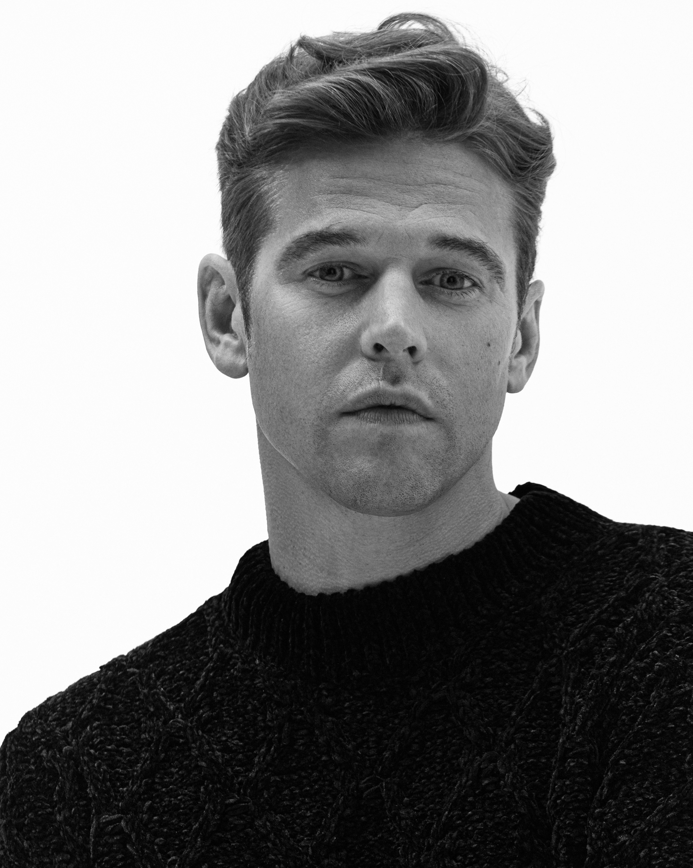
Zach Roerig is best known for his work starring in CW’s hit drama THE VAMPIRE DIARIES from Kevin Williamson & Julie Plec. Roerig played 'Matt Donovan', the all-American leading man who struggles to do the right thing in a town full of mystery, violence and the supernatural. The hit series ran 8 successful seasons, won multiple People’s Choice and Teen Choice Awards, and spawned 2 spinoffs, THE ORIGINALS and LEGACIES, which Roerig also appeared in.
Born and raised in Ohio, Roerig split his childhood between acting, school, sports (football and wrestling), and working for his family’s business making gravestones. Following high school, he moved to New York to pursue his acting career, quickly finding success and booking a major role on the daytime series, AS THE WORLD TURNS and a recurring role on the Emmy winning FRIDAY NIGHT LIGHTS.
Roerig continues to go from series to series, most recently appearing as a regular on USA’s limited series DARE ME, opposite Willa Fitzgerald and STEP UP: HIGH WATER for Starz.
Other notable credits include Roadside’s THE LAST FULL MEASURE with Sebastian Stan, Sean McNamara’s FIELD OF LOST SHOES with Jason Isaacs, Lea Thompson’s star-studded indie comedy THE YEAR OF SPECTACULAR MEN, and Paramount’s RINGS.
Roerig currently resides in Georgia with his daughter, Fiona, and their dog, Hank.

DANIELLE VEGA
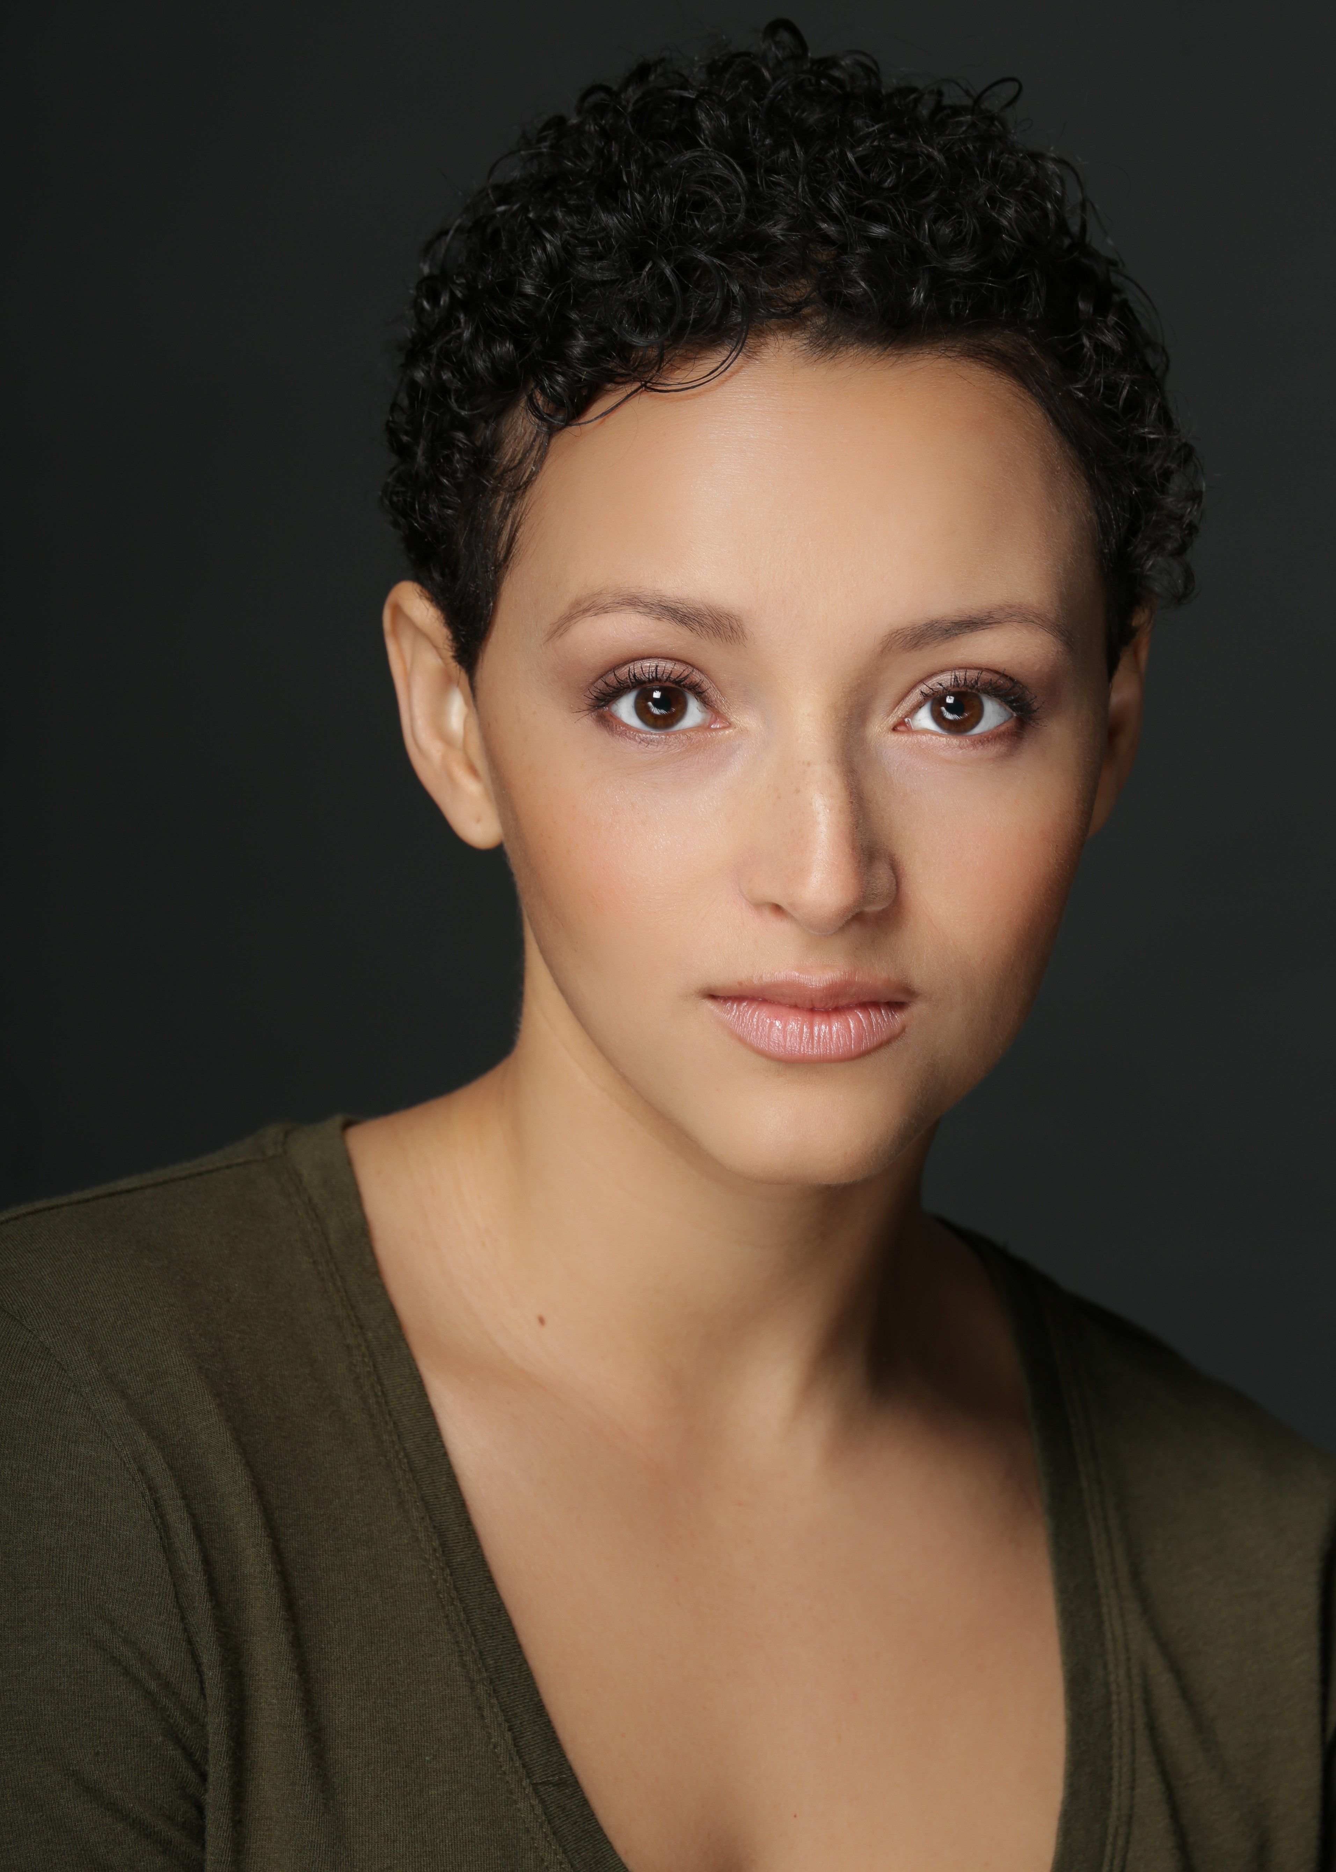
Born in Atlanta, GA and raised in Dallas, TX, Danielle received her BA in journalism from Southern Methodist University before taking the leap and heading west to Los Angeles. Her beauty is owed to her diverse lineage, which includes her mother of Spanish, African-American, and American Indian (Cherokee) descent, and father of British and Irish.
Off-camera, Danielle is a talented singer and dancer. She studied under the direction of Debbie Allen in various forms of dance, and also had the privilege of starring in Allen's musical stage production of "Pepito's Story."
Danielle was exposed to the world of television and film at the age of 9 when she was cast as a series regular on the children's television show, "Barney And Friends." Her other television credits include the Hulu Original Series "East Los High," directed by Carlos Portugal in which she plays young mother Ceci Camayo. Danielle also starred in the independent feature "So This Is Christmas," alongside Vivica A Fox and Eric Roberts.
She was nominated as Best Lead Actress in the Red Dirt International Film Festival 2014 for her work in the short film "Hana", as well as a Daytime Emmy award for Outstanding Performer in a New Approaches Drama Series in 2015 for her work as Ceci Camayo in Hulu's East Los High.
Danielle can be seen in the five standing seasons of East Los High on Hulu.
KAI BRADEN
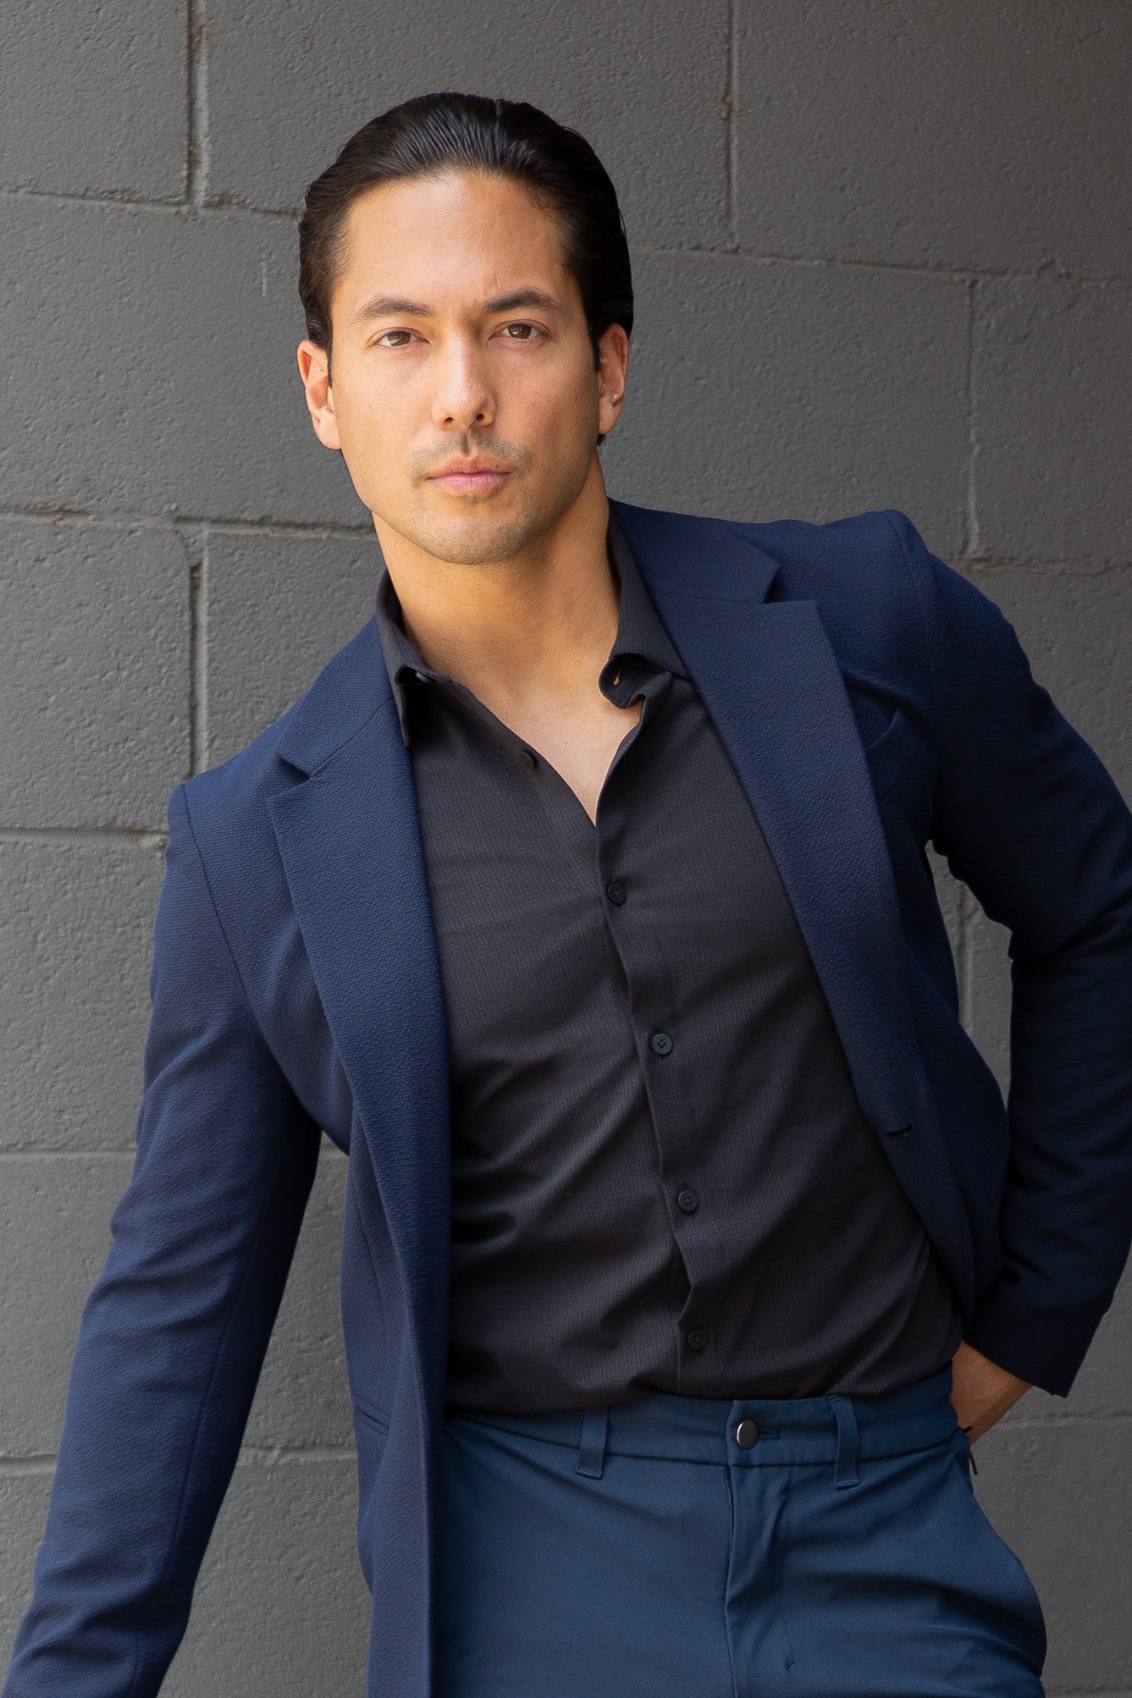
Actor/Model Kai Braden is a San Francisco native based in NYC and LA. As an actor, some of Kai's roles include television shows such as Orange Is The New Black (Netflix), Revenge (ABC), 90210 (CW), and General Hospital (ABC), national commercials for Crocs, Nivea, Toyota, and Dunkin Donuts, and international music videos for Katy Perry, Tata Young, and A-Mei.
As a Model with Wilhelmina as his first agency, Kai also has representation worldwide. His career has taken him around the globe to work with such clients as Men's Health Magazine, J.Crew, Cosmopolitan Magazine, Nike, 7 For All Mankind, lululemon, Gillette, and Samsung.
As a highly-certified and versatile Fitness Coach, Kai teaches on-demand classes for multiple virtual platforms. His coaching experience includes CrossFit and Orangetheory, with a foundation in Olympic Taekwondo. Kai's action training compliments his work in entertainment. He also has a television production degree from Pepperdine University and serves as a council member in the labor rights nonprofit, The Model Alliance.

Production Credits

Full Cast
Actors  ARIELLE KEBBEL  ZACH ROERIG  DANIELLE VEGA  KAI BRADEN  JOE SACHEM  DEENA DILL  HOLLY BONNEY  TAMMY CONNELLY  WALTER CONNELLY  JORDAN OVERTON  JAY HESELSCHWERDT  STEPHEN TEAGUE  CATHERINE SIRAVANTHA  NICHOLAS STONE  COLE DETELICH  CHARLIE BRICKLE  MALACIAH TAYLOR  LORETTA BOLDEN  CHELSEA JADE TAYLOR  BRANDYN MYERS  CODY TAYLOR  EMMA QUICK  LESLIE SMITH  NICHOLAS STONE  JORDYN A. GUALDANI  ESTER T. FERMAN  PETER AYLWARD  LORI STANFIELD  RODNEY STANFIELD  DENNIS CROSSWHITE  ANNA LAZZARE  HOLLIE DAWSON  SUSIE VINCENT  SKYLAR JUSTICE  BONNIE COPE  JUSTIN BYRD  TRIXIE TUGGLE  CHRISTELL HOLMES  TAMMY MATTINA  JORDAN DANELZ  AUSTIN HERNDON  EMILEE GUINN | Role  Hailey  Rob  Sky  Troy  Dr. Smith  Dr. Ettinger  Aubrey  Couple at Park  Archeologists  Blow Dart Performer  Elder Woman  Wood Carver  Oconaluftee Village Tourists  Lab Workers  Restaurant Patrons  Barista

Casting By
ROBIN DE LANO
NICOLE DIONNE

Music By
RUSS HOWARD III

Edited By
JOSHUA BUTLER

Production Designer
CHRISTELL HOLMES

Director of Photography
DAVID DOLNIK

Written By
BRUCE D JOHNSON

Directed By
DANNY J BOYLE

Full Crew
OLIVIA MARSTON PHILLIPS | Unit Production Manager
WESLEY CAYLOR | First Assistant Director
JUSTIN CROWE | First Assistant Camera
REID COLLINS | Second Assistant Camera
REID COLLINS | Still Photographer
CHRISTOPHER FRITH | Digital Imaging Technician
CATHERINE SIRAVANTHA | Art Director
STEPHEN TEAGUE | Set Decorator
COLE DETELICH | Art Assistant
ERICKA FERGELEC | Costume Designer
BRIANNA EDWARDS | Set Costumer
ASHLEY ALDRIDGE | Make-Up Artist
JESSICA CURTIS | Additional Makeup Artist
REGINA MCLEMORE | Script Consultant
TAMMY MATTINA | Location Manager
SWEET T MEDIA SERVICES | Location Scouting Services
LAUREN TAYLOR PHILLIPS | Driver
CHARLIE BRICKLE | Key Production Assistant
NICHOLAS STONE | Production Assistant
JORDAN DANELZ | Chief Lighting Technician
AUSTIN HERNDON | Key Grip
NICHOLAS STONE | Grip & Electric Swing
MIGUEL ÁNGEL RODRIGUEZ | Production Sound Mixer
ROBIN CONLY | Post Supervisor
JONATHANN LAUNER | Additional Editor
PETER LAM | Assistant Editor
SOUND AS ART | Post Sound
ANDRES BOULTON | Supervising Sound Editor
NICK HURTADO | Foley Editor
SCOTT CASILLAS | Foley Artist
ANDRES BOULTON | Re-Recording Mixer
BLUELINE FINISHING | Conform and Delivery
ALEX ROTHAUSER | Color Grading
PETER LALIC | VFX Artist
DOERTE LINDER | Accountant
RICHARD BIGGS | CPA
GREENSLATE | Payroll
ARTHUR J. GALLAGHER RISK MANAGEMENT SERVICES LLC | Insurance Services
BREAKDOWN SERVICES | Casting Support Services
TOOTSIE TRUCK | Catering
REBECCA SALDIVAR
STORYBLOCKS | Stock Footage
ADOBE STOCK
POND5
CLEARANCE UNLIMITED | Script Clearance
SUZY VAUGHAN
GRAVITY GRIP | Grip and Lighting Equipment
NASHVILLE CAMERA | Camera Equipment
NASHVILLE GRIP | Production Equipment
Special Thanks To
The Governor and The State of Tennessee
Bob Raines, Gisela Moore and The Tennessee Entertainment Commission
Department of Economic and Community Development
Kim Bumpas
President, Visit Knoxville
Curt Willis
Film Office Director, Visit Knoxville
Rachel Holmes
Director, Special Events
National Parks Conservation Association
Laura Blythe
Program Director, Cherokee Historical Association
Jayson Crusenberry and Kristy Herron
Eastern Band of Cherokee Indians Film Commission

Producer Biographies
TIMOTHY O. JOHNSON – Executive Producer
Timothy O. Johnson is among the most active and reliable producers in the business thanks to top rate productions and global distribution appeal. He is the managing partner of Johnson Production Group, a Canadian based operation that produces over 100 hours of dramatic television annually with hundreds of programs running internationally. The company is the leader supplier to Lifetime, Hallmark and other international outlets.
A graduate of the Marshall School of Business at the University of Southern California, he served as President of the USC Entertainment Management Association and a member of the Advisory Committee of the Center for Entrepreneurial Studies.
Johnson is also responsible for producing the international hit series, DR. QUINN, MEDICINE WOMAN for CBS for over 5 seasons. During his 100-episode tenure, he also developed and produced the original docu-drama COLD CASE for CBS network, which was the very first program to integrate television with the Internet.
Most recently, Johnson has produced the THE NOEL DIARY, being the #1 Film on Netflix’s Top 10 list in December of 2022. He was also at the helm of the successful GIRL IN THE SHED: THE KIDNAPPING OF ABBY HERNANDEZ, as well as the V.C. Andrews series of films, to date including TWILIGHT’S CHILD, MIDNIGHT WHISPERS, and DAWN, all produced for Lifetime..
Johnson has produced over 400 movies and 15 globally released series for every major US network - including Netflix, Lifetime, Hallmark, ABC, Disney, CBS, NBC, Netfly, FOX and Sony.
JOHNSON PRODUCTION GROUP
The Johnson Production Group contracts globally to produce television content for international networks, studios and distributors. Based in Los Angeles and Vancouver, British Columbia, the company manages production, facilitates development and financing, procures distribution and guarantees quality and timely execution of its programs. While costs have gone up, so has the demand for quality. No longer is good enough, good enough. Johnson Production Group serves that segment when a show needs to be "A" quality, but produced efficiently enough to meet a locked budget. JPG specializes in value, protection of creative elements, and delivery of a quality finished product.

JOSEPH WILKA – Executive Producer
Joseph Wilka is the Head of Production for Johnson Production Group. Los Angeles-based, Joseph had already produced and directed several feature films before serving as the senior marketing executive for Gravitas Ventures. While at Gravitas, Wilka helped pioneer new distribution models for independent films including day-and-date theatrical releases. It was also at Gravitas where Joseph first worked with Johnson Production Group to facilitate the release of their films to the worldwide Video On Demand audience. After serving as the Director of Distribution and Production for Viva Pictures, where he produced English-language versions of foreign animated titles for DirecTV, Wilka officially joined Johnson Production Group. As Head of Production, he oversees the development, production, and distribution of films from multiple production units for release on broadcast and streaming platforms.

LISA ALFORD – Co-Executive Producer
Lisa Alford is a development executive at Johnson Production Group. A Massachusetts native, Lisa has lived and worked in Los Angeles for over a decade, always in support of excellent storytelling. Prior to joining Johnson Production Group, Lisa worked as an executive at TriStar television where she specialized in identifying IP that supported TriStar’s mission to feature diverse, authentic characters and champion underrepresented voices. Lisa came up at Sony Pictures Television where she worked as a production coordinator in the Television Movies and Miniseries department and in the writers room on the WGN hit series OUTSIDERS. In her current role, Lisa shepherds projects from the concept phase through story development, production, and post.
ROBERT BALLO – Producer
With over 34 years of industry experience, Robert Ballo has created award-winning productions for clients that include ABC, TBS, PBS, Discovery Channel, and Lifetime, and that have aired on national network television, cable networks, and internationally in Asia and Europe. As Director of Photography and Producer at Shadowland, Ballo has created over a dozen feature films seen on the Lifetime Network and distributed internationally. As Director of Photography, his Shadowland films include MISSING AT 17, THE SURROGATE, STALKED AT 17, TEENAGE BANK HEIST, WALKING THE HALLS, BETRAYED AT 17, HOME INVASION, MATERNAL OBSESSION, ACCUSED AT 17 and SPECTRES. Other feature film credits include RUNNIN' AT MIDNITE, THE AFFAIR and STARVING ARTISTS. Ballo has also traveled the world on many documentary productions.
His television credits for national broadcast and cable networks include COLLEGE SPORTS IN AMERICA, GREAT EUROPEAN BALLOON ADVENTURE, DIRTY HARRY THE ORIGINAL, THE GREAT YEAR, and THE ROSE PARADE - PAGEANT FOR THE AGES. Through his other digital motion picture company, GOAL Productions, Ballo works with Fortune 500 companies, non-profit organizations and government agencies to produce sales and marketing videos as promotional communications. After a twenty-year tenure teaching film and video imaging, Ballo recently retired from his position as an Associate Professor of Practice at USC’s School of Cinematic Arts. A graduate of the USC film production program himself, Ballo is a member of the Academy of Television Arts and Sciences.

ROBIN CONLY – Producer
Robin is a boots-on-the-ground producer who can take any project from development thru deliverables; always aware of the artistic vision of the movies she makes. She is a PGA and DGA member who produced and directed a variety of successful, award-winning projects before joining Shadowboxer. Films. Most notable are her family films that can be seen on networks including HBO, Hallmark, Showtime, Hulu, Tubi and Netflix. At Shadowboxer Films, she has produced and overseen post-production on over a dozen features since 2021.
Her BA is in Radio / TV and Film production from the University of Louisiana.

Billing Block
JOHNSON PRODUCTION GROUP In Association With SHADOWBOXER FILMS Presents "LOVE IN THE GREAT SMOKY MOUNTAINS: A NATIONAL PARK ROMANCE”
Starring ARIELLE KEBBEL ZACH ROERIG Casting by ROBIN DE LANO & NICOLE DIONNE Music by RUSS HOWARD III Edited By JOSHUA BUTLER Production Designer CHRISTELL HOLMES Director Of Photography DAVID DOLNIK Executive Producers TIMOTHY O. JOHNSON & JOSEPH WILKA Co-Executive Producer LISA ALFORD Produced by ROBERT BALLO & ROBIN CONLY Co-Produced by ARIELLE KEBBEL Written by BRUCE D JOHNSON Directed by DANNY J BOYLE
© MMXXIII Hallmark Media Productions, LLC All Rights Reserved
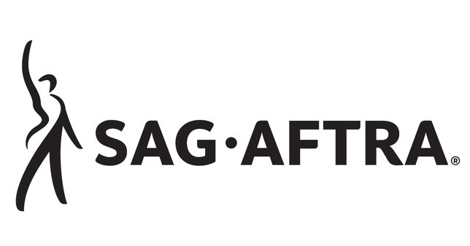
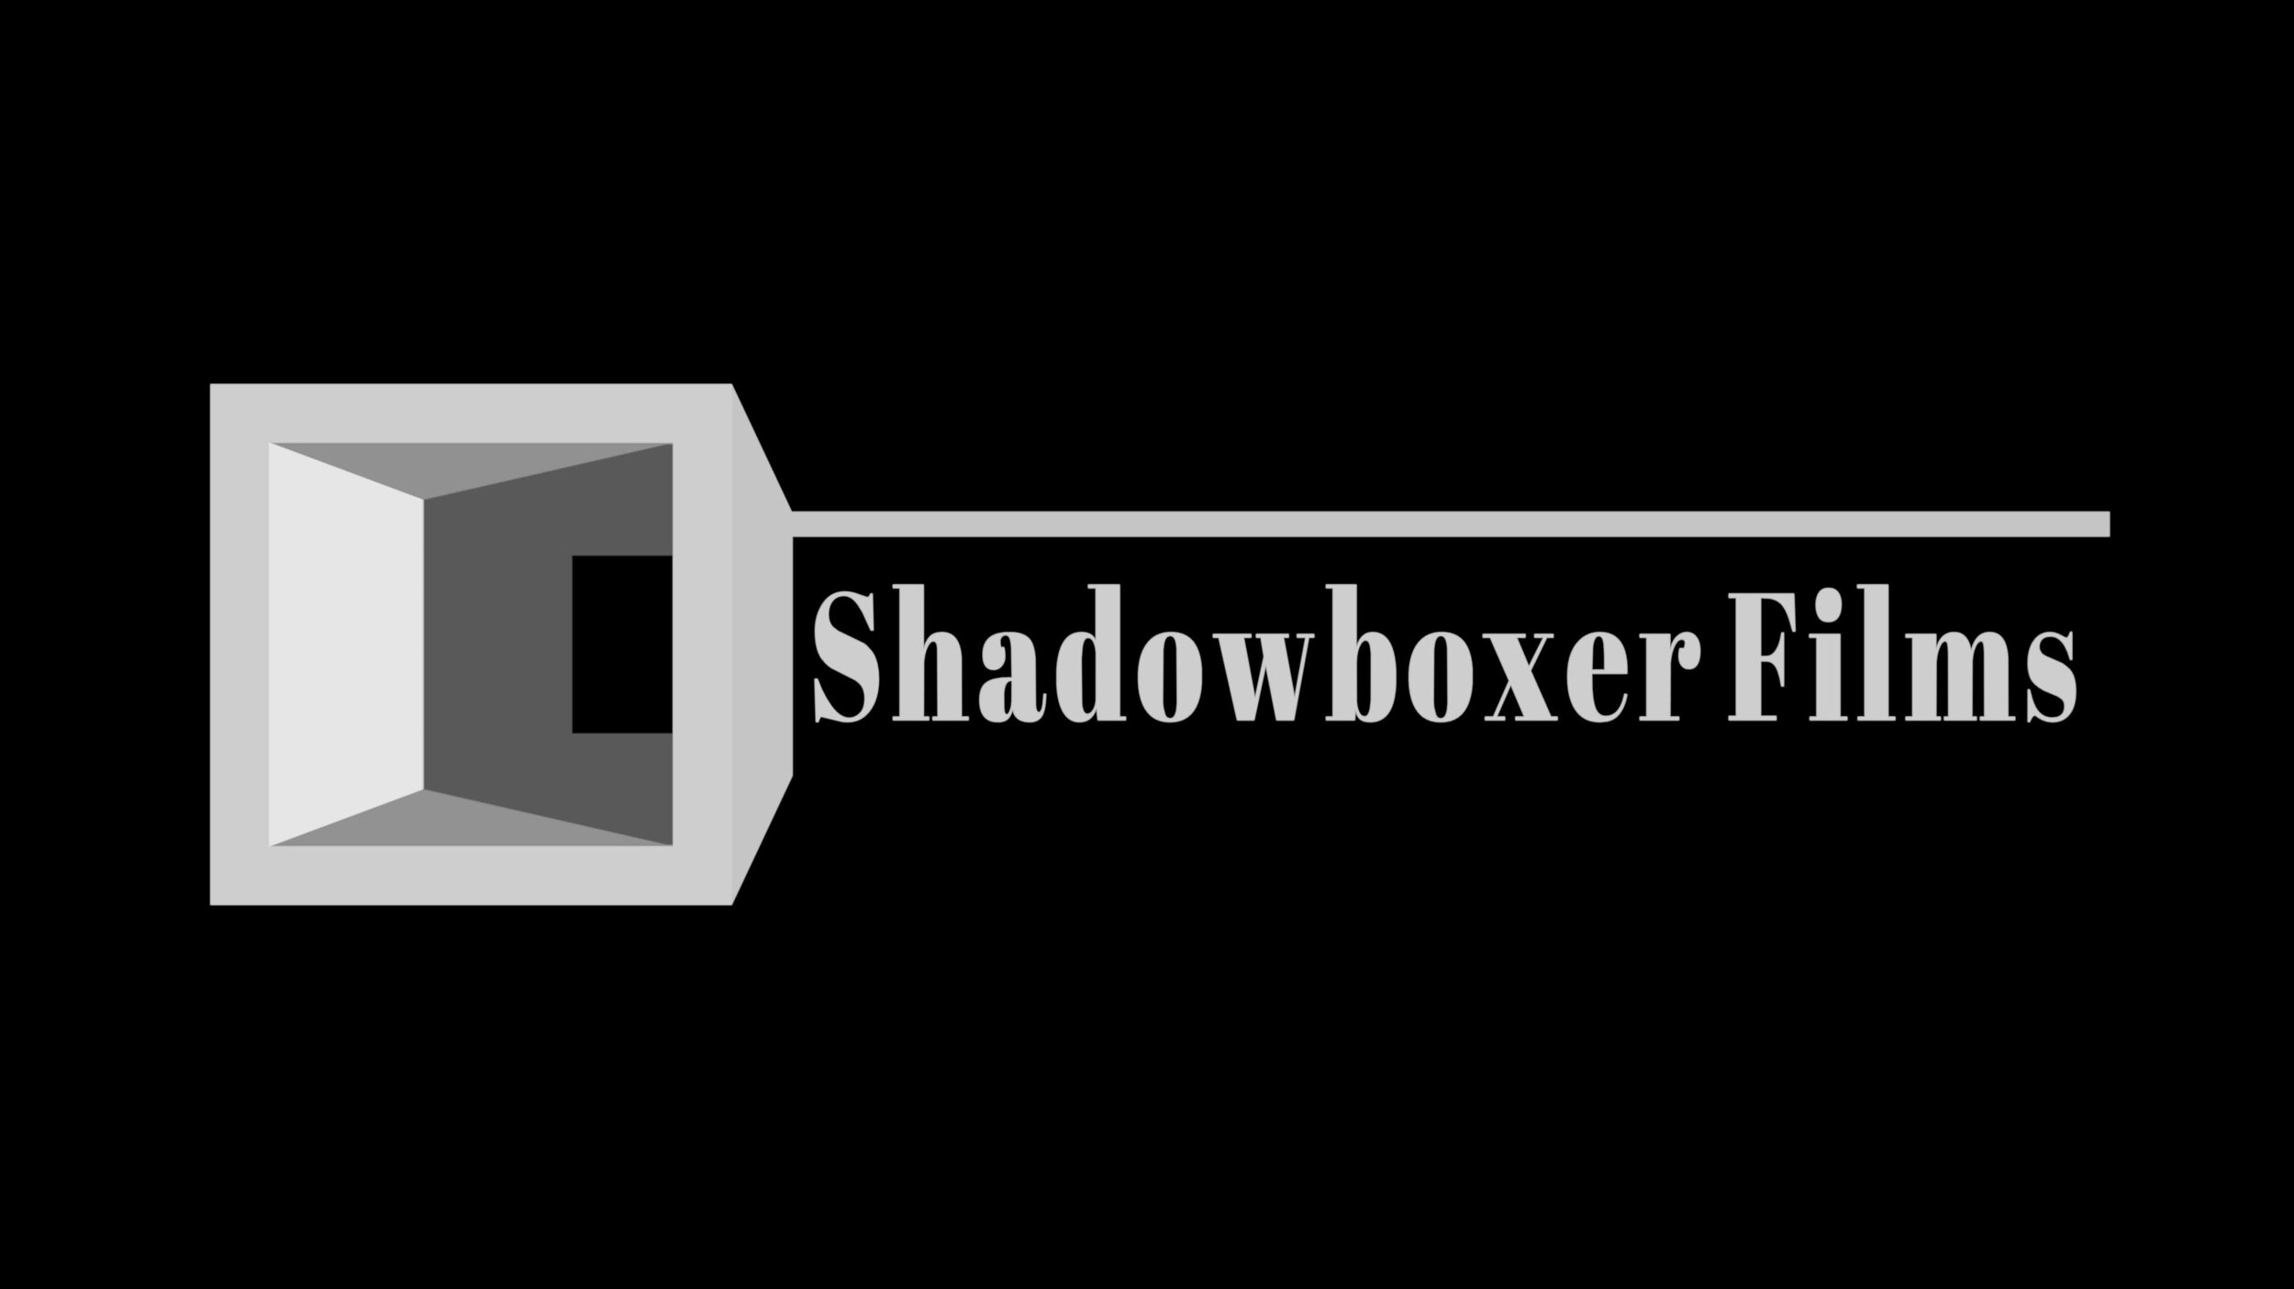

Meta Data
LONG (max 3000 characters) synopsis
Two student archaeologists, Hailey and Rob, once high school sweethearts, are assigned to the same archaeological dig in Great Smoky Mountains National Park and compete for the same grant as they search for ancient Cherokee artifacts and re-discover their love for each other. Along the way, they meet couple Troy and Sky, whose ancestors survived the Trail of Tears, and shed even more light on the trail’s mythology, making Hailey and Rob’s journey that much more meaningful (512)
MEDIUM (max 500) synopsis
Former sweethearts and now student archaeologists, Hailey and Rob, are assigned to the same archaeological dig in Great Smoky Mountains National Park and compete for the same grant as they search for ancient Cherokee artifacts and re-discover their love for each other. Along the way, they meet couple Troy and Sky, whose ancestors survived the Trail of Tears, and shed even more light on the trail’s mythology, making Hailey and Rob’s journey that much more meaningful. (470)
SHORT (max 100 characters) synopsis
Former sweethearts on an archaeological dig meet an indigenous couple who add depth to the journey
(98)
5 KEY WORDS
Archaeologists, Cherokee, Trail of Tears

