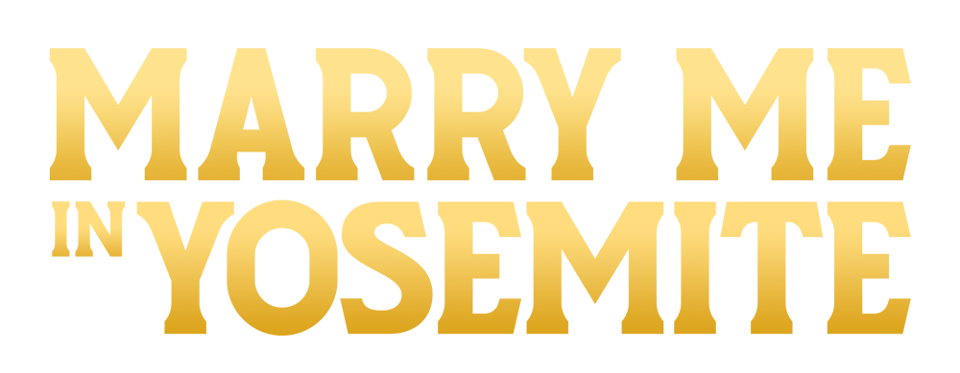

Johnson Production Group

Press Kit

One-Liner

When a top-notch photojournalist gets assigned by her publisher to create a coffee table book of famous Yosemite National Park landscapes, she enlists the help of an intriguing guide who helps her become a true artist, and with whom she falls in love.

Synopsis
Based in Chicago, photographer Zoe Best makes her living creating coffee table books of iconic photos and settings under her own brand: Zoe’s Best. Her first book, Zoe’s Best of Chicago did well, as did her latest, Zoe’s Best of the Midwest. Now her publisher Harris Walker wants to bring Zoe’s brand nationwide, starting with Zoe’s Best of the West: Yosemite. Zoe acknowledges that Yosemite’s master photographer Ansel Adams has set the bar extremely high, and Harris agrees but says, “This book will be your vision of Yosemite.” Insecure about her own artistic ability, Zoe heads west, arriving in Yosemite Valley and is rendered speechless by the Park’s stunning majesty. After checking into the Ahwahnee Hotel, she wanders down to the Merced River, in search of photographs. That’s when she stumbles on a fly fisherman who is startled when Zoe’s cell phone rings, interrupting his fishing solitude.
Later, in search of a guide she meets Park Ranger Sage Morningstar who tells her about Jack Hawkins, a conservationist and former rock climber who sometimes works as a guide, a confirmed bachelor who is usually “off the grid”. With the help of Sage’s grandfather, Kos Wilson, a Native American fishing guide, Zoe finds Jack at his mountain cottage in hopes that he will serve as her guide. Jack was the fisherman she interrupted on the river, and the meeting does not go well. Zoe decides to explore Yosemite on her own. After Sage gives her a map and some guidance, Zoe heads off with her camera in search of beautiful photographs. Her own personal goal is to take photos that others haven’t taken, and on the first day, she hikes up a cliff to capture a stunning landscape image. That’s when her foot gets stuck in a crevasse. Having been tipped off by Sage that Zoe might need some help, Jack finds her on the cliff and using ropes, he rescues her, and then reluctantly agrees to be her guide for the next five days.
As they tackle Yosemite’s iconic locations, Zoe comes to appreciate the conservation issues that are close to Jack’s heart; and Jack comes to appreciate the artistic photos Zoe has been taking as they explore the Park’s scenic wonders. Along the way, a romantic relationship begins to build between Jack (the scientist) and Zoe (the artist). Jack encourages her to look “inside the photos” to see what they reveal. And Zoe helps Jack appreciate the artistry she has achieved. But as stunning as many of her photographs are, Zoe wants to take “that one photo that will show I’m an artist, not just another photographer.” That’s when Jack’s friend Kos tells Zoe about the legend of Half Dome, and how it was formed by an unhappy woman whose tears “stain the face of the mountain” to this day. While it’s challenging to get close enough “to see the tears,” Jack helps guide Zoe to a location where she captures the “perfect photo.”
Her mission complete, she asks Jack to help write the brief essays for her book. He agrees, but when the essays arrive, they are more scientific than Zoe wanted. She drops the essays and that appears to be the end of the Zoe and Jack relationship. Despondent and under the pressure of her deadline, Zoe continues working and is pleasantly surprised when Jack arrives in Chicago. He helps her finish the book and they reveal they are in love with each other. A year later, after the successful book tour, Zoe and Jack are reunited in Yosemite and before setting off on their next adventure; they get married in the picturesque valley with Yosemite Falls and Half Dome in the background.

Producers
Executive Producer
TIMOTHY O. JOHNSON
Co-Producers
JOSEPH WILKA
Producer
ROBERT BALLO
ROBIN CONLY
Line Producer
KATE LUGTU

Key Cast
CHARACTER  Zoe  Jack  Sage Morning Star  Kos  Harris |  | ACTOR  CINDY BUSBY  TYLER HARLOW  LEXSY MCKOWEN  TIM THUNDERHORSE HALPIN  HARRY DANIEL DAVIS

Key Cast Biographies

CINDY BUSBY
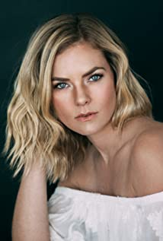
Cindy Busby has been making waves in the television and movie industry for almost 2 decades. Growing up in Montreal, Canada, Busby always dreamed of becoming an actress. To pursue these dreams, Busby attended the Professional Theater Program at Dawson College, rigorous three-year training, allowing Busby to demonstrate her professionalism, hard work, and devotion to her craft.
After graduation, Busby hit the ground running and landed a leading role as Ashley Stanton in over 50 episodes of the hit series HEARTLAND. The series took off quickly becoming one of the most popular Canadian shows ever, as well as syndicated in 81 countries around the world and is a Netflix top pick. Busby continued having success booking roles as the antagonist in the film PICTURE THIS alongside Ashley Tisdale, and booking guest starring roles on the smash hit series THE VAMPIRE DIARIES, SUPERNATURAL, LA COMPLEX, RUSH, PROOF, THE TOMORROW PEOPLE, and THE SECRET CIRCLE. In 2010 and 2011, Busby appeared on the big screen in DIARY OF A WIMPY KID from 20th Century Fox, followed by the Fox 2000 film THE BIG YEAR, playing opposite Hollywood heavy hitter Steve Martin.
Cindy’s work ethic and reputation has earned her over a dozen lead roles in the last few years, making her a household name and fan favorite among the Hallmark Channel community. She starred in UNLEASHING MR DARCY and MARRYING MR DARCY, viewed by over 3 million viewers individually and breaking the network’s social media record. In 2017, Busby traveled to Romania when she booked the lead in ROYAL HEARTS, directed by James Brolin and most recently Busby starred in the audience acclaimed A GODWINK CHRISTMAS: MEANT FOR LOVE alongside Kathie Lee Gifford.
Cindy also showed off her comedic chops as the leading lady in the series DATE MY DAD.
Time and time again, Cindy has won over audiences as a chameleon performer with her quick wit, comedic timing, and dramatic ability. With several movies slated to release in 2021 & 2022, it’s safe to say that Cindy Busby is here to stay.

TYLER HARLOW

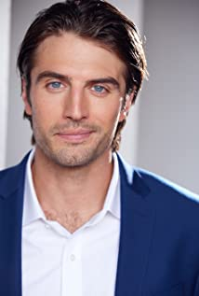
Tyler Ambrose Harlow was born in Westminster West, Vermont. Tyler is a 10th generation Vermonter and comes from a long lineage of outdoorsman. After graduating from the University of Vermont in Burlington, Tyler dove into his passion for the outdoors. Working with Wilderness Ventures, Tyler lead kids ages 12-16 throughout Wyoming, Fiji, Hawaii and across California to help them build foundational outdoor skills and appreciate the beauty of nature through immersed education and lots of stories around a campfire. After riding his bicycle across the country for charity, Tyler knew he wanted to make the west his home. Tyler spent almost 8 years living among the beauty of the Tetons in Jackson Hole, Wyoming.

As Tyler’s modeling career began to blossom, he remained an avid camper, hiker, ice hockey player & fisherman, and contributed to his community by becoming a trained EMT and Firefighter. When a production of “Water by the Spoonful” came to Jackson, Tyler knew it was time to make the leap from his modeling career to pursuing his long time passion for acting. Tyler landed the role of Fountainhead and was hooked. He moved to Los Angeles less than a year later working as a full time model and actor. Tyler has represented several brands such as Old Spice, Engelbert-Strauss, and LG. He has modeled for international photographers and appeared in Taylor Swift’s “The Man” music video. Tyler is excited to finally combine his lifelong love of the outdoors, with his passion for film in his first lead role as Jack in "Yosemite Romance".

LEXSY MCKOWEN
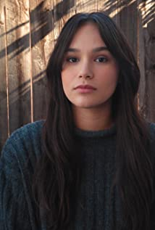
Born and raised in San Diego, actress Lexsy McKowen is an alumni of Mesa College Theatre Company and the Royal Academy of Performing Arts.. As a Native Choctaw and Native Hawaiian, she has met some amazingly talented Indigenous actors, directors and models all who have really inspired her and pushed her to be where she is today. She is passionate and dedicated to her art and is definitely a team player. She is known for her roles in Demon Protocol (2018), The Music of Erich Zann (2019) and Chasing Time (2020).

TIM THUNDERHORSE HALPIN
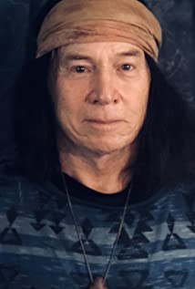
Tim Thunderhorse Halpin is a graduate of SJSU, whose first breaking into films came while working security as a police officer on the set of the Warner Brother's film MAD CITY. Oscar-winning director Costa-Gravos summoned Tim off the set perimeter and put him to work as an FBI rooftop sniper in the movie. He has since worked on many movies, most recently including Attack in LA, Jimmy Attitude: Buffalo, Parasites and Beat The Shift. Trained as a method actor at both at The Lee Strasberg Film and Theatrical Institute and the Stella Adler Theatre in Hollywood, Tim is a Lifetime member the Actors Studio both in New York City and Los Angeles.

HARRY DANIEL DAVIS
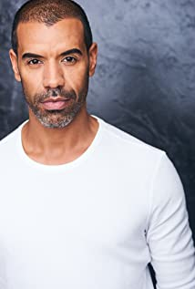
Harry Daniel Davis was born in Philadelphia and grew up in a small town outside of Baltimore Maryland. He’s always been interested in English and philosophy which he studied at the University of Michigan from the years 1994 to 1998; following his college education he moved to Los Angeles where he briefly pursued acting. After getting his SAG card in 2004, Harry studied at Playhouse West North Hollywood; he also studied with John Homa and Jeff Dockweiler at the Lemley theater for scene study, at UCB for improv training and several other commercial and camera workshop. Following that he moved into personal training for 10 years then came back to Los Angeles and got several agents and began acting and modeling. He enjoys outdoor activities including hiking, bikram yoga, mountain biking and climbing and continues to study and enjoy his life in Los Angeles. Harry Daniel Davis is known for his work on Crisis and Teachers.

Production Credits

FULL CAST
ACTORS  CINDY BUSBY  TYLER HARLOW  LEXSY MCKOWEN  TIM THUNDERHORSE HALPIN  HARRY DANIEL DAVIS  BRUCE JOHNSON  ROBIN CONLY  KATRINA BENDZ  RUSS BRECHBUEHL  FRANK MULLER  KATE LUGTU  LANCE OSBORNE  MICHELLE CASTELLANI  JOSEPH BRODY  LISA SIEWERT  LYNO HYCHONG  JANNETTE LY  CARISSA SILL  EMILY FLACK  DIANE AVILA  GIRSTIN BERGQUIST  ZAC COMPTON  MIKE GRIFFITH  FAITH WINKLEY  JAMIE FORST  HALIE STEWART  AVERY HATCH  ROBERT BALLO  WAHID HASHIME  MOE SESAY  CHRIS RUFFIN  CODY WOOLSEY  JENNIFER WOOLSEY  PAIGE COMPTON | ROLE  Zoe  Jack  Sage Morning Star  Kos  Harris  Officiant  Female Climber 1  Female Climber 2  Male Climber 1  Young Couple  Rock Climbers  Line Dancers  Bar Patrons  Country Band  Wilderness Center Patrons

Casting by
ROBIN DE LANO
NICOLE DIONNE

Sound Design by
ANDRES BOULTON

Music by
RUSS HOWARD III

Edited by
JOSH MUSCATINE

Costume Designer
ISABEL MANDUJANO

Production Designer
CAMERON BARRETT

Director of Photography
DAVID DOLNIK

Written and Directed by
BRUCE JOHNSON

Other Crew
PAIGE COMPTON | Unit Production Manager
KATE LUGTU | First Assistant Director
MITCH SABERI | Second Unit First Assistant Director
JUSTIN CROWE | First Assistant Camera
REID COLLINS | Second Assistant Camera
STEVE CURLEY | Still Photographers
PAIGE COMPTON
REID COLLINS
CATHERINE VELOSA | Assistant Costume Designer
CHANEL MOREHEAD | Set Costumer
ASHLEY ALDRIDGE | Makeup Artist
KOURTNEY CAIN | Additional Makeup Artist
CHANTAL MASSUH-FOX | Art Director
ZANDRA CULLEN | Chief Lighting Technician
AYDEN MARCUS | Second Unit Chief Lighting Technician
ASH BHASIN | Key Grip
EDGAR NUNLEY | Second Unit Key Grip
BRIAN HAYNES | Grip & Electric Swing
OLIVIA MARSTON-PHILLIPS | Production Office Coordinator
MIGUEL ANGEL RODRIGUEZ | Production Sound Mixer
FRANK MULLER | Key Production Assistant
CHRIS CARDOZA | Production Assistant
OLIVIA MARSTON-PHILLIPS | Production Office Coordinator
FRANK MULLER | Key Production Assistant
CHRIS CARDOZA | Production Assistant
ROBIN CONLY | Post Supervisor
SOUND AS ART | Post Sound
ANDRES BOULTON | Sound Designer
JONATHAN MORGAN | Foley Editor
NICK JOHNSON | Additional Editor
JACOB KAUFMAN | Assistant Editor
BLUELINE FINISHING | Conform and Delivery
ALEX ROTHAUSER | Color Grading
DOERTE LINDER | Accountant
WRAPBOOK | Payroll
BREAKDOWN SERVICES | Casting Support Services
TJ CRAFTY | Catering
TOSHA WILLIAMS
GLOW CAFÉ
CHRISTINA WELBORN
PAIGE COMPTON | Covid Safety Supervisor
GOAL PRODUCTIONS, INC. | Stock Footage
CLEARANCE UNLIMITED | Script Clearance
SUZY VAUGHAN
BLACKSTONE ENTERTAINMENT | Grip and Lighting Equipment
CHAD MCCLELLAN
ALTERNATIVE CAMERA RENTALS | Camera Equipment
CLIFF HSUI
WALK & TALK PRODUCTION RENTALS | Production Equipment
YOSEMITE NATIONAL PARK  STEVE WAGNER  WILLOW STUDIOS  DANIEL KOTZNER  YOSEMITE NATIONAL PARK  CAT CARLISLE-MCMULLEN  BASS LAKE RECREATION POINT  WADE WHEELER | Special Thanks
CAT CARLISLE-MCMULLEN
WADE WHEELER
RHONDA SALISBURY
YOSEMITE RANGER ROBERT LESTER
YOSEMITE RANGER AARON STEWARTS
YOSEMITE RANGER ERIN GEARTY
THE VILLA SERENA – STEVE WAGNER
WILLOW STUDIOS – DANIEL KOTZNER

Producer Biographies
TIM JOHNSON – Executive Producer
Tim Johnson is among the most active and reliable producers in the business thanks to top rate productions and global distribution appeal.
Johnson is also responsible for producing the international hit series, DR. QUINN, MEDICINE WOMAN for CBS for over 5 seasons. During his 100-episode tenure, he also developed and produced the original docu-drama COLD CASE for CBS network, which was the very first program to integrate television with the Internet.
Johnson has produced over 150 movies, 15 globally released series for every major US network - including ABC, Disney, CBS, NBC, Netfly, FOX and Sony.

JOHNSON PRODUCTION GROUP
The Johnson Production Group contracts globally to produce television content for international networks, studios and distributors. Based in Los Angeles and Vancouver, British Columbia, the company manages production, facilitates development and financing, procures distribution and guarantees quality and timely execution of its programs. While costs have gone up, so has the demand for quality. No longer is good enough, good enough. Johnson Production Group serves that segment when a show needs to be "A" quality, but produced efficiently enough to meet a locked budget. JPG specializes in value, protection of creative elements, and delivery of a quality finished product.

JOSEPH WILKA – Co-Producer
Joseph Wilka is the Head of Production for Johnson Production Group. Los Angeles-based, Joseph had already produced and directed several feature films before serving as the senior marketing executive for Gravitas Ventures. While at Gravitas, Wilka helped pioneer new distribution models for independent films including day-and-date theatrical releases. It was also at Gravitas where Joseph first worked with Johnson Production Group to facilitate the release of their films to the worldwide Video On Demand audience. After serving as the Director of Distribution and Production for Viva Pictures, where he produced English-language versions of foreign animated titles for DirecTV, Wilka officially joined Johnson Production Group. As Head of Production, he oversees the development, production, and distribution of films from multiple production units for release on broadcast and streaming platforms.
ROBERT BALLO – Producer
With over 34 years of industry experience, Robert Ballo has created award-winning productions for clients that include ABC, TBS, PBS, Discovery Channel, and Lifetime, and that have aired on national network television, cable networks, and internationally in Asia and Europe. As Director of Photography and Producer at Shadowland, Ballo has created over a dozen feature films seen on the Lifetime Network and distributed internationally. As Director of Photography, his Shadowland films include MISSING AT 17, THE SURROGATE, STALKED AT 17, TEENAGE BANK HEIST, WALKING THE HALLS, BETRAYED AT 17, HOME INVASION, MATERNAL OBSESSION, ACCUSED AT 17 and SPECTRES. Other feature film credits include RUNNIN' AT MIDNITE, THE AFFAIR and STARVING ARTISTS. Ballo has also traveled the world on many documentary productions.
His television credits for national broadcast and cable networks include COLLEGE SPORTS IN AMERICA, GREAT EUROPEAN BALLOON ADVENTURE, DIRTY HARRY THE ORIGINAL, THE GREAT YEAR, and THE ROSE PARADE - PAGEANT FOR THE AGES. Through his other digital motion picture company, GOAL Productions, Ballo works with Fortune 500 companies, non-profit organizations and government agencies to produce sales and marketing videos as promotional communications. After a twenty-year tenure teaching film and video imaging, Ballo recently retired from his position as an Associate Professor of Practice at USC’s School of Cinematic Arts. A graduate of the USC film production program himself, Ballo is a member of the Academy of Television Arts and Sciences.

ROBIN CONLY –Producer
Robin's career has spanned from Texas to Los Angeles, where she's produced several internationally distributed films that can be seen on networks including HBO, Hallmark, Showtime, Hulu, and Netflix. Recently, she worked with a former Disney Imagineer to produce multiple segments of a 4D IMAX attraction for the Mall of America; helmed research and development for a documentary production company; and produced an award-winning web-series.

KATE LUGTU – Line Producer
Kate Lugtu is a Los Angeles based Director. Her career began in in the Philippines where she produced TV shows, commercials, industrials, and live events. You can find her mentoring up & coming filmmakers in the craft of being a 1AD at the American Film Institute.

Billing Block
Johnson Production Group presents A Hallmark Movie ‘MARRY ME IN YOSEMITE’
starring CINDY BUSBY TYLER HARLOW LEXSY MCKOWEN TIM THUNDERHORSE HALPIN WITH HARRY DANIEL DAVIS Casting by ROBIN DE LANO NICOLE DIONNE Music by RUSS HOWARD III Edited by JOSH MUSCATINE Costume Designer ISABEL MANDUJANO Production Designer CAMERON BARRETT Director of Photography DAVID DOLNIK
Line Producer KATE LUGTU Co-Producer JOSEPH WILKA Executive Producer
TIMOTHY O. JOHNSON Produced by ROBERT BALLO ROBIN CONLY
Written and Directed by BRUCE JOHNSON
© MMXXII Johnson Production Group Inc. All Rights Reserved

Meta Data
LONG (max 3000 characters) synopsis

Based in Chicago, photographer Zoe Best makes her living creating coffee table books of iconic photos and settings under her own brand: Zoe’s Best. Her first book, Zoe’s Best of Chicago did well, as did her latest, Zoe’s Best of the Midwest. Now her publisher Harris Walker wants to bring Zoe’s brand nationwide, starting with Zoe’s Best of the West: Yosemite. Zoe acknowledges that Yosemite’s master photographer Ansel Adams has set the bar extremely high, and Harris agrees but says, “This book will be your vision of Yosemite.” Insecure about her own artistic ability, Zoe heads west, arriving in Yosemite Valley and is rendered speechless by the Park’s stunning majesty.

Later, in search of a guide she meets Park Ranger Sage Morningstar who tells her about Jack Hawkins, a conservationist and former rock climber who sometimes works as a guide, a confirmed bachelor who is usually “off the grid”. With the help of Sage’s grandfather, Kos Wilson, a Native American fishing guide, Zoe finds Jack at his mountain cottage in hopes that he will serve as her guide but the meeting does not go well. Zoe decides to explore Yosemite on her own. After Sage gives her a map and some guidance, Zoe heads off with her camera in search of beautiful photographs. Her own personal goal is to take photos that others haven’t taken, and on the first day, she hikes up a cliff to capture a stunning landscape image. That’s when her foot gets stuck in a crevasse. Having been tipped off by Sage that Zoe might need some help, Jack finds her on the cliff and using ropes, he rescues her, and then reluctantly agrees to be her guide for the next five days.

As they tackle Yosemite’s iconic locations, Zoe comes to appreciate the conservation issues that are close to Jack’s heart; and Jack comes to appreciate the artistic photos Zoe has been taking as they explore the Park’s scenic wonders. Along the way, a romantic relationship begins to build between Jack (the scientist) and Zoe (the artist). (1992)
MEDIUM (max 500) synopsis
When a top-notch Chicago photographer gets assigned by her publisher to photograph the Yosemite landscapes made famous by Ansel Adams, she enlists the help of an intriguing Park Ranger who guides her to the locations and opens her eyes to new priorities. (255)
SHORT (max 100 characters) synopsis
A photographer captures the famous Yosemite landscapes with the help of an intriguing Park Ranger(97)
5 KEY WORDS
Photographer, Ansel Adams, Park Ranger

