Johnson Production Group

Press Kit

One-Liner
A reporter and detective discover great chemistry as they work together to solve the mystery of missing Christmas displays.

Synopsis

When Leslie, a rising star reporter inadvertently botches her investigative piece about a powerful City Council member, her boss decides she needs to pivot to something more seasonal. Her next assignment is to uncover the identity of a local late-night bandit who has been stealing beautiful home Christmas displays across the city. She's not the only one on the case though, Preston, local detective and Christmas enthusiast has made it his mission to identify the culprit and restore the town's holiday spirit. As they spend more time together, they discover more than just clues pointing them to their culprit, they also discover that their undeniable chemistry might actually be true love.

Producers
Executive Producers
TIMOTHY O. JOHNSON
DAVID GOLDEN
ANDREW C. ERIN
OLIVER DE CAIGNY
Co-Executive Producers
JOSEPH WILKA
LISA ALFORD
Producer
TARALEE GERHARD

Key Cast
CHARACTER  Krista Danser  Detective Ryan Bridger  Ally Willard  Stu Sanderson  Joyce Bridger  Gilbert Emerich |  | ACTOR  BRITTANY BRISTOW  OLIVIER RENAUD  ELIZA KING  JUSTIN NURSE  JILLIAN REES-BROWN  RICHARD VELTRI

Key Cast Biographies

BRITTANY BRISTOW
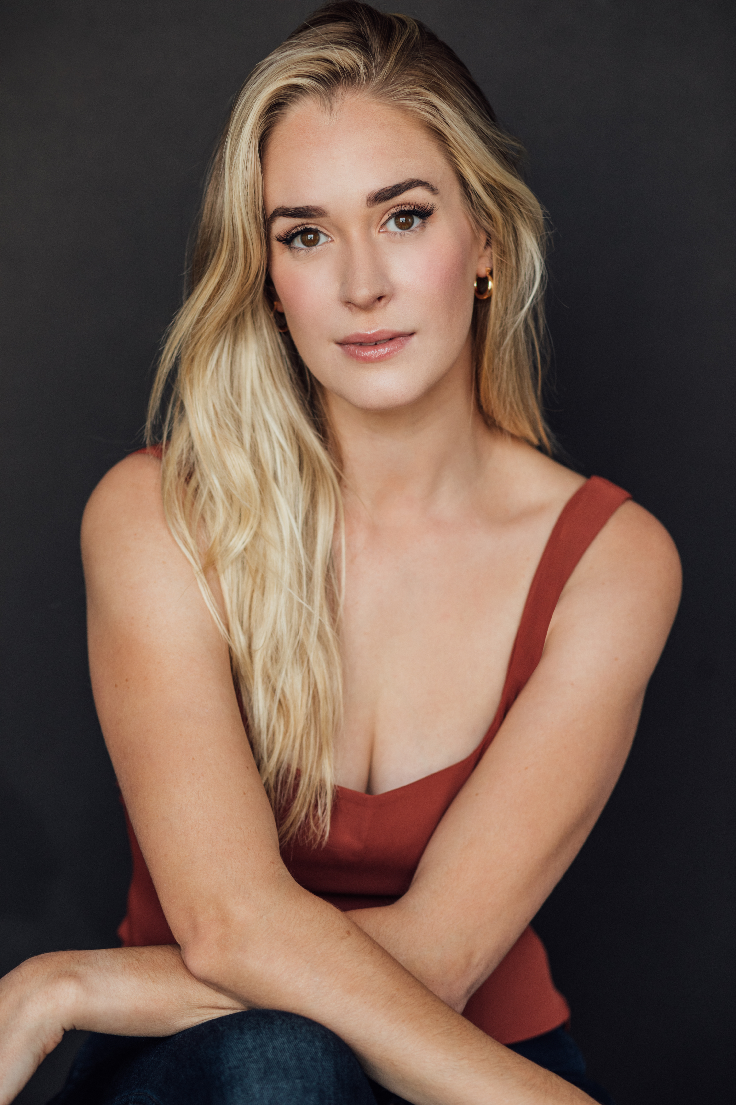
A native of Toronto, Canada, Brittany Bristow began acting at the age of six. At the age 12, after numerous national commercials, a television guest star appearance and four films, she auditioned for Canada’s National Ballet School. Upon acceptance, she put her acting career on hold to attend the prestigious program and complete her studies. In 2008, Bristow graduated from the professional training program and returned to acting, her true passion. Taking time to study through intensive programs at the American Academy of Dramatic Arts in New York and with Larry Moss, she continues to find further passion and joy for the work she does.
Interested in understanding every aspect of the industry, Bristow has worked as a producer, writer and script editor. At the end of 2017, she was elated to accept the CIFF (Canadian International Faith & Family Film Festival) Award for Best Supporting Actress for her portrayal of Johanna in Saul: The Journey to Damascus.
Over the past few years, Bristow has worked on several projects with Hallmark Channel and has had starring roles in Holiday Date, Love in Whitbrooke, Loving Christmas, The Story of Love, A Tail of Love and A Royal Seaside Romance. She starred in the Icelandic mystery film, Shadowtown and appeared in Dancing Through the Shadow, The Marijuana Conspiracy and is currently starring in the TV Series, The Love Club. Bristow also starred in the television series “Rising Suns” and serves as host of “Wildlife Quest,” a show created, written and produced with her family for National Geographic.

OLIVIER RENAUD
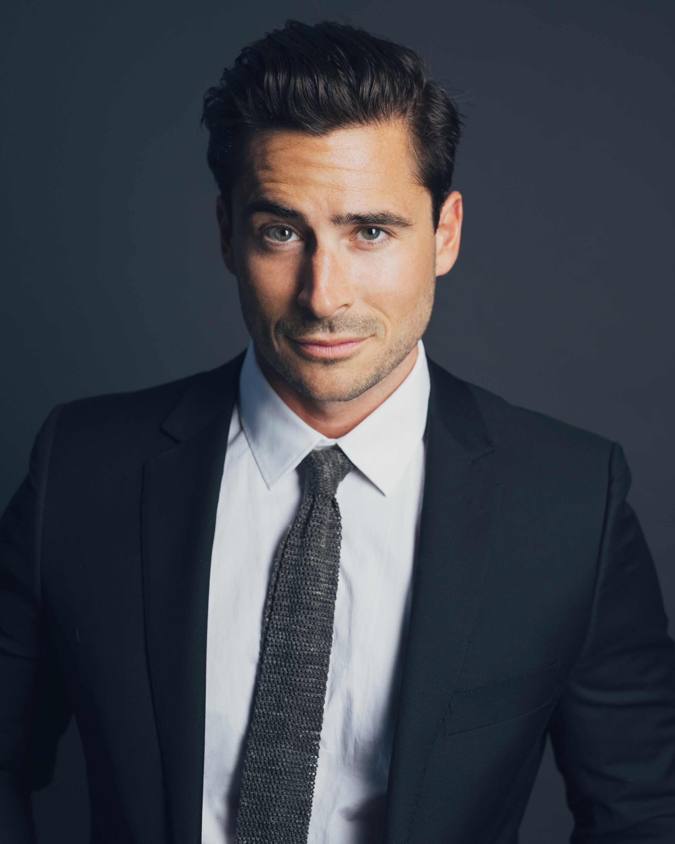
Olivier is a multilingual Third Culture Kid having lived abroad most of his life in countries such as Brazil, Romania, Czech Republic and Thailand. He is a HEC Montreal Business School Trilingual Program graduate. Six months shy of graduating, Olivier ran away with the circus (literally!) touring the US, Scandinavia, Western and Eastern Europe with Cirque du Soleil as a stage performer. He finished his studies while on tour, and became the first HEC Montreal Alum to do so while being an acrobat. Later he moved to New York and Los Angeles to hone the craft of acting with the Hollywood’s leading teachers and coaches. He has studied with Terry Knickerbocker, Larry Moss and Jim Calder, Aitor Basauri and Philippe Gaulier.
His film credits include Midnight at the Magnolia, Christmas in London, A Christmas Village Romance, Loving Christmas, Christmas on 5th Avenue, Planes, Trains and Christmas Trees, Christmas on the Slopes and the recent thriller, Snow Angel. He has also had recurring roles in several TV Series including The Wedding Planners, Paris Paris and Astrid and Lilly Save the World.

ELIZA KING
Eliza King is a Canadian Actor/Performer who resides on the island of Newfoundland, and has portrayed many roles within the local film industry. She is most known for her uncanny portrayal of the popular Disney character "Queen Elsa" from the hit movie Frozen. Previously employed with the Canadian Coast Guard, Eliza is now a freelance actor/model/artist and is the sole owner and operator of NL Bus Tours Inc & Dream Parties NL. Eliza is very passionate about her island home, and plays a role in making local tourism more accessible and enticing to younger generations.

JUSTIN GERARD NURSE
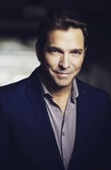
Justin Nurse is a multifaceted performer with a wide range of talents and professionally honed skills. As an actor he is capable of taking on both comedy and drama with remarkable skill. Justin is reliable and versatile. As both a exceptioanl singer and gifted actor Justin can deliver topnotch performances every time. Currently Justin is recording a number of Radio and Tv Commercials in his home province of NFLD and performing with his cover band Stixx N Stones and his big Band 709. His recent TV appearances include Behind Closed Doors, The Death of Winter, Hudson and Rex, Spin and Republic of Doyle.

JILLIAN REES-BROWN
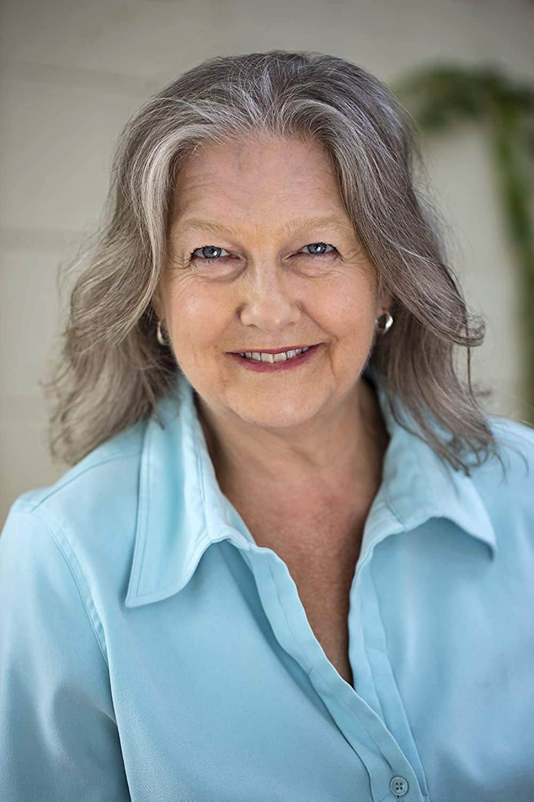
Canadian Jillian Rees-Brown is an established actor, director and writer working in the theatre, television and film industries. Her film work includes roles in Blues Brothers 2000, Beeba Boys, Little Death, Luba and Burned by Love. She has also appeared in several TV Series including Man Seeking Woman, Save Me, Private Eyes, Son of a Critch, Hudson & Rex an You’re My Hero.

RICHARD VELTRI
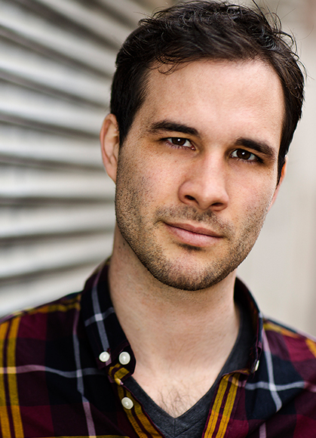
From a very young age, Richard Veltri always wanted to be an actor. As a child he had very diverse interests and people would always ask what he wanted to be and there were just too many things he wanted to be in his life when it hit him that if he was an actor he could live all the lives he wanted to. With every taste he fell more and more in love with performing, from winning multiple public speaking awards to community and high school theatre. However, while growing as a person and a performer he didn't really believe in the possibility of acting as a real career until he was encouraged by his peers to pursue it. On advice from the first agent he met he enrolled at The Armstrong Acting Studio where he studied to adapt his energetic and comedy based performances to a more diverse and filmed driven style. From there he started auditioning and booking everything that he could from short films and student films to low budget features while still studying at Brock University. By the time he was in third year there he was actually in Toronto more days out of the week than not working on different film projects and realized that that's where he really needed to be. The summer before moving out he booked his first ACTRA role in a Microsoft promotion and hasn't looked back since. Continuing to grow and work on diverse and exciting projects and years into this business he still loves every moment of the process from auditioning to seeing the final edit.

Production Credits

Full Cast
Actors  BRITTANY BRISTOW  OLIVIER RENAUD  ELIZA KING  JUSTIN NURSE  JILLIAN REES-BROWN  RICHARD VELTRI  COLIN FURLONG  NICHOLAS CARELLA  CHRIS ADAMS  RUTH LAWRENCE  NICOLE UNDERHAY  TARUN SUBRAMANIAN  SUSAN LUNDRIGAN | Role  Krista Danser  Detective Ryan Bridger  Ally Willard  Stu Sanderson  Joyce Bridger  Gilbert Emerich  Gordon Howard  Rudy Archer  Jameson Ward  Eloise  Captain Mast  Young Man  Reporter

Casting
RON LEACH, c.d.c.

Composer
CATALIN MARIN

Costume Designer
MORGAN LEIGH TODD

Editor
RICHARD MANDIN

Production Designer
DAVE WHITTY

Director of Photography
JUAN MONTALVO

Written by
BRYAR FREED

Directed by
MICHELLE OUELLET

Associate Producers
ALEXANDRA WARING
LOGAN A. WAGNER

Other Crew
SHARA DÉSIRÉE KING | First Assistant Director
RACHEL DEAL | Second Assistant Director
MALLORY HORSMAN | Third Assistant Director
MALLORY HORSMAN | Local & BG Casting Director
ZOË BALSOM | Production Coordinator
VICTORIA PICKETT | Assistant Production Coordinator
LOGAN A. WAGNER | Production Accountant
MATTHEW CARVELL | Post Production Accountant
DAVE WHITTY | Production Designer
STEPHEN BUTLER | Art Director
KOBE DILLON | Set Decorator
DEENA RIGGS | Set Decorator Assistant
SAMANTHA KOSUB | Art Swings
MEGAN GREGORY
NATHALIE JAVAULT | Art Department PA
MICHAEL LAWLOR | Graphic Designer
MICHAEL LAWLOR | Props Master
BRADLEY GOOD | Greenspersons
RYAN HUNT
MORGAN LEIGH TODD | Costume Designer
KELSEY MAYE | Wardrobe Assistant
JUAN MONTALVO | Director of Photography
ADAM PENNEY | B Camera Operator
JOSEF GERHARDS | A Cam - First Assistant Camera
NICK EDGAR DUNNE | A Cam - Second Assistant Camera
SPENCER THOMPSON | B Cam - First Assistant Camera
RILEY HARNETT | B Cam - Second Assistant Camera
MATTHEW FITZGERALD | Camera Trainee
AARON ELLIOTT | Lab Technician
SARAH HOWSE | Camera Utility
SARAH HOWSE | Stills Photographer
CHRISTOPHER LEO | Gaffers
ALEX TUCKER
CHRIS ADAMS | Best Electrics
JIMMY KEAN
ROBERT ALEXANDER PIKE
BECKY DAVIS | Electrics
TIM SULLIVAN
ANDREW HAMOND | Key Grip
CHRIS ADAMS | Best Grips
LIAM SMALL
JORDAN C. FARRELL | Grips
CHRIS HANLEY
JAMES HARRIS | Third Grip
DAVID FLEMMING | Grip / Electric Swing
DIEGO MEDINA | Sound Mixer
STEPHEN POND | Boom Operators
ALEX TOPOLNISKI
DAVE CONNORS | Script Supervisor
DANNY NOSEWORTHY | Location Manager
ALEXANDER PIERCE | Assistant Location Manager
KELSEY MAYE | Location Scout
CAMERON COURTNEY | Location Production Assistants
AVALON
DAN GILL
ALEX TOPOLNISKI
LAUREN SNOW | Key Makeup Artist
MEGAN GREGORY | First Assistant Makeup Artist
ZACK CLARKE | Key Hairstylist
CYNTHIA GREENLAND | Hairstylist
SAMANTHA KOSUB | Makeup & Hair Assistant
PAUL ELLIOTT | Transport Coordinator
JAMES WALL | Transport Captain
JAMES WALL | Driver
JAMES MICHAEL WOOLRIDGE | Off-Set Labour
JULIA MORRISSEY | Set Medic
JENNIFER NORMAN | Food & Beverage Manager
CHERYL RYALL | First Assistant Caterer
MELANIE GIBBONS | Assistant Craft Server
THE NO CONFLICT CLEARANCE COMPANY | Script Clearance
HALL WEBBER LLP | Legal Services
DANNY WEBBER
ABOVE THE LINE MEDIA SERVICES | Business Affairs
BRENDAN MCNEILL
ARTHUR J. GALLAGHER CANADA LTD. | Insurance
ALEXANDRA WARING | Post Production Supervisor
RICHARD FRAZIER | Post Production Coordinators
GEGHANI PANOSIAN
URBAN POST PRODUCTION | Post Production Services
JOSEPH FACCIUOLO | Dialogue & ADR Editor
EHREN PFEIFER | ADR Recordist
KIRSTY SMITH | Sound FX Editor
RYANN MACNEILL | Foley Artist
JESSICA SEVIER | Foley Recordist
BRAD TIGWELL | Re-Recording Mixer
TYLER HALL | Re-Recording Assistant
EVAN GRAVES | VFX Artist
STEVE LAHEY | Colorist
RICHARD VALA | Online & Packaging Editor
PETER TOKARSKY | Project Manager
BRUCE REES | Picture Operations Manager
ROBERTA BRATTI | V.P. of Operations
POND5/AIRSTOCK | Stock Footage
POND5/BLACKBOXGUILD
POND5/CATMANHD
POND5/LOGANIMAGES
POND5/RSTOCK
POND5/THIRDBORNENTERTAINMENT
POND5/VISUALALTITUDE1587
ISTOCK/ADAMHORNER
ISTOCK/LEVKARAVANOV
ISTOCK/SERGEYXPS
ARTGRID/CREATIVELIGHT
Music
CHRISTMAS IN THE CITY
by David Ayers
courtesy of West One Music Limited
SILENT NIGHT, HOLY NIGHT
by Barrie Gledden, Richard Lacy & Simeon Wood
courtesy of Audio Rights Network Limited
UPBEAT CITY 4
by Tim Garland
courtesy of Audio Rights Network Limited
CHRISTMAS MEDLEY
by Patrick T. Hawes
courtesy of West One Music Limited
MERRY CHRISTMAS WISHES
by Patrick T. Hawes
courtesy of West One Music Limited
CHRISTMAS TREE
by Alexander L'Estrange
courtesy of Audio Rights Network Limited
JINGLE BELLS
Public Domain
courtesy of Extreme Production Music USA & Artfully Entertaining Music Library
ON YOUR BIKE
Public Domain
courtesy of Extreme Production Music USA, Artfully Entertaining Music Library,
& Brilliant Musik Switzerland Joachim Tautz
MAYBE THIS YEAR
by Tony Osborne
courtesy of Refuel Music
WE WISH YOU A MERRY CHRISTMAS
Public Domain
courtesy of Extreme Production Music USA & Artfully Entertaining Music Library
EASY CHRISTMAS
by Igor Dvorkin, Elfed Hayes & Ellie Kidd
courtesy of Audio Rights Network Limited

Producer Biographies

TIM JOHNSON – Executive Producer
Tim Johnson is among the most active and reliable producers in the business thanks to top rate productions and global distribution appeal.
Johnson is also responsible for producing the international hit series, DR. QUINN, MEDICINE WOMAN for CBS for over 5 seasons. During his 100-episode tenure, he also developed and produced the original docu-drama COLD CASE for CBS network, which was the very first program to integrate television with the Internet.
Johnson has produced over 150 movies, 15 globally released series for every major US network - including ABC, Disney, CBS, NBC, Netfly, FOX and Sony.

JOHNSON PRODUCTION GROUP
The Johnson Production Group contracts globally to produce television content for international networks, studios and distributors. Based in Los Angeles and Vancouver, British Columbia, the company manages production, facilitates development and financing, procures distribution and guarantees quality and timely execution of its programs. While costs have gone up, so has the demand for quality. No longer is good enough, good enough. Johnson Production Group serves that segment when a show needs to be "A" quality, but produced efficiently enough to meet a locked budget. JPG specializes in value, protection of creative elements, and delivery of a quality finished product.

DAVID GOLDEN – Executive Producer
As a writer and producer, David Golden has worked on more than two dozen television movies. His producing credits include the award winning Love Finds You in Sugarcreek for UPTV, with Tom Everett Scott and Kelly McGillis, as well as the other films made from the series of books, Love Finds You in Charm, and the upcoming Love Finds You in Valentine. Other producing credits include The Music in Me with Debbie Gibson, and Paper Angels, with Josie Bissett. Most recently, he was Executive Producer for the Hallmark movie Family For Christmas, with Lacey Chabert. Golden’s writing credits for Hallmark include Debbie Macomber’s Mrs. Miracle, with Doris Roberts and James Van Der Beek, Oliver’s Ghost, with Martin Mull and Rhea Perlman, and Kiss at Pine Lake, with Barry Watson. Other writing credits include Personal Effects, with Penelope Ann Miller and Casper Van Dien, Nightmare, with Haylie Duff, and Time and Again, with Brooke Burns.
ANDREW C. ERIN – Executive Producer
Andrew Erin is a Canadian Writer/Director making a big splash in the US, and has produced, written and directed numerous commercially successful films. His directorial debut, SAM’S LAKE, was an official selection at the Tribeca Film Festival and did an excellent theatrical run in select theaters around the country; distributed by Lionsgate Films. Andrew also wrote the script for the film. Andrew’s directorial credits include, SIMPLE THINGS, produced for Screen Media Ventures and Universal Studios. Besides winning The Bob Clark Award for Best Director at the California Independent Film Festival, the film was commercially received. Andrew has worked continuously as a writer/director, building a strong library of films in the Thriller/Horror genres with: Embrace of The Vampire, The Clinic, Final Sale, Confined and Toxic Skies.
OLIVER DE CAIGNY – Executive Producer
Oliver De Caigny is a Canadian producer originally from Belgium, his background in financing, production, and post production makes him a well-rounded producer for any type of production. His experience in financing and production agreements (film and TV series and movies-of-the week), distribution agreements (both domestic and foreign) as well as international co-productions, Canadian tax credit, Telefilm Canada and Canada Media Fund incentives provides him with a well-rounded background in development, production and distribution for motion pictures, television series and productions.

JOSEPH WILKA – Co-Executive Producer
Joseph Wilka is the Head of Production for Johnson Production Group. Los Angeles-based, Joseph had already produced and directed several feature films before serving as the senior marketing executive for Gravitas Ventures. While at Gravitas, Wilka helped pioneer new distribution models for independent films including day-and-date theatrical releases. It was also at Gravitas where Joseph first worked with Johnson Production Group to facilitate the release of their films to the worldwide Video On Demand audience. After serving as the Director of Distribution and Production for Viva Pictures, where he produced English-language versions of foreign animated titles for DirecTV, Wilka officially joined Johnson Production Group. As Head of Production, he oversees the development, production, and distribution of films from multiple production units for release on broadcast and streaming platforms.

LISA ALFORD – Co-Executive Producer
Lisa Alford is a development executive at Johnson Production Group. A Massachusetts native, Lisa has lived and worked in Los Angeles for over a decade, always in support of excellent storytelling. Prior to joining Johnson Production Group, Lisa worked as an executive at TriStar television where she specialized in identifying IP that supported TriStar’s mission to feature diverse, authentic characters and champion underrepresented voices. Lisa came up at Sony Pictures Television where she worked as a production coordinator in the Television Movies and Miniseries department and in the writers room on the WGN hit series OUTSIDERS. In her current role, Lisa shepherds projects from the concept phase through story development, production, and post.

TARALEE GERHARD – Producer
Taralee Gerhard committed to following her dream of making movies almost 20 years ago when the film industry was in its infancy in Ottawa. She spent several years with Fireside Pictures in Ottawa and truly cares about the family culture that Fireside has fostered amongst the crew, supporting each other's big sky dreams, making movies to be proud of. During the Covid-19 pandemic, the spirit of taking risks and following her heart lead Taralee to Newfoundland and she remains truly grateful to be able to continue working with Fireside Pictures as an in house Producer opening a new territory, expanding the Fireside Family and helping to foster the independent film industry in Newfoundland.

Billing Block
JOHNSON PRODUCTION GROUP PRESENTS MERRY MYSTERY CHRISTMAS starring BRITTANY BRISTOW OLIVIER RENAUD ELIZA KING JUSTIN NURSE JILLIAN REES-BROWN RICHARD VELTRI Casting RON LEACH, c.d.c. Composer CATALIN MARIN Costume Designer MORGAN LEIGH TODD Editor RICHARD MANDIN Production Designer DAVE WHITTY Director of Photography JUAN MONTALVO Co-Executive Producers JOSEPH WILKA LISA ALFORD Executive Producers TIMOTHY O. JOHNSON OLIVER DE CAIGNY ANDREW C. ERIN DAVID GOLDEN Producer TARALEE GERHARD
Written by BRYAR FREED Directed by MICHELLE OUELLET

The Canadian Film or Video Production Tax Credit
© MMXXIII HSC Productions Inc. & HSC Ontario Films Inc. All Rights Reserved

Meta Data
LONG (max 3000 characters) synopsis
When Leslie, a rising star reporter inadvertently botches her investigative piece about a powerful City Council member, her boss decides she needs to pivot to something more seasonal. Her next assignment is to uncover the identity of a local late-night bandit who has been stealing beautiful home Christmas displays across the city. She's not the only one on the case though, Preston, local detective and Christmas enthusiast has made it his mission to identify the culprit and restore the town's holiday spirit. As they spend more time together, they discover more than just clues pointing them to their culprit, they also discover that their undeniable chemistry might actually be true love.
(693)
MEDIUM (max 500) synopsis
When a reporter botches an assignment, her next job is to uncover the identity of a local bandit who has been stealing Christmas displays across the city. She's not the only one on the case though. A detective and Christmas enthusiast has made it his mission to identify the culprit and restore the town's holiday spirit. As they spend more time together, they discover more than just clues, they also discover that their undeniable chemistry might actually be true love.
(471)
SHORT (max 100 characters) synopsis
A reporter and detective work together to solve the mystery of missing Christmas displays.
(90)
5 KEY WORDS
Missing displays, police detective, reporter

