Johnson Production Group

Press Kit

One-Liner
A single dad who suddenly loses his sight bonds with the trainer of his new seeing-eye dog.

Synopsis

Trevor, a college literature professor, has recently and suddenly lost his sight. A single dad to his daughter Annie, Trevor is badly shaken and barely hanging on. To make matters worse, a new construction project at his college poses everyday dangers for him, and the head of his department worries for his safety and suggests that Trevor take some time off until the project is complete. Concerned for her dad, Annie decides that a seeing-eye dog would help him enormously, and she convinces him to visit Best Friend Dog Guides, a facility that trains dogs for the vision impaired. There they meet Peyton who introduces them to the perfect guide dog, Max. As Peyton trains Trevor with Max, the two bond, and Peyton helps Trevor regain his old self-confidence. But when Trevor is finally forced to take leave from his department, he fears bringing Max into his life was all for naught. But His students rally around him, insisting that he's the best professor in the department, and their heartfelt display renews his faith in his abilities -- and paves the way for romance with Peyton, just in time for Christmas.

Producers
Executive Producers
TIMOTHY O. JOHNSON
OLIVER DE CAIGNY
ANDREW C. ERIN
Co-Executive Producers
JOSEPH WILKA
LISA ALFORD
Producer
TARALEE GERHARD

Key Cast
CHARACTER  Peyton Lewis  Trevor Donovan  Annie Donovan  Chad |  | ACTOR  AMBER MARSHALL  BEN MEHL  AVA WEISS  JUSTIN GERALD NURSE

Key Cast Biographies

AMBER MARSHALL
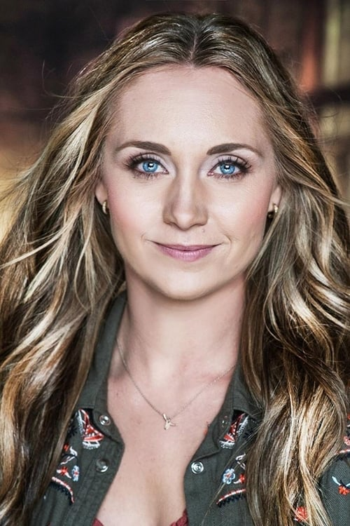
Amber Marshall is a rare find in the busy world of today. A strong role model for many, she captivates audiences across the globe in her leading role as Amy Fleming on Heartland. This popular television drama set on an Alberta ranch has been in the homes of millions for well over a decade. Not only does Marshall play a horse lover on television; she lives the cowgirl lifestyle. Hardworking, independent and talented, Amber has been pursuing her life goals since she was old enough to voice them.
Born and raised in London, Ontario, Amber grew up with a blend of big-city smarts and down-home groundedness that has enabled her to accomplish success in each of her many passions. She was introduced to horses shortly after saying goodbye to her toddler years and it was a match made in heaven. Amber also engaged with her other love, acting, at an equally young age. Joining The Original Kids Theatre Company she performed in many productions and attended Lester B. Pearson School for the Arts for her elementary teachings. Developing rapidly as an artistic presence, Amber obtained an agent in Toronto by the age of 11, and within the year was cast as a young Lorna Luft in her first major production, a mini-series called Me and My Shadows: The Life of Judy Garland. Soon after, she was cast as Ally on the YTV Network’s Super Rupert. This was her first opportunity to play a principal character, and she quickly demonstrated that her combination of talent, charisma and passion for her work enabled her to carry a grand production on her young shoulders.
When she was 14, Amber was cast in the title role in The Elizabeth Smart Story, a movie-of-the-week based on the true story of the 2002 abduction of a Utah teenager. Amber’s unique combination of strength and vulnerability shone through this role. People took notice and rewarded her performance with a nomination for the Los Angeles-based Young Artist Award for Best Actress in a Movie. At this point, Amber could clearly see the career path that lay before her and she pursued it with all her being. She made the most of her opportunities to show her range as an actor, appearing is such varied productions as Resident Evil, Doc, Power Strikers and Dark Oracle. It was at this time that the hand of fate brought together her two great passions, horses and acting in her role on Heartland.
For over 15 years Amber has starred as a cowgirl who uses her intuition to help heal troubled horses. Marshall plays a role who rings true with the show’s millions of fans around the world. At 20 years old Amber left behind the rolling hills of southwestern Ontario to make her home in the same beautiful terrain of southern Alberta that is depicted on Heartland. Horses are as big a part of her home life as they are of her workday. Amber and her husband, Shawn currently have several horse companions on their ranch as well as cattle, dogs, cats and a variety of other critters.
Never one to become involved in organized sports, Amber has nevertheless always led a very active life. Whether it is daily farm chores around her ranch or riding her beloved horses, Amber is a living example of the old adage that an active life is a healthy life and a healthy life is a happy life.

BEN MEHL
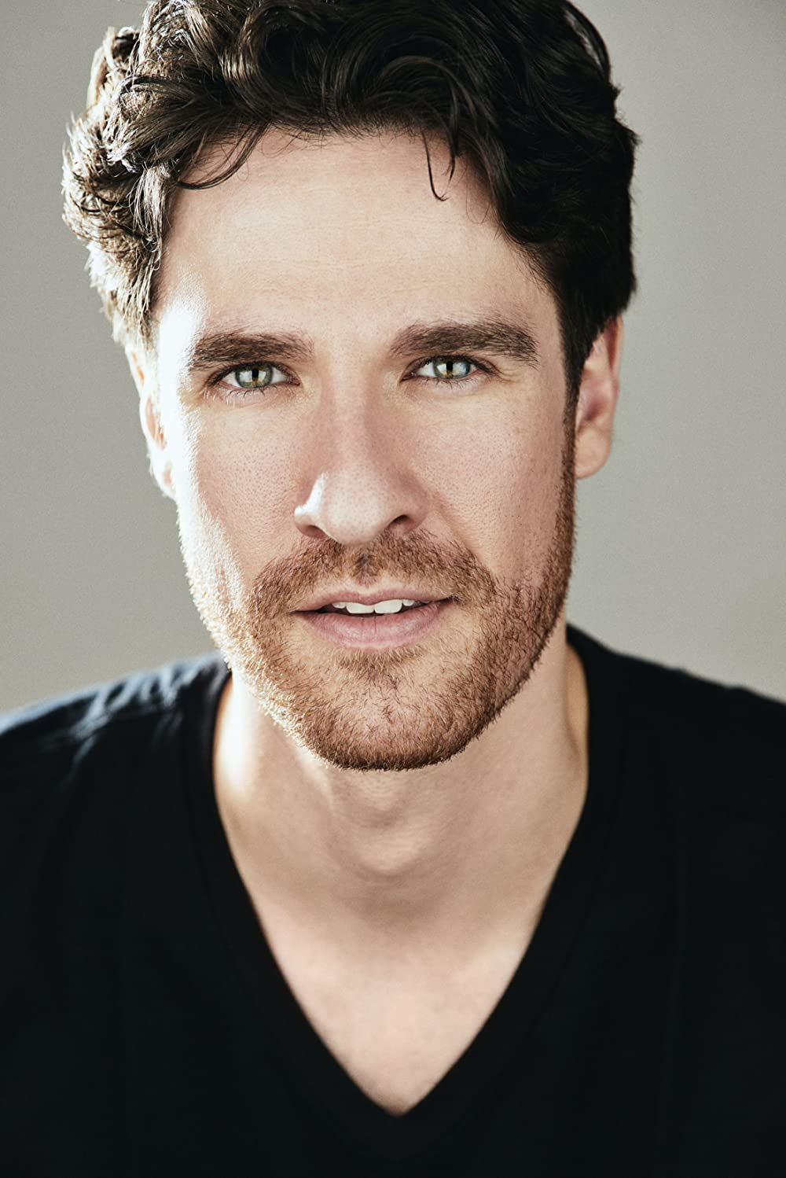
Born and raised in Toronto, the legally blind Ben Mehl graduated from the University of Toronto where he double majored in Astrophysics and Drama. He was accepted to both NYU’s Graduate Acting Program and Julliard but received his MFA from NYU. Mehl has performed largely in theater but has also appeared on television such as “The Good Wife.” In addition to acting, Mehl also teaches acting, voice and movement for actors in NYC. He has taught Movement and Shakespeare’s Clowns at the NYU Graduate Acting Program in addition to Voice and Movement, Physical Characterization and Combat at the New York Film Academy.
Ben starred as ‘Dante’ alongside Penn Badgley in the third season of Netflix’s hit series “You.” where he plays Dante, a veteran whose eyesight was damaged. Dante is a dedicated family man with a husband and two stepchildren, who longs to expand his family and delights in helping his friends with their children.

AVA WEISS
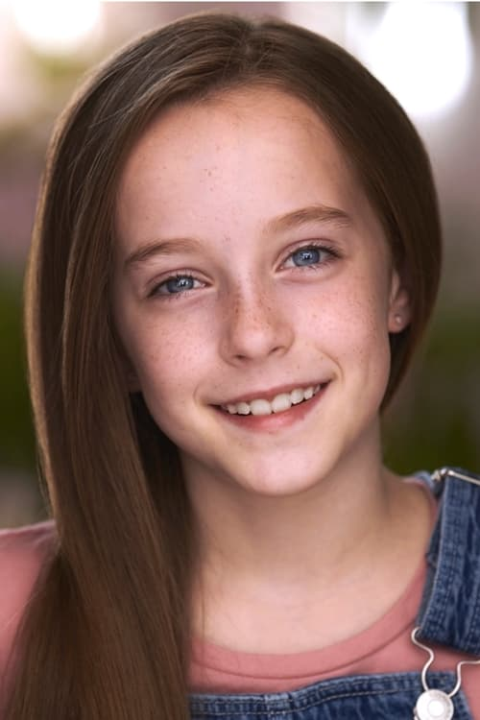
Young Ava Weiss is a Canadian actress, based in Northern Ontario. She received her first role on Honey Bee exactly one year to the day that she started her series regular role on When Hope Calls. Ava is also known for roles in the films A Christmas Letter, Moonfall, Lemonade Stand Romance, The Breach, The Most Colorful Time of the Year and Twas the Night Before Christmas.

JUSTIN GERARD NURSE
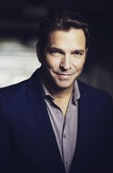
Justin Nurse is a multifaceted performer with a wide range of talents and professionally honed skills. As an actor he is capable of taking on both comedy and drama with remarkable skill. Justin is reliable and versatile. As both a exceptioanl singer and gifted actor Justin can deliver topnotch performances every time. Currently Justin is recording a number of Radio and Tv Commercials in his home province of NFLD and performing with his cover band Stixx N Stones and his big Band 709. His recent TV appearances include Behind Closed Doors, The Death of Winter, Hudson and Rex, Spin and Republic of Doyle.

Production Credits

Full Cast
Actors  AMBER MARSHALL  BEN MEHL  AVA WEISS  JUSTIN GERALD NURSE  BRIDGET WAREHAM  JONATHAN VALVANO  LESLIE TAKEDA  VOX SMITH  RORY LAMBERT  PETER SOUCY  ERIN MACKEY  PATRINA BROMLEY  AIDAN KALECHSTEIN  HEATHER REARDIGAN  DAVID FRASER  EVAN STERN | Role  Peyton Lewis  Trevor Donovan  Annie Donovan  Chad  Katie  Nathan  Dr. Shaw  Sean  Foreman  Dr. Lewis  Chef  Principal Harris  Older Boy  Receptionist  Audiobook Narrator  Phone App Voice

Casting
RON LEACH, c.d.c.

Composer
RUSS HOWARD III

Costume Designer
MORGAN TODD

Editor
DAVID J. CAIN

Production Designer
STEPHEN BUTLER

Director of Photography
JUAN MONTALVO

Associate Producer
ALEXANDRA WARING

Written by
KEITH HEMSTREET

Directed by
MAXWELL MCGUIRE

Other Crew
BORYS SHAPOVALOV | First Assistant Director
RACHEL DEAL | Second Assistant Directors
JEFF LEWIS
MALLORY HORSMAN | Third Assistant Director
DION EMBERLEY | Fourth Assistant Director
BARRY REID | Animal Wrangler
MALLORY HORSMAN | Associate Casting Director
ZOË BALSOM | Production Coordinator
VICTORIA PICKETT | Assistant Production Coordinator
LOU MARTIN | Office Manager
DEBORAH HORSMAN | Production Secretary
LOGAN WAGNER | Production Accountant
MATTHEW CARVELL | Post Production Accountant
JAMES BERESFORD | Petty Cash Officer
STEPHEN BUTLER | Production Designer
DEENA RIGGS | Art Director
KOBE DILLON | Set Decorator
NATHALIE JAVAULT | Art Department PA
MITCHELL MCGEE-HERRITT
KIRSTI MIKODA
GERRY RIGGS
TREVOR WHITE
MICHAEL LAWLOR | Graphic Designer
MICHAEL LAWLOR | Props Master
MORGAN LEIGH TODD | Costume Designer
KELSEY MAYE | Wardrobe Assistant
JUAN MONTALVO | Director of Photography
ADAM PENNEY | B Camera Operator
JOSEF GERHARDS | A Cam - First Assistant Camera
NICK EDGAR DUNNE | A Cam - Second Assistant Camera
SPENCER THOMPSON | B Cam - First Assistant Camera
RILEY HARNETT | B Cam - Second Assistant Camera
MATTHEW FITZGERALD | Camera Trainee
AARON ELLIOTT | Lab Technician
SARAH HOWSE | Stills Photographer
CHRISTOPHER LEO | Gaffer
GRANT COURTNEY | Best Electrics
ROBERT ALEXANDER PIKE
TIM SULLIVAN | Grip / Electric Swing
ANDREW HAMOND | Key Grip
LIAM SMALL | Best Grip
COLIN MERDSOY | Grips
ALEX TUCKER
NICK MASTERS CONTENT INC. | Third Grips
DAVID FLEMMING
CHRIS HANLEY
JIMMY KEAN
DIEGO MEDINA | Sound Mixer
NEIL MCINTYRE | Boom Operators
STEPHEN POND
OTTO QUINTON
DAVE CONNORS | Script Supervisor
DANNY NOSEWORTHY | Location Manager
ALEXANDER PIERCE | Assistant Location Manager
CAMERON COURTNEY | Location Production Assistants
AVALON
DAN GILL
CHRISTIAN HEFFERNAN
BRANDON LAWLOR
ALEXANDER PIERCE
ALEX TOPOLNISKI
LAUREN SNOW | Key Makeup Artist
MEGAN GREGORY | First Assistant Makeup Artist
ZACK CLARKE | Key Hairstylist
SAMANTHA KOSUB | Makeup & Hair Assistant
PAUL ELLIOTT | Transport Coordinator
JAMES WALL | Transport Captain
DONNA CORCORAN | Driver
RHODA PENDER
JAMES MICHAEL WOOLRIDGE | Off-Set Labour
JENNIFER NORMAN | Food & Beverage Manager
JOHN MACKINNON | First Assistant Caterer
MELANIE GIBBONS | Assistant Craft Service
DANICA SANTUCCIONE
THE NO CONFLICT CLEARANCE COMPANY | Script Clearance
HALL WEBBER LLP | Legal Services
DANNY WEBBER
ABOVE THE LINE MEDIA SERVICES | Business Affairs
BRENDAN MCNEILL
ARTHUR J. GALLAGHER CANADA LTD. | Insurance
ALEXANDRA WARING | Post Production Supervisor
RICHARD FRAZIER | Post Production Coordinators
URBAN POST PRODUCTION | Post Production Services
JOSEPH FACCIUOLO | Dialogue & ADR Editor
EHREN PFEIFER | ADR Recordist
KIRSTY SMITH | Sound FX Editors
LUKA TOMA
JESSICA SEVIER | Foley Artists
DAWN LEWIS
JESSICA SEVIER | Foley Recordists
MIKE POISSON
FIL HOSEK | Re-Recording Mixer
KENT MCCORMICK | Colorist
KALI RAIGH | Online/Packaging Editors
RICHARD DORMAN
PETER TOKARSKY | Project Manager
BRUCE REES | Picture Operations Manager
ROBERTA BRATTI | V.P. of Operations
PETER BENISON | Stock Footage
ARTGRID/21AERIALS
ARTGRID/ARTEMMEDVEDIEV
ARTGRID/OLEKSANDROSTAPCHUK
ARTGRID/OMRIOHANA
ARTGRID/ROSSHILLIER
ARTGRID/THESTOCKSTUDIO
POND5/BLACKBOXGUILD
POND5/BRENDANRILEY
POND5/RSTOCK
Cold This Christmas
courtesy of Extreme Production Music USA and Artfully Entertaining Music Library
Christmas Cocktail Hour
by Russell L. Howard III and Massimo Sammi
courtesy of Sweaty Avocado Music and Astral Avocados Music
Jive With Me
by Russell L. Howard III
courtesy of Sweaty Avocado Music
Santa's Got Something For You
by Russell L. Howard III and Todd Herfindal
courtesy of Sweaty Avocado Music and Valley Vista Music LLC
Not Going Anywhere
courtesy of Extreme Production Music USA and Artfully Entertaining Music Library
courtesy of Sweaty Avocado Music and Valley Vista Music LLC

Producer Biographies

TIM JOHNSON – Executive Producer
Tim Johnson is among the most active and reliable producers in the business thanks to top rate productions and global distribution appeal.
Johnson is also responsible for producing the international hit series, DR. QUINN, MEDICINE WOMAN for CBS for over 5 seasons. During his 100-episode tenure, he also developed and produced the original docu-drama COLD CASE for CBS network, which was the very first program to integrate television with the Internet.
Johnson has produced over 150 movies, 15 globally released series for every major US network - including ABC, Disney, CBS, NBC, Netfly, FOX and Sony.

JOHNSON PRODUCTION GROUP
The Johnson Production Group contracts globally to produce television content for international networks, studios and distributors. Based in Los Angeles and Vancouver, British Columbia, the company manages production, facilitates development and financing, procures distribution and guarantees quality and timely execution of its programs. While costs have gone up, so has the demand for quality. No longer is good enough, good enough. Johnson Production Group serves that segment when a show needs to be "A" quality, but produced efficiently enough to meet a locked budget. JPG specializes in value, protection of creative elements, and delivery of a quality finished product.
ANDREW C. ERIN – Executive Producer
Andrew Erin is a Canadian Writer/Director making a big splash in the US, and has produced, written and directed numerous commercially successful films. His directorial debut, SAM’S LAKE, was an official selection at the Tribeca Film Festival and did an excellent theatrical run in select theaters around the country; distributed by Lionsgate Films. Andrew also wrote the script for the film. Andrew’s directorial credits include, SIMPLE THINGS, produced for Screen Media Ventures and Universal Studios. Besides winning The Bob Clark Award for Best Director at the California Independent Film Festival, the film was commercially received. Andrew has worked continuously as a writer/director, building a strong library of films in the Thriller/Horror genres with: Embrace of The Vampire, The Clinic, Final Sale, Confined and Toxic Skies.
OLIVER DE CAIGNY – Executive Producer
Oliver De Caigny is a Canadian producer originally from Belgium, his background in financing, production, and post production makes him a well-rounded producer for any type of production. His experience in financing and production agreements (film and TV series and movies-of-the week), distribution agreements (both domestic and foreign) as well as international co-productions, Canadian tax credit, Telefilm Canada and Canada Media Fund incentives provides him with a well-rounded background in development, production and distribution for motion pictures, television series and productions.

JOSEPH WILKA – Co-Executive Producer
Joseph Wilka is the Head of Production for Johnson Production Group. Los Angeles-based, Joseph had already produced and directed several feature films before serving as the senior marketing executive for Gravitas Ventures. While at Gravitas, Wilka helped pioneer new distribution models for independent films including day-and-date theatrical releases. It was also at Gravitas where Joseph first worked with Johnson Production Group to facilitate the release of their films to the worldwide Video On Demand audience. After serving as the Director of Distribution and Production for Viva Pictures, where he produced English-language versions of foreign animated titles for DirecTV, Wilka officially joined Johnson Production Group. As Head of Production, he oversees the development, production, and distribution of films from multiple production units for release on broadcast and streaming platforms.

LISA ALFORD – Co-Executive Producer
Lisa Alford is a development executive at Johnson Production Group. A Massachusetts native, Lisa has lived and worked in Los Angeles for over a decade, always in support of excellent storytelling. Prior to joining Johnson Production Group, Lisa worked as an executive at TriStar television where she specialized in identifying IP that supported TriStar’s mission to feature diverse, authentic characters and champion underrepresented voices. Lisa came up at Sony Pictures Television where she worked as a production coordinator in the Television Movies and Miniseries department and in the writers room on the WGN hit series OUTSIDERS. In her current role, Lisa shepherds projects from the concept phase through story development,

TARALEE GERHARD – Producer
Taralee Gerhard committed to following her dream of making movies almost 20 years ago when the film industry was in its infancy in Ottawa. She spent several years with Fireside Pictures in Ottawa and truly cares about the family culture that Fireside has fostered amongst the crew, supporting each other's big sky dreams, making movies to be proud of. During the Covid-19 pandemic, the spirit of taking risks and following her heart lead Taralee to Newfoundland and she remains truly grateful to be able to continue working with Fireside Pictures as an in house Producer opening a new territory, expanding the Fireside Family and helping to foster the independent film industry in Newfoundland.

Billing Block
JOHNSON PRODUCTION GROUP PRESENTS MY CHRISTMAS GUIDE
starring AMBER MARSHALL BEN MEHL AVA WEISS JUSTIN GERALD NURSE Casting RON LEACH, c.d.c. Composer RUSS HOWARD III Costume Designer MORGAN TODD Editor DAVID J. CAIN Production Designer STEPHEN BUTLER Director of Photography JUAN MONTALVO Co-Executive Producers JOSEPH WILKA LISA ALFORD Executive Producers OLIVER DE CAIGNY ANDREW C. ERIN TIMOTHY O. JOHNSON Producer TARALEE GERHARD Written by KEITH HEMSTREET Directed by MAXWELL MCGUIRE
The Canadian Film or Video Production Tax Credit
© MMXXIII Fireside (BCL) ON Films Inc & Fireside (BCL) NL Films Inc. All Rights Reserved

THIS HAS BEEN A HALLMARK MOVIES & MYSTERIES PRESENTATION

Meta Data
LONG (max 3000 characters) synopsis
Trevor, a college literature professor, has recently and suddenly lost his sight. A single dad to his daughter Annie, Trevor is badly shaken and barely hanging on. To make matters worse, a new construction project at his college poses everyday dangers for him, and the head of his department worries for his safety and suggests that Trevor take some time off until the project is complete. Concerned for her dad, Annie decides that a seeing-eye dog would help him enormously, and she convinces him to visit Best Friend Dog Guides, a facility that trains dogs for the vision impaired. There they meet Peyton who introduces them to the perfect guide dog, Max. As Peyton trains Trevor with Max, the two bond, and Peyton helps Trevor regain his old self-confidence. But when Trevor is finally forced to take leave from his department, he fears bringing Max into his life was all for naught. But His students rally around him, insisting that he's the best professor in the department, and their heartfelt display renews his faith in his abilities -- and paves the way for romance with Peyton, just in time for Christmas. (1116)
MEDIUM (max 500) synopsis
When Trevor, a college professor and single dad, loses his sight, his daughter Annie convinces him to get a seeing-eye dog from Peyton at Best Friend Dog Guides. As she trains Trevor with his new dog, he regains his old self-confidence. When a campus construction project poses too many dangers, Trevor is forced to take leave until his students rally around him, urging the college to find a safe solution. Their display renews his faith – as does a romance with Peyton, just in time for Christmas. (501)
SHORT (max 100 characters) synopsis
A single dad who suddenly loses his sight bonds with the trainer of his new seeing-eye dog. (92)
5 KEY WORDS
Seeing-eye dog, romance, dad, professor

