Johnson Production Group

Press Kit

One-Liner

Ex-dancer, Luna, pairs up with Bennet, a professional aerialist, when he finds himself without a partner for his upcoming silks performance for the local arts festival.

Synopsis

Luna, an ex-dancer who left that dream behind for a grounded life managing her family’s construction business, steps into a life changing opportunity when she takes a job turning a gymnasium into a studio for aerials. As she finishes up the job, she can’t resist giving the silks a try, just to see if she’s still got it. She’s transported back to her days on stage for just a moment before Bennet, a professional aerialist, interrupts her…and he’s rather annoyed to find his contractor messing around on the silks. The studio is now ready for rehearsals for the local Hazelton Arts Festival where Bennet will perform an aerial duet in a show stopping finale. The only problem is his partner has bailed at the last minute and he can’t do it alone. With the festival just a few short weeks away, Bennet's sister convinces him to partner up with Luna, who is eager to prove herself and get back on stage. Soon enough she faces the challenge of a lifetime as they rehearse for the show. As the hard work of this dynamic sport and the joys of the holiday season bring them closer together, will their relationship crash or will they find a way to reach new heights?

Producers
Executive Producers
TIMOTHY O. JOHNSON
DAWN WALFROM
ANDREW C. ERIN
OLIVER DE CAIGNY
Co-Executive Producers
JOSEPH WILKA
LISA ALFORD
Producer
JOSIE FITZPATRICK

Key Cast
CHARACTER  Luna  Bennet  Gabby  Katrina  Henry  Audrey  Rosie  Richard  Candice  Holly |  | ACTOR  JOCELYN HUDON  OLIVIER RENAUD  CANDICE LIDSTONE  STEPHANIE HERRERA  JAMIE CHAMPAGNE  NAOMI GASKIN  TANYA CLARKE  DARRIN BAKER  REBECCA APPLEBAUM  ALICE HAMID

Key Cast Biographies

JOCELYN HUDON
Jocelyn Hudon was born and raised in Toronto, Canada. Originally a ballerina, she trained and performed at the National Ballet School of Canada since the age of eleven. After completing a degree in communications and a post graduate degree in PR, she began her acting career.
Jocelyn is known for her memorable role of ‘Abby’ on Guillermo Del Toro’s FX Series The Strain, and has also made an impact in the Netflix series The Order, CBS’s Criminal Minds, and FOX’s 911. She recently played the lead role of 'Grace Bennett' in the series, When Hope Calls. She also starred in the TV Movies, Love in the Maldives and One of a Kind Love.
She has starred in Paramount Plus’s feature film V For Vengeance, Netflix’s Sniper, and indie film The Fall. She also appeared in the Apple Plus’s comedy series Acapulco, and FX's Dave.

OLIVIER RENAUD
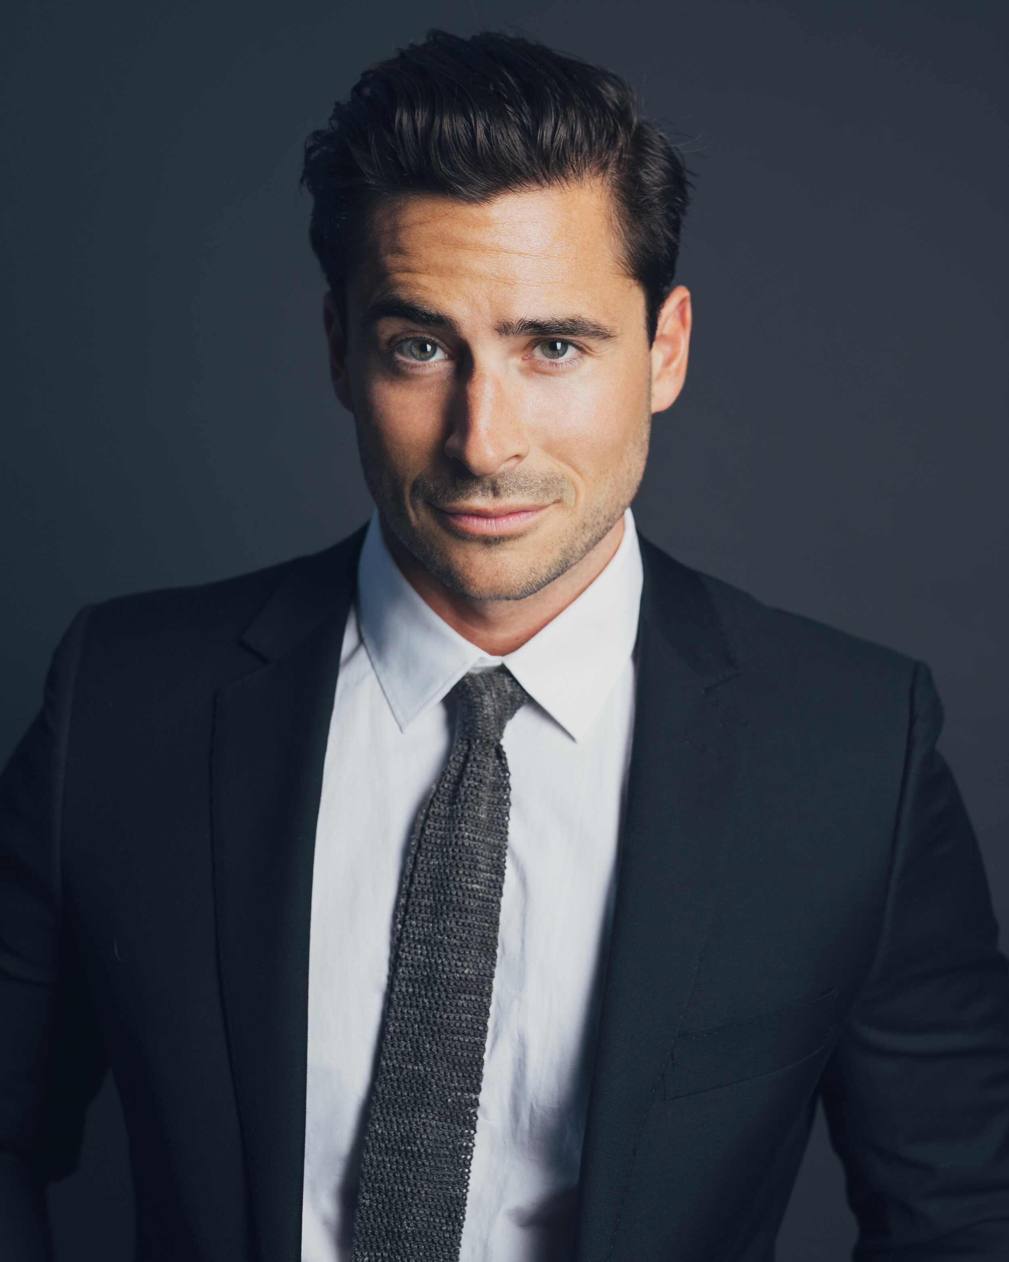
Olivier is a multilingual Third Culture Kid having lived abroad most of his life in countries such as Brazil, Romania, Czech Republic and Thailand. He is a HEC Montreal Business School Trilingual Program graduate. Six months shy of graduating, Olivier ran away with the circus (literally!) touring the US, Scandinavia, Western and Eastern Europe with Cirque du Soleil as a stage performer. He finished his studies while on tour, and became the first HEC Montreal Alum to do so while being an acrobat. Later he moved to New York and Los Angeles to hone the craft of acting with the Hollywood’s leading teachers and coaches. He has studied with Terry Knickerbocker, Larry Moss and Jim Calder, Aitor Basauri and Philippe Gaulier.
His film credits include Midnight at the Magnolia, Christmas in London, A Christmas Village Romance, Loving Christmas, Christmas on 5th Avenue, Planes, Trains and Christmas Trees, Christmas on the Slopes and the recent thriller, Snow Angel. He has also had recurring roles in several TV Series including The Wedding Planners, Paris Paris and Astrid and Lilly Save the World.

CANDICE LIDSTONE
Canadian actress, Candice Lidstone, has had a busy few years in film, including roles in Hens Night, A Daughter’s Revenge, Unholy Night, Konga TNT, Ice Road Killer, Rush for Your Life and One Delicious Christmas.

STEPHANIE HERRERA
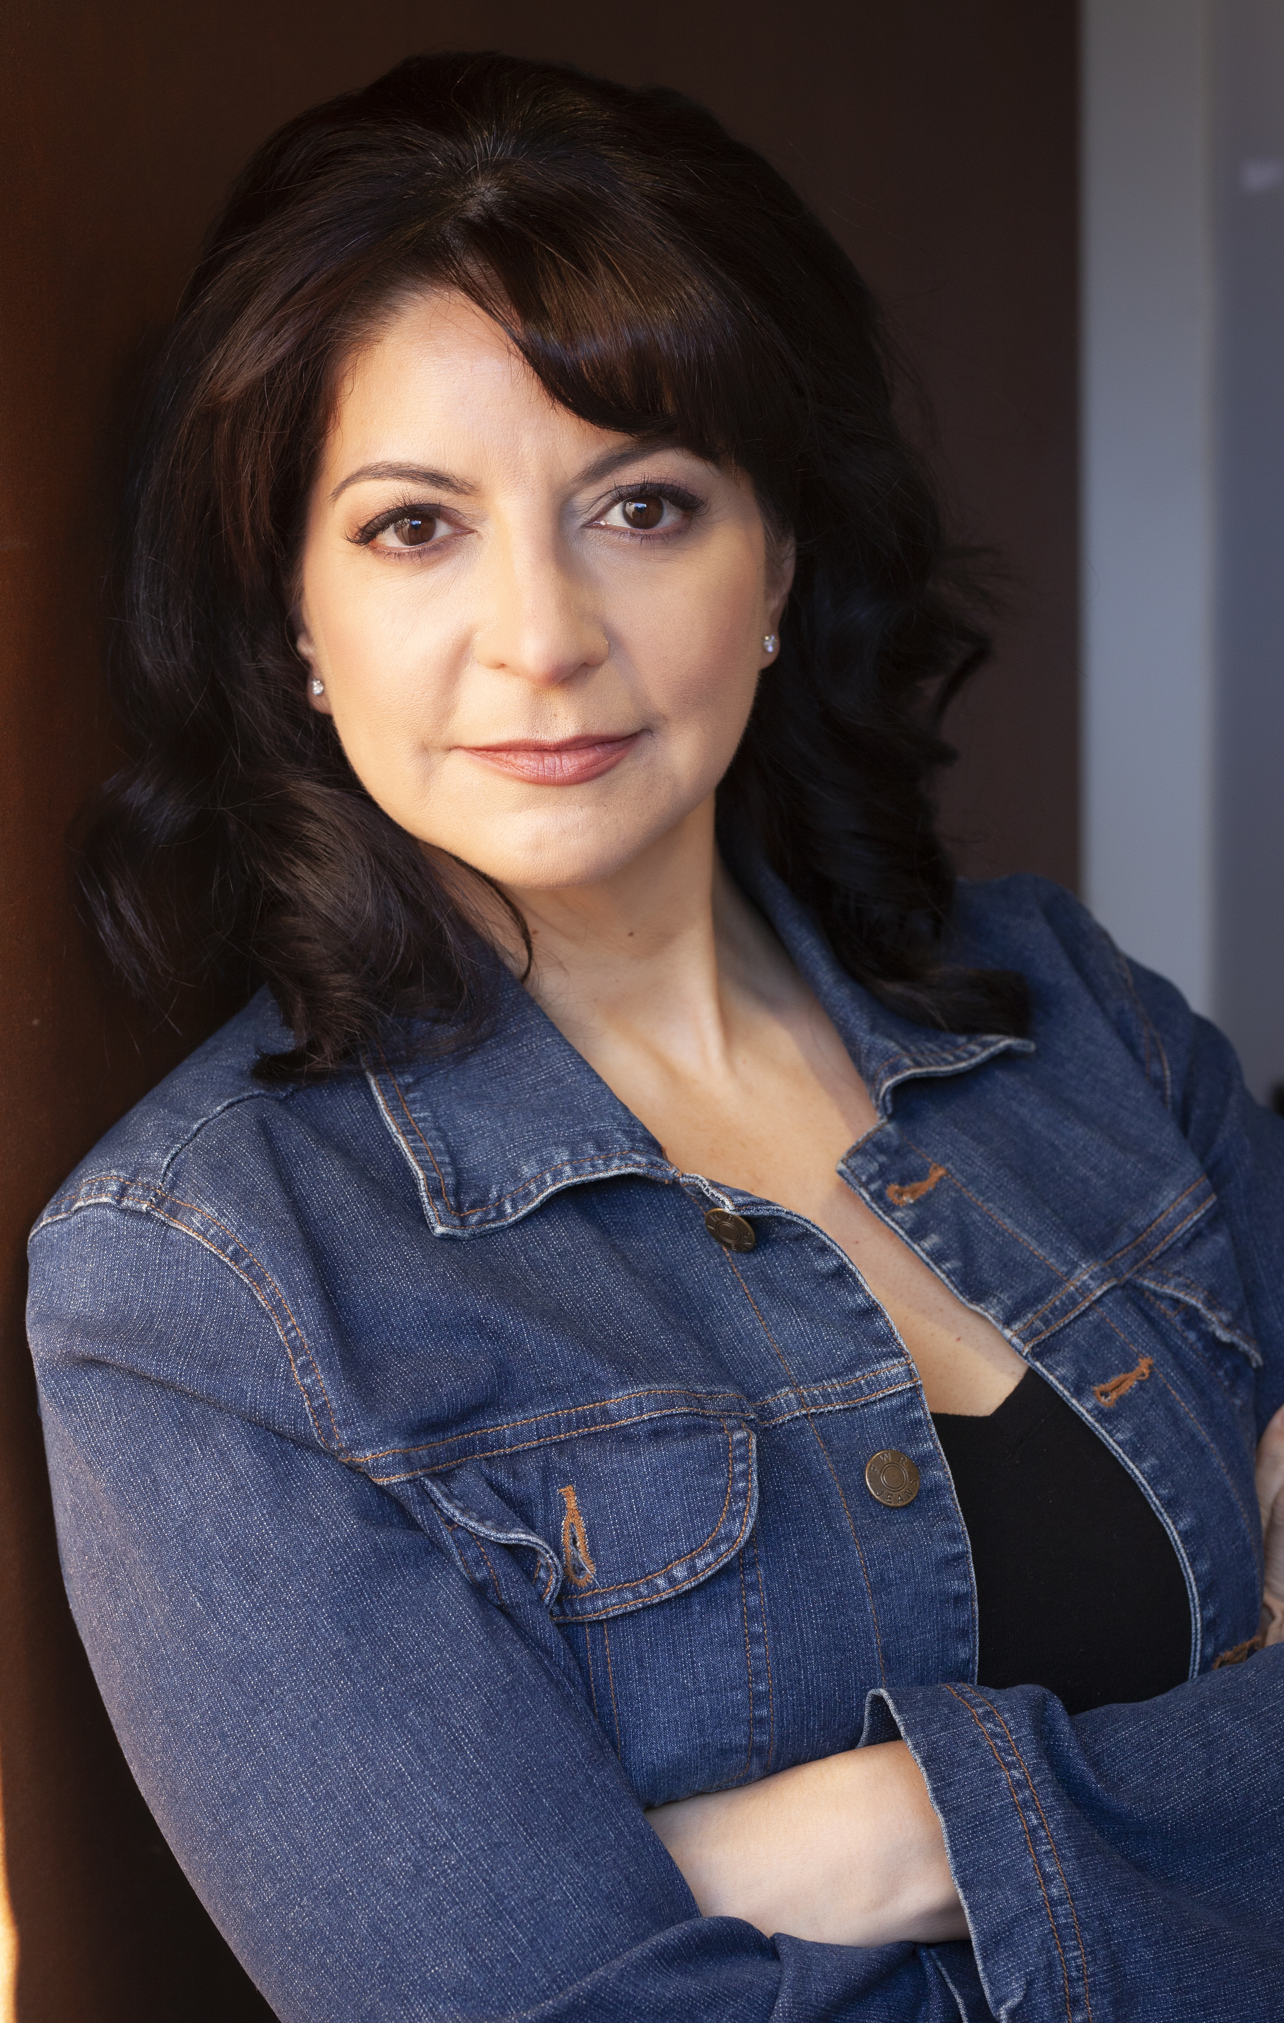
Stephanie Herrera is a multi-award winning actor and writer and her work in the arts has led to nominations for a Latin American Achievement Award and a Canadian Comedy Award. Stephanie has performed in a plethora of TV, film, theatre, and voice, as well as professionally in improv and sketch. She has been the Director of Operations and a judge for several film festivals as well as the Artistic Director of the Ontario International Film Festival. She writes for film and TV, with credits including "Camp Snoopy", "Open Season" (Sony Pictures' animated series), and "Tiny and Tall" for TVO Kids. Her greatest accomplishments to date are her four, overly dramatic children and her book "The Ten Commandments (of Improvising)".

JAMIE CHAMPAGNE
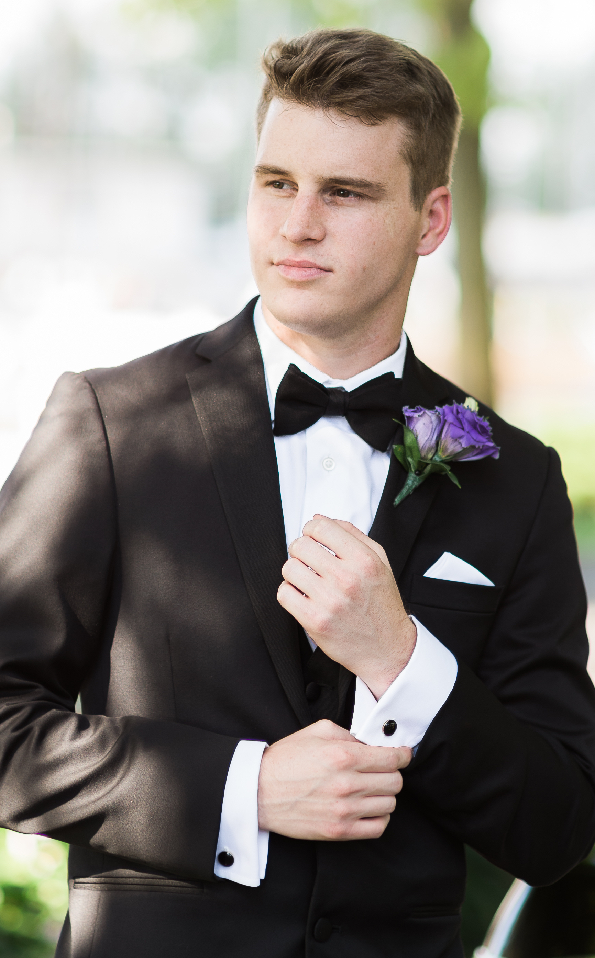
Jamie Champagne is a Canadian actor, who portrays the role of Drew Davis in the Netflix show Spinning Out. He is also known for his roles in Wayne , Let It Snow, The Most Colorful Time of the Year and Abducted on Prom Night.
He has a twin brother, Jon Champagne who also starred in Spinning Out. Jamie and his brother found a passion for acting at a young age; he and his siblings performed shows for his parents where their mother would film the little plays.
The identical twin brothers moved to Toronto, Canada and studied at The Second City. Since then, the pair have performed in numerous theatrical and film productions, and hosted their own program on the popular Canadian kids television channel Teletoon.

NAOMI GASKIN
Naomi Gaskin is a Canadian actress and former model who is best known for her work in Transplant, The Expanse, Exit Wounds, Jungleground, Beauty and the Beast and a recurring role in Barbelle.

TANYA CLARKE
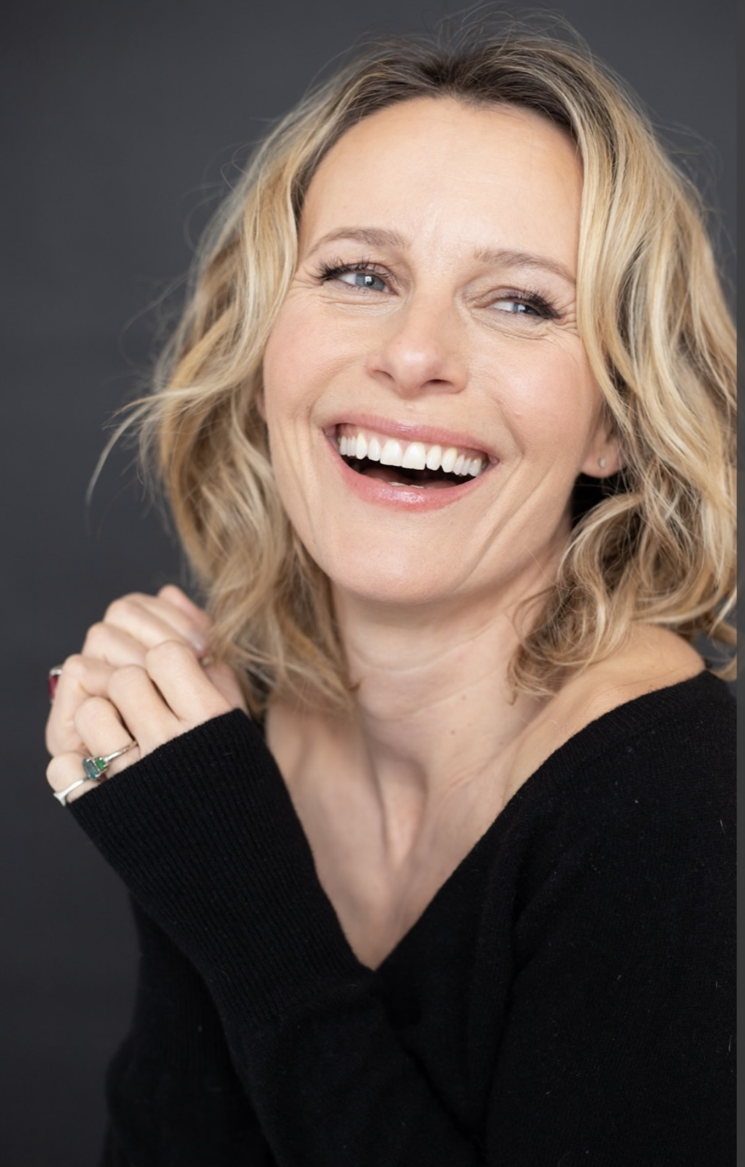
Tanya Clarke was born in Chicago, Illinois and was raised in Ottawa, Canada. She spent many years in New York City performing on Broadway, Off-Broadway and regional stages.
Her film credits include 'A Beautiful Mind', 'Tenderness', 'Repo Men', 'Driver X' & 'Blackbird'. She received a Best Actress Nomination (Method Fest Independent Film Festival) for her performance in 'Delivery Method'.
Her television roles include the character of Emily Lotus on HBO's 'Banshee' & Queen Reyna on Marvel's 'Inhumans'. Other: 'Grey's Anatomy', 'American Horror Story', 'Glee', 'Hawaii Five-0', 'CSI Miami', 'Supernatural' & 'Major Crimes'.
She made her Broadway debut in 'I'm Not Rappaport' opposite Judd Hirsch & Ben Vereen, directed by Daniel Sullivan.

DARRIN BAKER
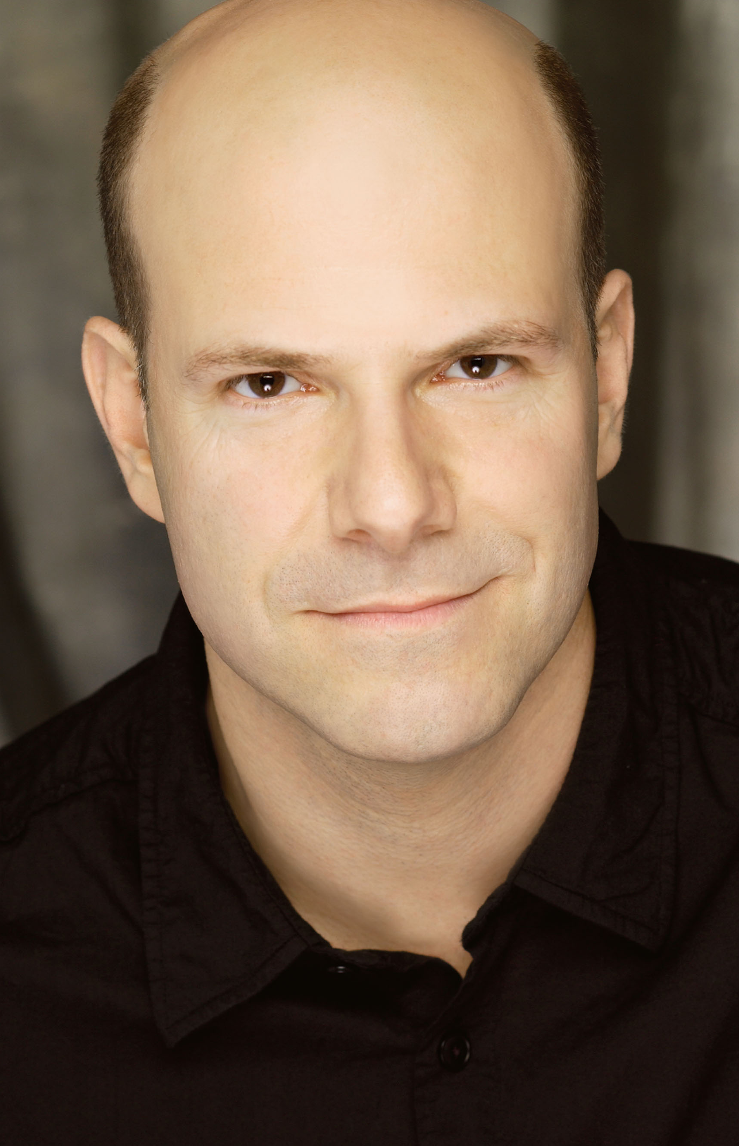
Darrin has been acting professionally for 38 years...in the USA and CANADA
He can be seen in the 2022 TV season recurring as Dr Hartman on NETFLIX’s PAINKILLER directed by Peter Berg and as Dr Martin Bisely recurring on APPLE TV’s FIVE DAYS AT MEMORIAL created and directed by John Ridley and is thrilled to appear in the comedy action film THE MAN FROM TORONTO with Kevin Hart and Woody Harrelson.
His many Acting credits include leading roles on TV and Film in The Good Doctor, The Man From Toronto, My Spy, Kodachrome, Suits, Designated Survivor, People Of Earth, The Strain, Covert Affairs, The Lottery, Law and Order, The Firm, Law & Order and SVU , Rogue, Dark Matter, The Girlfriend Experience, Flash Point, Warehouse 13, Queer as Folk, King, Murdoch Mysteries and many more. Films include: The Glass Castle, Spotlight ,The Man From Toronto, The Good Guy, What Happens Next and A Guide to Recognizing Your Saints.
Broadway credits include: Sunset Blvd, Footloose, The Scarlet Pimpernel, Wonderful Town. Laughing Room Only! and Tarzan.
AWARDS:
2015 SAG Award /Best Ensemble in a motion picture
2013 TORONTO THEATRE CRITICS AWARD (Best Supporting Actor)
2013 DORA AWARD (Nomination) for FEATURED ACTOR in a Musical
2010 CARBONELL AWARD (Nomination) for BEST SUPPORTING ACTOR
DRAMA LOGUE AWARD for BEST DIRECTION /PERSONALS Los Angeles Premiere

REBECCA APPLEBAUM
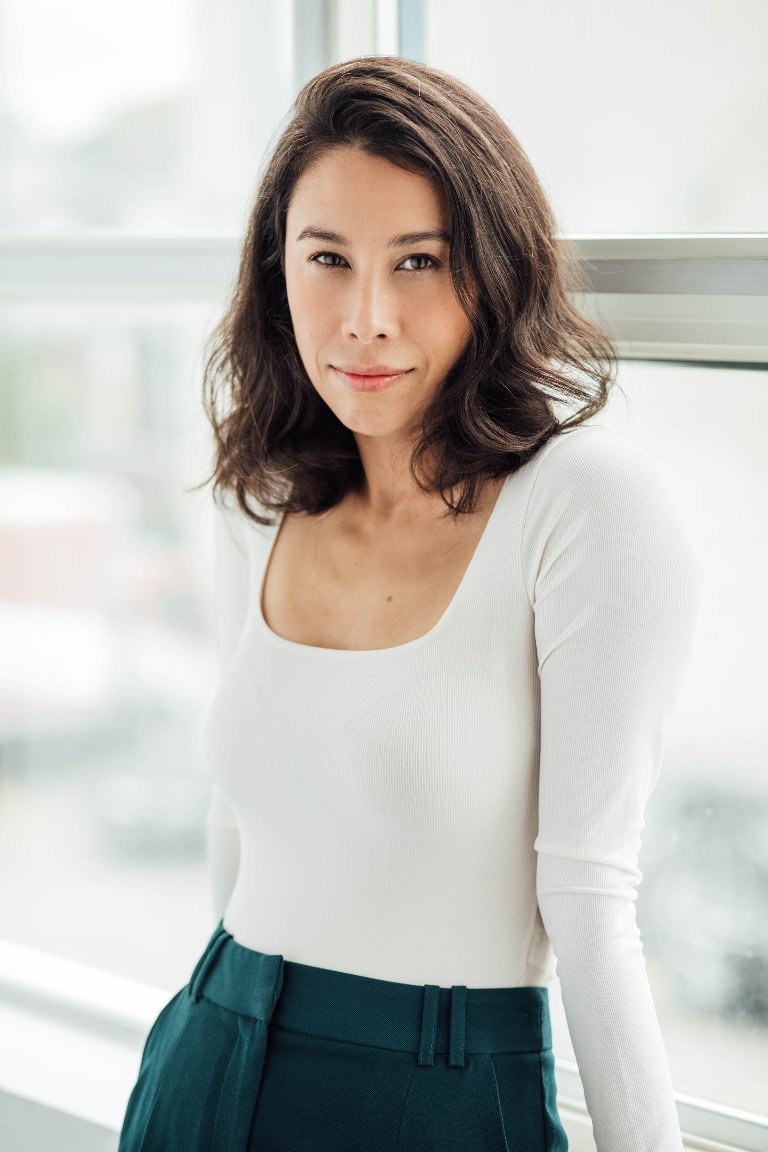
Rebecca Applebaum burst into the commercial directing world with “Distant Friends”, a pandemic-specific spec she sold to BetterHelp that hit over 20 million views online. Her second spot for BetterHelp, “Want”, did even better. Winning the Special Jury Prize for Performance from the Marketing Awards, it also received a bronze statue from Clio Health, nods from The One Show, and ADC Awards — as well as international coverage in Adweek, Shots, Little Black Book, The Message, The Stable, Stimulant, Trendhunter, AdStasher, and Applied Arts. Rebecca has also most recently been featured in Shoot Magazine’s New Directors Showcase and shortlisted for shots 2023 New Director of The Year.
An experienced performer herself, Rebecca loves and is especially skilled at finding the right actors for a project and bringing out their best on set. Her short film Spooning is featured in CBC Television’s Canadian Reflections series, and garnered a Best Actor win from the Canadian Film Fest and an Outstanding Performance nomination from the ACTRA Awards.

ALICE HAMID
Alice Hamid is an actress and model who has a passion for film and television, as well as theatre. This Canadian is from Ottawa and is a graduate from Pace University in NYC with a BFA in Acting for Film/TV/Voice Over/Commercial.
Her impressive resume includes a recurring role in Orphan Black: Echoes, principal roles in A Royal Christmas Crhus and Good Witch for Hallmark, The Great Holiday Bake War for the Oprah Winfrey Network and roles in Family History Mysteries (Hallmark) and Malory Towers (BBC).

Production Credits

Full Cast
Actors  JOCELYN HUDON  OLIVIER RENAUD  CANDICE LIDSTONE  STEPHANIE HERRERA  JAMIE CHAMPAGNE  NAOMI GASKIN  TANYA CLARKE  DARRIN BAKER  REBECCA APPLEBAUM  ALICE HAMID  EMMA CARROTHERS  EDIO SILVIO  THE ALCHEMY SISTERS | Role  Luna  Bennet  Gabby  Katrina  Henry  Audrey  Rosie  Richard  Candice  Holly  Luna’s Double  Bennet’s Double  Pro Performers

Casting
BRIAN LEVY
JASON STROUD

Composer
RUSS HOWARD III

Costume Designer
SAGINE CAVÉ

Editor
ALVIN CAMPANA

Production Designer
ELIZABETH FITZPATRICK

Director of Photography
CHRISTIAN BIELZ

Written by
UMA INCROCCI

Directed by
MAXWELL MCGUIRE

Full Crew
ALEXANDRA WARING | Associate Producers
LOGAN A. WAGNER
CHRISTOPHER CORDELL | Stunt Coordinators
BRIAN JAGERSKY
EMMA CARROTHERS | Stunt Doubles
MICHEL BRAY
EDIO SILVIO NETO
ERIN GUTRI | The Alchemy Sisters
LIAM MCLOUGHLIN | First Assistant Director
VIRGO VELASQUEZ | Second Assistant Director
SANDERSON VINCIC | Third Assistant Director
MARY CROZIER | Fourth Assistant Director
SMYTH CASTING | Extras Casting
ILONA SMYTH
GORAN POBRIĆ | Production Coordinator
LOGAN A. WAGNER | Production Accountant
JOSHUA LANGE | Assistant Accountant
MATTHEW CARVELL | Post Production Accountant
RYAN WHITEHURST | Accounting Clerk
ALEXANDRA WARING | Post Production Supervisor
RIC FRAZIER | Post Production Coordinator
ELIZABETH FITZPATRICK | Production Designer
GREGORY PHILIP WILSON | Design Consultant
TOMAS CHOVANEC | Art Director
ANTHONY RANKIN | Set Decorator
GREG LOWE | Set Dresser
MARY CROZIER | Assistant Set Dresser
MORGAN DUNBAR | Graphics
NATHALIE GREGOIRE | Property Master
ALEXANDRE GREGOIRE | Assistant Props Master
SAGINE CAVÉ | Costume Designer
RÉNALD JEAN-PIERRE | Costume Truck Supervisor
JESSIE EDWARDS | Costume Set Supervisor
JULIANNE HJARTARSON | Wardrobe Assistants
HANNAH LUNDRIGAN
CHRISTIAN BIELZ | Director of Photography
JOSH HENDERSON | B Camera Operator
ADAM TESTA | A Camera - First Assistant Camera
ABRAHAM ISSA
MUNG HATLANG | A Camera - Second Assistant Camera
MATT CROSSE | B Camera - First Assistant Camera
DANIEL COSTEA | B Camera - Second Assistant Camera
RICHARD FRAZIER | Digital Imaging Technician
GEGHANI PANOSIAN | EPKBTS Camera Daily
RICHARD FRAZIER | Camera Technicians
GEGHANI PANOSIAN
PETR MAUR | Stills Photographer
MARCUS LAUTENBACH | Stills Assistants
LILIANA DEL VEDOVA
STEVEN F. S. BRUNI | Gaffer
NICK LYNCH | Best Electrics
YAN SCHNELL
NICHOLAS HERMIER | Key Grip
RJ NADON | Best Grip
DOUG POLSON | High Rigger
CONNOR DORZEK | Grip / Electric Swings
IAN FRASER
DANIEL KAUNISVIITA
FRANCESCO FALSETTO | Sound Mixer
PASCAL DUPUIS | Boom Operators
KARLYNE FÉLIX
NICK SMITH | Script Supervisor
JOSHUA GARBY | Location Manager
NATALIE HONSHORST | Assistant Location Manager & Location Scout
KEENE IMBLEAU | Key Location Production Assistant
ASHLEY GORMAN | Location Production Assistants
SAM KITTS
BRENDAN MCLOUGHLIN
EVAN POSNER
WILLIAM THIBODEAU
ALYSSA "ALY" MORDEN-HAYLEY | Key Makeup Artists
CHANCELLE MULELA
KASSANDRA PEREIRA | Assistant Makeup Artist
CHRISTINA MCGUIRE | Makeup & Hair Assistants
CHANCELLE MULELA
RACHEL WOLFE
NATASHA GABRIELA TREPANIER | Key Hairstylist
CIERA HEARN | Assistant Hairstylist
DARCY RYAN
STEFANE GREGOIRE | Transport Coordinator
GREG LEWIS | Transport Captain
MICHAEL DICKSON | Drivers
BILAL MAHMOUD
KIM RODGER
ALEXANDRE GREGOIRE | Transport Production Assistants
COOPER HUDSON
PERRY MCCONNELL
LYNN SPRACKLIN
JAY VISNESKIE
ERIC P. BEAUCHAMP | Move Crew
SHAWN NADEAU
KEITH STEFFENSEN
CHRIS SURUJNARAIN
CORNELIA VILLENEUVE
DAN VILLENEUVE
ERIC VILLENEUVE
SEAN VILLENEUVE
TOM WARRELL | Head Chef
GERRY WHALEN | Chef
MATTHEW DUBUC | Caterer
RONDA MACKINNON | Craft Service
THE NO CONFLICT CLEARANCE COMPANY | Script Clearances by
HALL WEBER LLP | Legal Services by
DANNY WEBBER
ABOVE THE LINE MEDIA SERVICES | Business Affairs by
BRENDAN MCNEILL
ARTHUR J. GALLAGHER CANADA LTD. | Insurance by
URBAN POST PRODUCTION | Post Production Services provided by
JOSEPH FACCIUOLO | Dialogue & ADR Editor
EHREN PFEIFER | ADR Recordist
KIRSTY SMITH | Sound FX Editor
TESS MOIR | Foley Artists
JESSICA SEVIER
DAVE MERCEL | Foley Recordists
JESSICA SEVIER
COLIN MCCLELLAN | Re-Recording Mixers
CALVIN TRAN
KENT MCCORMICK | Colorist
URBAN PRAIRIE POST | VFX
JESSICA GOEBELL | Online / Packaging Editor
ASHLEY POUCHING | Project Manager
BRUCE REES | Picture Operations Manager
ROBERTA BRATTI | V.P. of Operations
AUDIO VALLEY RECORDING STUDIO | Additional Recording
STEVE FOLEY
POND5/BLACKBOXGUILD | Stock Footage provided by
POND5/LENA_PLATONOVA
POND5/MEDIAWURXUSA
POND5/MILTONBUZON
POND5/ODESIGNS
POND5/RICKRAY
POND5/THE4KGUY

Producer Biographies

TIMOTHY O. JOHNSON – Executive Producer
Timothy O. Johnson is among the most active and reliable producers in the business thanks to top rate productions and global distribution appeal. He is the managing partner of Johnson Production Group, a Canadian based operation that produces over 100 hours of dramatic television annually with hundreds of programs running internationally. The company is the leader supplier to Lifetime, Hallmark and other international outlets.
A graduate of the Marshall School of Business at the University of Southern California, he served as President of the USC Entertainment Management Association and a member of the Advisory Committee of the Center for Entrepreneurial Studies.
Johnson is also responsible for producing the international hit series, DR. QUINN, MEDICINE WOMAN for CBS for over 5 seasons. During his 100-episode tenure, he also developed and produced the original docu-drama COLD CASE for CBS network, which was the very first program to integrate television with the Internet.
Most recently, Johnson has produced the THE NOEL DIARY, being the #1 Film on Netflix’s Top 10 list in December of 2022. He was also at the helm of the successful GIRL IN THE SHED: THE KIDNAPPING OF ABBY HERNANDEZ, as well as the V.C. Andrews series of films, to date including TWILIGHT’S CHILD, MIDNIGHT WHISPERS, and DAWN, all produced for Lifetime..
Johnson has produced over 400 movies and 15 globally released series for every major US network - including Netflix, Lifetime, Hallmark, ABC, Disney, CBS, NBC, Netfly, FOX and Sony.

JOHNSON PRODUCTION GROUP
The Johnson Production Group contracts globally to produce television content for international networks, studios and distributors. Based in Los Angeles and Vancouver, British Columbia, the company manages production, facilitates development and financing, procures distribution and guarantees quality and timely execution of its programs. While costs have gone up, so has the demand for quality. No longer is good enough, good enough. Johnson Production Group serves that segment when a show needs to be "A" quality, but produced efficiently enough to meet a locked budget. JPG specializes in value, protection of creative elements, and delivery of a quality finished product.

DAWN WOLFROM – Executive Producer
Dawn Wolfrom specializes in developing and producing female driven movies and family friendly content. She has been involved in the film & television industry for 25 years having worked on over a dozen feature films, numerous television projects, shorts, a documentary, and over 250 commercials, promotional spots, industrials and music videos.
Dawn has also served as a panelist for the Austin Film Festival & Conference for several years as well as various panels for The Greater Philadelphia Film Office. She has served as a judge and consultant for the annual Set In Philly Screenwriting Competition, among other nationwide writing competitions.
Dawn was Executive Producer of two award winning short films. THE BOY won the Director's Choice Award at the The Diversity in Cannes Film Showcase 2015, The Award of Excellence at the International Film Festival for Women, Zero Discrimination and Social Issues. THE BOY received the INTERNATIONAL HUMANITARIAN SILVER AWARD. As well, a special recognition for Director, Cayman Grant -- The Star of Humanity Award. On October 21st 2015, Gina Davis announced Best Female Filmmaker award to Cayman Grant City for THE BOY. Her film BUTTERFLIES has won the Winnipeg Film Festival and the Grand Prize Award at the Canada International Film Festival. At the London Film Awards, Butterflies was awarded the Cinematic Vision Award. At the Big Island Film Festival, Butterflies won Best Family Short and Best Audience Choice Award.
ANDREW C. ERIN – Executive Producer
Andrew Erin is a Canadian Writer/Director making a big splash in the US, and has produced, written and directed numerous commercially successful films. His directorial debut, SAM’S LAKE, was an official selection at the Tribeca Film Festival and did an excellent theatrical run in select theaters around the country; distributed by Lionsgate Films. Andrew also wrote the script for the film. Andrew’s directorial credits include, SIMPLE THINGS, produced for Screen Media Ventures and Universal Studios. Besides winning The Bob Clark Award for Best Director at the California Independent Film Festival, the film was commercially received. Andrew has worked continuously as a writer/director, building a strong library of films in the Thriller/Horror genres with: Embrace of The Vampire, The Clinic, Final Sale, Confined and Toxic Skies.
OLIVER DE CAIGNY – Executive Producer
Oliver De Caigny is a Canadian producer originally from Belgium, his background in financing, production, and post production makes him a well-rounded producer for any type of production. His experience in financing and production agreements (film and TV series and movies-of-the week), distribution agreements (both domestic and foreign) as well as international co-productions, Canadian tax credit, Telefilm Canada and Canada Media Fund incentives provides him with a well-rounded background in development, production and distribution for motion pictures, television series and productions.

JOSEPH WILKA – Co-Executive Producer
Joseph Wilka is the Head of Production for Johnson Production Group. Los Angeles-based, Joseph had already produced and directed several feature films before serving as the senior marketing executive for Gravitas Ventures. While at Gravitas, Wilka helped pioneer new distribution models for independent films including day-and-date theatrical releases. It was also at Gravitas where Joseph first worked with Johnson Production Group to facilitate the release of their films to the worldwide Video On Demand audience. After serving as the Director of Distribution and Production for Viva Pictures, where he produced English-language versions of foreign animated titles for DirecTV, Wilka officially joined Johnson Production Group. As Head of Production, he oversees the development, production, and distribution of films from multiple production units for release on broadcast and streaming platforms.

LISA ALFORD – Co-Executive Producer
Lisa Alford is a development executive at Johnson Production Group. A Massachusetts native, Lisa has lived and worked in Los Angeles for over a decade, always in support of excellent storytelling. Prior to joining Johnson Production Group, Lisa worked as an executive at TriStar television where she specialized in identifying IP that supported TriStar’s mission to feature diverse, authentic characters and champion underrepresented voices. Lisa came up at Sony Pictures Television where she worked as a production coordinator in the Television Movies and Miniseries department and in the writers room on the WGN hit series OUTSIDERS. In her current role, Lisa shepherds projects from the concept phase through story development, production, and post.

JOSIE FITZGERALD - Producer
Josie Fitzgerald is a Canadian born Producer currently residing and working in Ottawa, Ontario. Josie is also a passionate photographer and writer, with an education in Justice Studies and a professional background in Human Resources and Project Management.

MAXWELL McGUIRE - Director
As a writer and director, Max's projects have been financed or distributed by; Netflix, Bron Studios, Telefilm Canada, Ontario Media Development Corp, Hallmark, Lifetime, CBC TV, UPtv, Canada Council for the Arts, the Harold Greenberg Fund and a number other private international distributors.
Foreverland, his most personal movie, was produced by Bron Studios and Screen Siren Media. It was distributed theatrically by Eone and sold internationally by Vision Films. It stars Max Thieriot (Seal Team/Bates Motel), Laurence Leboeuf (Transplant) and Oscar nominees Juliette Lewis (Cape Fear) and Demian Bichir (The Bridge) along with Sarah Wayne Callies, Matt Frewer and Thomas Dekker.
Max recently directed, Midnight at the Magnolia starring Natalie Hall and Evan Williams for Marvista Entertainment which can currently be seen on Netflix where it was TOP 5 worldwide most watched movie.
Love at Look Lodge, starring Clark Backo and Jonathan Keltz recently premiered on Hallmark to over 2 million viewers this past fall while Mistletoe and Menorahs starring Kelley Jakle and Jake Epstein continues to air on Lifetime TV and around the world.
He's directed numerous thrillers such as The Narcissist, starring Amber Goldfarb, Damon Runyon and Sam Ashe Arnold for Lifetime along with multiple movies for Johnson Production Group, Fireside Pictures, Reel World Management, Neshama Entertainment and Marvista Entertainment.

Billing Block

Johnson Production Group Presents “ROMANCE WITH A TWIST”
starring JOCELYN HUDON OLIVIER RENAUD CANDICE LIDSTONE STEPHANIE HERRERA JAMIE CHAMPAGNE NAOMI GASKIN TANYA CLARKE DARRIN BAKER REBECCA APPLEBAUM ALICE HAMID Casting BRIAN LEVY JASON STROUD Composer RUSS HOWARD III Costume Designer SAGINE CAVÉ Editor ALVIN CAMPANA Production Designer ELIZABETH FITZPATRICK Director of Photography CHRISTIAN BIELZ
Co-Executive Producers JOSEPH WILKA LISA ALFORD Executive Producers
TIMOTHY O. JOHNSON DAWN WALFROM ANDREW C. ERIN OLIVER DE CAIGNY Producer JOSIE FITZGERALD Written by UMA INCROCCI
Directed by MAXWELL MCGUIRE
The Canadian Film or Video Production Tax Credit
© MMXXIII Fireside (Silk) Films Inc. All Rights Reserved

Meta Data
LONG (max 3000 characters) synopsis
Luna, an ex-dancer who left that dream behind for a grounded life managing her family’s construction business, steps into a life changing opportunity when she takes a job turning a gymnasium into a studio for aerials. As she finishes up the job, she can’t resist giving the silks a try, just to see if she’s still got it. She’s transported back to her days on stage for just a moment before Bennet, a professional aerialist, interrupts her…and he’s rather annoyed to find his contractor messing around on the silks. The studio is now ready for rehearsals for the local Hazelton Arts Festival where Bennet will perform an aerial duet in a show stopping finale. The only problem is his partner has bailed at the last minute and he can’t do it alone. With the festival just a few short weeks away, Bennet's sister convinces him to partner up with Luna, who is eager to prove herself and get back on stage. Soon enough she faces the challenge of a lifetime as they rehearse for the show. As the hard work of this dynamic sport and the joys of the holiday season bring them closer together, will their relationship crash or will they find a way to reach new heights? (1161)
MEDIUM (max 500) synopsis
Ex-dancer, Luna, pairs up with Bennet, a professional aerialist, when he finds himself without a partner for his upcoming silks performance for the local arts festival. Soon enough she faces the challenge of a lifetime as they rehearse for the show. As the hard work of this dynamic sport and the joys of the holiday season bring them closer together, will their relationship crash or will they find a way to reach new heights? (428)
SHORT (max 100 characters) synopsis
An ex-dancer pairs up with a professional aerialist for a performance for the local arts festival. (98)
5 KEY WORDS
Ex-dancer, Professional aerialist, Romance, Challenge

