
Johnson Production Group
Press Kit

One-Liner
A young fashion designer wrestles between appeasing her bachelor client and staying true to her own aesthetic

Synopsis
Rachel Rocca is a fresh face in men’s fashion whose formalwear designs are instantly recognized by their bold colors. When she is offered the opportunity to compete with other designers to create tuxedos for the annual NYC Christmas Charity Gala and Bachelor Auction, she learns the winning design will be featured on the cover of a global fashion magazine. But when she is assigned bachelor and tech guru, Brett Stone, she quickly learns his reputation for having an unyielding personality is warranted. As the determined Rachel wrestles between appeasing Brett and staying true to her own aesthetic, her heart softens when she hears the secret of Brett’s past, but an inadvertent holiday confession may keep them from falling into a well-suited love.

Producers
Executive Producers
TIMOTHY O. JOHNSON
ANDREW C. ERIN
DAWN WOLFROM
Co-Executive Producer
JOSEPH WILKA
Producer
HAYDEN BAPTISTE
Supervising Producer
OLIVER DE CAIGNY

Key Cast
CHARACTER  Rachel Rocca  Brett Stone  Tomas Rocca  Marci Rocca  DeMario Truitt  Dhruvi Patel  Fashion Journalist  Atticus Winters |  | ACTOR  MERCEDES DE LA ZERDA  FRANCO LO PRESTI  XAVIER SOTELO  STEPHANIE HERRERA  GABRIEL HUDSON  LARA AMERSEY  NCK NAME  PIERRE SIMPSON

Key Cast Biographies

MERCEDES DELA ZERDA
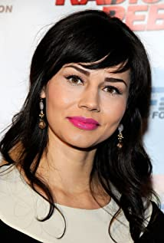
Mercedes dela Zerda is a Canadian born actress who started acting professionally at the age of 15. After early success in the Television and Film industry, Mercedes paused her career to focus on training and went on to receive her Bachelor of Fine Arts in Theatre at the University of British Columbia. She now splits her time working in major Hollywood productions and in the Canadian Theatre Industry. Mercedes often gets singled out for her unique look and her ability to bring depth and groundedness to characters who find themselves in extraordinary circumstances. Her range can be seen in her work opposite Andy Serkis in War for The Planet of The Apes where she played the only female soldier to be held captive. Mercedes was also handpicked to play the only female hunter in Sony's Epic ice age film Alpha. Mercedes' has the ability to bring both strength and vulnerability to her characters, which often leads her to be cast as characters who have a tough exterior but who could fall apart at any moment. Mercedes' distinct talent can soon be seen in her next role as a police officer with a big secret in the CW drama Nancy Drew as well as a regular on this season of USA’s The Sinner opposite Bill Pullman.

FRANCO LO PRESTI
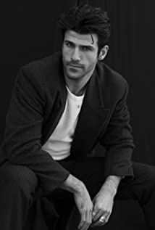
Franco Lo Presti was born and raised in Scarborough, Ontario. At a young age, Franco developed a passion for performance, especially playing guitar and soccer. This passion landed him a Division I scholarship at the University of Rhode Island, where he also developed a love of theatre.
After graduating, he played soccer in Italy for a team in Serie D, went on trial with Toronto FC and was eventually forced to call time on his soccer career, after succumbing to a hip injury.
At the age of 26, dream taken from the palm of his hands, Franco was reminded of his past pursuits in the theatre and was encouraged by family and friends to
partake in an acting class. It was in that class where Lo Presti found his peace and purpose.
His commitment and dedication to the performing arts have led to current and upcoming film and television roles on Letterkenny, Schitt’s Creek, Bad Blood & Jupiter’s Legacy. He is eager to explore and grow as an artist and takes great pride in all his experiences in life, playing music, living abroad and especially, as an athlete.
When not acting, Lo Presti enjoys his time with family and friends, writing poetry and music, playing the guitar, travelling the world, and juggling a soccer ball from time to time.

XAVIER SOTELO
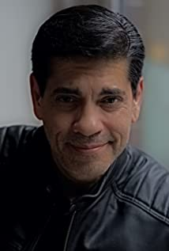
Born and raised in San Francisco, California, Xavier's first exposure to acting was a location shoot for the T.V. series "Streets of San Francisco" starring Michael Douglas and Karl Malden in 1973, a Quinn Martin Production, at 8 years of age. Since then, Xavier has gone on to study acting in California, New York, Toronto and Ottawa, Canada; most notably with John Strasberg.
Xavier next appears in the U.K.'S/Canada's production of "No Easy Days", found on Amazon Prime, "Street Legal" currently filming and directed by Academy Award Nominated director, Sturla Gunnarson, CBS's "Star Trek: Discovery" staring in January 2019, and, due out for release in December of 2018 "The Truth About Christmas" directed by Jay Karas (Brooklyn 9-9 and Parks And Recreation). Additionally, Xavier can be seen in Zed Filmworks'production of "Gutshot" and in the CBC Mini-Series, "The Best Laid Plans" directed by Peter Moss. Recently released is the made for television movie, "Guilty At 17", directed by Tony Lefresne. Xavier can also been seen in a starring role in "September Runs Red (Aquaphobia)(2013)", a Blackhouse Pictures Production, also starring Adam Beach and Caroline Redekopp; marking Xavier's second feature film with Adam Beach, and in "Donkey" directed by Adrian Langley.
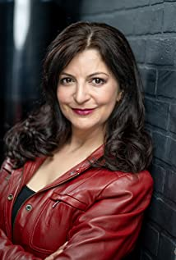
STEPHANIE HERRERA
Stephanie Herrera's work in the arts has led to nominations for a Latin American Achievement Award and a Canadian Comedy Award. She has won a THEA for Best Leading Actress in a Musical and the Art of Transition "Best Entertainment" Award from the Durham Region, ON. Stephanie has performed in a plethora of TV, film, theatre, improv and sketch shows, and is a professional Voice Talent. She has been the Director of Operations and a judge for several film festivals as well as the Artistic Director of the Ontario International Film Festival. She writes for film and TV, with credits including "Camp Snoopy", a soon to be released Sony Pictures animated series, and another for TVO & CBC. Her greatest accomplishments to date are her four, overly dramatic children and her book "The Ten Commandments (of Improvising)".

GABRIEL HUDSON
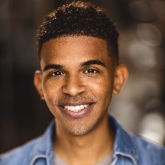
Gabriel Hudson is a Toronto based actor from the Bahamas. He has experience in stage, film, TV and Voiceover. He's most recently portrayed Dezmon Henry in the TV series "Fear thy Neighbor". Gabriel also played the character of Abe in the stage play Disgraced by Ayad Akhtar. He has received training in acting at EVN Film Studios, voiceover training from Kim Hurdon and Ted Sutton and On Camera training with Earl Nanhu and Tony Babcock. He's continuously honing his skills in the craft that he loves.

LARA AMERSEY
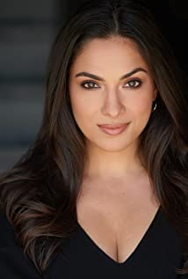
A Canadian actress of South Asian heritage, Lara's career across film, television and commercial mediums has spanned almost 20 years. A successful career in kids television (this includes 52 episodes in a lead role in the YTV series Monster Warriors as well as many other credits across the Family Channel and Nickelodeon network) transitioned into a successful career as an adult. A 5 year break from the screen to have her two children only strengthened her passion and resolve for a career on screen. Lara has booked a number of lead and supporting lead roles in the last few years and has also added to her creative repertoire by channeling her work in Toronto as a sommelier into a successful collaboration with New York based company Thrillist in the new web show "Wine and Cheeseburger". She has also found her voice as a writer, working to bring diverse stories centered around women and motherhood to the screen, already having successfully earned a screenwriting award on the film festival circuit for her short film "Reject". An integral part of the Canadian film and television industry, Lara is looking forward to her further creative endeavors and the opportunities to tell unique and diverse stories. Upcoming projects in 2021/2022 include a new movie for the Hallmark Channel and a role in the CBC/Netflix show Workin' Moms.

NCK NAME
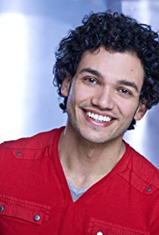
Nick Londoño (AKA Nck Name) is an actor, musician & producer based in Toronto, Canada.
His on-screen work includes shows such as 'Star Trek: Discovery', 'Murdoch Mysteries', '9 Films About Technology', 'Mayday', and Nickelodeon's Emmy-winning 'Odd Squad; as well as films such as 'A Mother's Lie', 'I Won't Let You Go', 'Love & The Radio Star', and 'An Ice Wine Christmas'. He's been the face of over 30 national marketing campaigns for brands such as Coca-Cola, Toyota, McDonalds, Walmart, Budweiser, Rice Krispies, Intel, Rogers, Fido, BMO, Virgin and TD Bank, and more.
As a composer/audio producer Nick has worked with several music houses, labels, and production companies, with his work featured in over 20 international film festivals, earning him an 'Emerging New Media Artist of The Year' MARTY award.

PIERRE SIMPSON
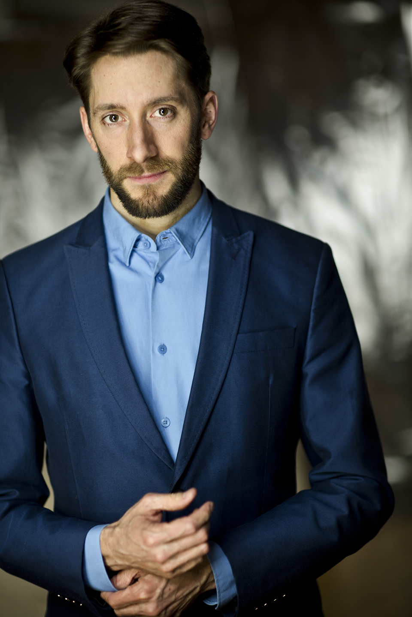
Dora Award-nominated actor Pierre Simpson has been delighting audiences professionally for over 20 years. Fluently bilingual, Pierre's charm shines through in both of Canada's official languages ​​making him not only highly skilled at shooting bilingual training videos and commercials, but also a very busy stage, TV, film and new media actor across the country.
Pierre hails from Welland, Ontario, and is a graduate of the University of Ottawa's bilingual Theater Department. Film and Television credits include Three Pines (Amazon) , Transplant & Hannibal (NBC) , The Detectives, Murdoch Mysteries , The Border (CBC), Last Patrol, The Rarebit Fiend , 12 Monkeys , Fugitive at 17 (Showcase), Let the Daylight into the Swamp ( NFB , TIFF), Reign, Nikita (CW), Motel Monstre , Météo+ and Le Rêve de Champlain (TFO), as well as hosting many bilingual videos for Parks Canada and private companies. English Theater credits include A Midsummer Night's Dream (Canadian Stage), When it Rains (2b theater International Tour, Edinburgh, Mumbai), Strawberries in January (Great Canadian Theater Company), It's A Wonderful Life (Theatre New Brunswick), The Bookshop , a reading of Look Back in Anger (The National Arts Centre), Dangerous Liaisons (Third Wall Theatre), and A Thought in Three Parts (SummerWorks). His great voice work has been featured in National Nissan campaigns and the animated series Let's Go Luna!. French Theater credits include Les Médecins de Molière (Rideau Award, Dora Award nomination for Outstanding Performance) L'Emmerdeur, Le Dîner de Cons and Le Misanthrope (Théâtre français de Toronto) as well directing Les Zinspirés 1, 2.0 and 3D which earned him nominations for the Pauline McGibbon and John Hirsch Awards for Emerging Directors.
Originally from Welland, Ontario, and graduating from the Department of Theater at the University of Ottawa, Pierre had the great pleasure of performing with most French-speaking theater companies in Canada. Installed since 2006 in Toronto, he appeared on the boards of the French Theater of Toronto in The Bald Cantatrice , Dom Juan , Le Placard, L'Emmerdeur , Le Dîner de cons, Et si on chantait, Le Misanthrope , and Les Médecins de Molière , a piece that allowed him to tour from Vancouver to Moncton. His hilarious performance in A Midsummer Night's Dream for Canadian Stage in High Park this summer has charmed the public. On the small screen, he has been seen in the TV series Murdoch Mysteries , The Border , (CBC), Hannibal (NBC), Reign (CW), 12 Monkeys (Syfy, Showcase), Nikita (CTV), Le Rêve de Champlain , Météo+ , Mission XY , and Francoeur II (TFO), Motel Monstre , Toi & Moi, Mehdi & Val - Gémeaux 2020 nomination, then Makinium (Radio-Canada) as well as in the short film Let The Daylight Into the Swamp ( ONF , TIFF) and the webseries 2h14 and Vision Polyphonique (TV5, Gémeaux finalist). As a trainer, Pierre has hosted for the Ontario Arts Council, Learning through the Arts, and Théâtre Action. He co-signed the staging and scenography of the children's show Oz de Vox Théâtre (finalist for the Masques 2007), and in 2006 he was awarded the Prix d'excellence de Théâtre Action and the Prix d'Excellence. Excellence from the Ontario Ministry of Culture.
And let's not forget: His productions of Zinspirés 1, 2.0 and 3D at the Théâtre français de Toronto were warmly received by critics and the general public, as well as a nomination for the Pauline McGibbon and John Hirsch Prizes for emerging directors. His theatrical adaptation of The Biggest Poutine in the World enchants crowds and hopes to re-start a provincial tour once public health permits.

Production Credits

Full Cast
Actors  MERCEDES DE LA ZERDA  FRANCO LO PRESTI  XAVIER SOTELO  STEPHANIE HERRERA  GABRIEL HUDSON  LARA AMERSEY  ALLISON BUSNER  PIERRE SIMPSON  VANESSA BURNS  NCK NAME  ALIREZA SHOJAEI  KATE MACLELLAN  ANDREA PAVLOVIC | Role  Rachel Rocca  Brett Stone  Tomas Rocca  Marci Rocca  DeMario Truitt  Dhruvi Patel  Sloan Avery  Atticus Winters  Sybil Neale  Fashion Journalist  Marc  Photographer  Bethann

Casting
RON LEACH, c.d.c

Composer
CATALIN MARIN

Costume Designer
SARAH A. CARROLL

Editor
CASEY TOURANGEAU

Production Designer
GREG WILSON

Director of Photography
MICHAEL TIEN
GORDON YANG

Written by
W. STEWART

Directed by
MICHELLE OUELLET

Other Crew
THOMAS STANFORD | Associate Producer
JOHNNY ROSS | First Assistant Director
BEN HRKACH
BEN HRKACH | Second Assistant Director
NICK GAUTHIER | Third Assistant Directors
LORI HAREUTHER
AIDAN MAZEROLLE | Fourth Assistant Director
AMTI | Extras Casting
ANGIE SAKLA-SEYMOUR
HAYDEN BAPTISTE | Line Producer
JACKIE MASSAR | Production Coordinator
GORAN POBRIĆ | Assistant Production Coordinator
JOSIE FITZGERALD | Office Manager
LOGAN A. WAGNER | Production Accountant
JOSHUA LANGE | Assistant Production Accountant
GREG WILSON | Production Designer
TOMAS CHOVANEC | Art Director
RACHEL FENTON | Set Dressers
ELIZABETH FITZPATRICK
JOSH BRIDGEN
STEPHEN SANBORN
NATHALIE GREGOIRE | Property Master
ALEXANDRE GREGOIRE | Prop Assistant
SARAH A. CARROLL | Costume Designer
AMANDA COLLIE | Costume Dresser
ELLA JAMES-BESWICK | Costume Set Supervisor
ERIN MORRISON | Costume Laborer
MICHAEL TIEN | Director of Photography
GORDON YANG
JESSIE TURNER | B Camera Operator
ADAM TESTA | A Cam - First Assistant Camera
NIKKI TUBONGBANUA | A Cam - Second Assistant Camera
MATT CROSSE | B Cam - First Assistant Camera
LINDSEY BELANAGER | B Cam - Second Assistant Camera
ZOE WOJTAS
DANIEL COSTEA
GEGHANI PANOOSIAN-HAJIABADI | Camera Utility
GEGHANI PANOOSIAN-HAJIABADI | Camera Technicians
RICHARD FRAZIER
DANIEL COSTEA | Camera Trainee
JEFF BRAY | Digital Imaging Technician
PETR MAUR | Stills Photographer
STEVEN BRUNI | Gaffer
YAN SCHNELL | Best Electrics
RJ NADON
ALEXANDRA ADAMS | Electric
NICHOLAS HERMIER | Key Grip
MARTIN GREGOR | Best Grips
NICK LYNCH
RACHEL VRECIC | Grips
PAR HATLANG
SONIC LIGHTNING ENTERTAINMENT INC. | Sound
LASZLO SZIJARTO | Production Sound Mixers
ANDREW SUTHERLAND
SCOTT RAWSON BROWN | Boom Operator
LORI HAREUTHER | Script Supervisors
CHRIS DAVIES
LASZLO SZIJARTO | Location Manager
SAGINE CAVÉ | Assistant Location Manager
DAVE ROSE | Location Scout
KEENE IMBLEAU | Key Location Production Assistant
CIMARRON LANGLOIS | Location Production Assistants
CHRYSTINE ST. LOUIS
RYAN MYLES
ALYSSA "ALY" MORDEN-HAYLEY | Key Makeup Artists
LULU TORIO
CHRISTIE CAPUSTINSKY | Assistant Makeup Artist
NATASHA GABRIELA TREPANIER | Key Hair Stylist
DARCY RYAN | Assistant Hair Stylists
CIERA HEARN
STEFANE GREGOIRE | Transport Coordinator
GREG LEWIS | Transport Captain
DAVE ROSE | Drivers
MICHAEL DICKSON
SANDY MCDERMID
TONY PLEBON
TAMMY PARENT
DAVID PARENT
ROBERT STRONACH | Transport Production Assistants
SHAWNA M
JAY VISNESKIE
CRAIG WRIGHT
KEITH STEFFENSEN | Move Crew
CORNELIA VILLENEUVE
DAN VILLENEUVE
ERIC VILLENEUVE
SEAN VILLENEUVE
ACTION SET MEDICS INC. | Health & Safety
BIAGIO'S | Catering
TOM WARRELL | Craft
CAMERON MATHESON | Craft Laborer
HALL WEBER LLP | Script Clearances
HALL WEBER LLP | Legal Services
ABOVE THE LINE MEDIA SERVICES | Business Affairs
BRENDAN MCNEILL
ARTHUR J. GALLAGHER CANADA LTD. | Insurance
ALEXANDRA WARING | Post Production Supervisor
URBAN POST PRODUCTION | Post Production Services
STEVE MOORE | Re-Recording Mixers
TYLER HALL
LUCAS CECCHETTI | Re-Recording Assistant
CHRIS MATHESON | Sound FX Editor
LAUREN RICE | Dialogue Editor
JEREMY LIANG | ADR Editor
EHREN PFEIFER | ADR Recordist
MARILEE YORSTON | Foley Artists
MATT THIBIDEAU
TESS MOIR
DAVE MERCEL | Foley Recordists
JESS SERVIER
NIKA SHEVCHENKO | Colorist
RICHARD DOMAN | Online Editor
BRUCE REES | Picture Operations Manager
ROBERTA BRATTI | V.P. of Operations
CAROLYNE BUCHANAN | Paintings and Prints
ISTOCK/MVIAMONTE | Stock Footage
ISTOCK/FUNKEYFACTORY
ISTOCK/STUDIOKIET
ISTOCK/ISTOCKMARADONA
ISTOCK/ALEXPOTEMKIN
ISTOCK/BLAKE83
ISTOCK/ZXVISUAL
ISTOCK/LITTLECRUSHFILMCO.
ARTGRID/21AERIALS
ARTGRID/VIAFILMS
ARTGRID/CONTINUOUSCONTENT
ARTGRID/DENYSHRISHYN
"Here Comes Santa Claus"
by David Tobin, Jason Pedder, Jeff Meegan and Mark Armstrong
courtesy of Audio Network Limited

"We Wish You"
by Patrick Hawes
courtesy of Audio Network Limited

"As Long As You Are Here"
by Adam Double
courtesy of West One Music Limited

"Mis Enemigos"
by Hector H. Torres Mariscal
courtesy of SOMOS

"Christmas Tree"
by Alexander L'Estrange
courtesy of Audio Network Limited

"It's Christmas Time"
by Patrice Covington
courtesy of Just Call Me Angel Music

"Silent Night"
courtesy of Extreme Production Music USA
and Artfully Entertaining Music Library

"Merry Christmas One and All"
by Andy Powell and Tara Chinn
courtesy of Audio Network Limited

"All I Want Is You"
by John Isaac Charles Coggins
courtesy of Extreme Production Music USA
and Artfully Entertaining Music Library

"Que Verdes Son"
by Pete Masitti and John Andrew Barrow
courtesy of Audio Network Limited

Producer Biographies

TIM JOHNSON – Executive Producer
Tim Johnson is among the most active and reliable producers in the business thanks to top rate productions and global distribution appeal.
Johnson is also responsible for producing the international hit series, DR. QUINN, MEDICINE WOMAN for CBS for over 5 seasons. During his 100-episode tenure, he also developed and produced the original docu-drama COLD CASE for CBS network, which was the very first program to integrate television with the Internet.
Johnson has produced over 150 movies, 15 globally released series for every major US network - including ABC, Disney, CBS, NBC, Netfly, FOX and Sony.

JOHNSON PRODUCTION GROUP
The Johnson Production Group contracts globally to produce television content for international networks, studios and distributors. Based in Los Angeles and Vancouver, British Columbia, the company manages production, facilitates development and financing, procures distribution and guarantees quality and timely execution of its programs. While costs have gone up, so has the demand for quality. No longer is good enough, good enough. Johnson Production Group serves that segment when a show needs to be "A" quality, but produced efficiently enough to meet a locked budget. JPG specializes in value, protection of creative elements, and delivery of a quality finished product.

JOSEPH WILKA – Co-Executive Producer
Joseph Wilka is the Head of Production for Johnson Production Group. Los Angeles-based, Joseph had already produced and directed several feature films before serving as the senior marketing executive for Gravitas Ventures. While at Gravitas, Wilka helped pioneer new distribution models for independent films including day-and-date theatrical releases. It was also at Gravitas where Joseph first worked with Johnson Production Group to facilitate the release of their films to the worldwide Video On Demand audience. After serving as the Director of Distribution and Production for Viva Pictures, where he produced English-language versions of foreign animated titles for DirecTV, Wilka officially joined Johnson Production Group. As Head of Production, he oversees the development, production, and distribution of films from multiple production units for release on broadcast and streaming platforms.
ANDREW C. ERIN – Executive Producer
Andrew Erin is a Canadian Writer/Director making a big splash in the US, and has produced, written and directed numerous commercially successful films. His directorial debut, SAM’S LAKE, was an official selection at the Tribeca Film Festival and did an excellent theatrical run in select theaters around the country; distributed by Lionsgate Films. Andrew also wrote the script for the film. Andrew’s directorial credits include, SIMPLE THINGS, produced for Screen Media Ventures and Universal Studios. Besides winning The Bob Clark Award for Best Director at the California Independent Film Festival, the film was commercially received. Andrew has worked continuously as a writer/director, building a strong library of films in the Thriller/Horror genres with: Embrace of The Vampire, The Clinic, Final Sale, Confined and Toxic Skies.

DAWN WOLFROM – Executive Producer
Dawn Wolfrom specializes in developing and producing female driven movies and family friendly content. She has been involved in the film & television industry for 25 years having worked on over a dozen feature films, numerous television projects, shorts, a documentary, and over 250 commercials, promotional spots, industrials and music videos.
Dawn has also served as a panelist for the Austin Film Festival & Conference for several years as well as various panels for The Greater Philadelphia Film Office. She has served as a judge and consultant for the annual Set In Philly Screenwriting Competition, among other nationwide writing competitions.
Dawn was Executive Producer of two award winning short films. THE BOY won the Director's Choice Award at the The Diversity in Cannes Film Showcase 2015, The Award of Excellence at the International Film Festival for Women, Zero Discrimination and Social Issues. THE BOY received the INTERNATIONAL HUMANITARIAN SILVER AWARD. As well, a special recognition for Director, Cayman Grant -- The Star of Humanity Award. On October 21st 2015, Gina Davis announced Best Female Filmmaker award to Cayman Grant City for THE BOY. Her film BUTTERFLIES has won the Winnipeg Film Festival and the Grand Prize Award at the Canada International Film Festival. At the London Film Awards, Butterflies was awarded the Cinematic Vision Award. At the Big Island Film Festival, Butterflies won Best Family Short and Best Audience Choice Award.
HAYDEN BAPTISTE – Producer
Hayden Baptiste is a Producer and Development Executive with The Mob Entertainment, an LA Based production company with a Canadian office in Ontario. After spending nearly 15 years working as an Associate Producer for The Johnson Production Group and working as an Independent Producer in Toronto and Vancouver, Hayden has evolved into a well rounded producer who understands all aspects of production from development to delivery. Hayden has produced films for various networks including CBC, Bravo, The Hallmark Network, UP TV and Lifetime Network. His films have been selected for film festivals around the world including the Montreal World Film Festival, Atlantic Film Festival, Screamfest, Catalina Film Festival, National Screen Institute and Chicago International. In addition to his extensive production experience, Hayden is a screenwriter and composer. Hayden has studied at the Canadian Screen Training Centre, and completed the summer intensive screenwriting program at UBC.
OLIVER DE CAIGNY – Supervising Producer
Oliver De Caigny is a Canadian producer originally from Belgium, his background in financing, production, and post production makes him a well-rounded producer for any type of production. His experience in financing and production agreements (film and TV series and movies-of-the week), distribution agreements (both domestic and foreign) as well as international co-productions, Canadian tax credit, Telefilm Canada and Canada Media Fund incentives provides him with a well-rounded background in development, production and distribution for motion pictures, television series and productions.

Billing Block
LIFETIME PRESENTS IN ASSOCIATION WITH JOHNSON PRODUCTION GROUP “WELL SUITED FOR CHRISTMAS” starring MERCEDES DE LA ZERDA FRANCO LO PRESTI XAVIER SOTELO STEPHANIE HERRERA GABRIEL HUDSON LARA AMERSEY NCK NAME
Casting RON LEACH, c.d.c Composer CATALIN MARIN Costume Designer SARAH A. CARROLL Editor CASEY TOURANGEAU Production Designer GREG WILSON
Director of Photography MICHAEL TIEN GORDON YANG Co-Executive Producer JOSEPH WILKA Supervising Producer OLIVER DE CAIGNY Executive Producers ANDREW C. ERIN DAWN WOLFROM TIMOTHY O. JOHNSON Produced by HAYDEN BAPTISTE
Written by W. STEWART Directed by MICHELLE OUELLET

The Canadian Film or Video Production Tax Credit

© MMXXII Well Suited Films Inc. All Rights Reserved




Meta Data
LONG (max 3000 characters) synopsis
Rachel Rocca is a fresh face in men’s fashion whose formalwear designs are instantly recognized by their bold colors. When she is offered the opportunity to compete with other designers to create tuxedos for the annual NYC Christmas Charity Gala and Bachelor Auction, she learns the winning design will be featured on the cover of a global fashion magazine. But when she is assigned bachelor and tech guru, Brett Stone, she quickly learns his reputation for having an unyielding personality is warranted. As the determined Rachel wrestles between appeasing Brett and staying true to her own aesthetic, her heart softens when she hears the secret of Brett’s past, but an inadvertent holiday confession may keep them from falling into a well-suited love. (753)
MEDIUM (max 500) synopsis

Up-and-coming men’s fashion designer, Rachel Rocca, lands a spot in a competition to design a tuxedo for one of the city’s most eligible bachelors, Brett Stone, for a Christmas Charity Gala and Auction. As Rachel begins to unthread his well spun public image, she discovers the true reason behind his Christmas charity, and they find themselves falling in love.
(361)
SHORT (max 100 characters) synopsis
A fashion designer wrestles between appeasing her bachelor client and staying true to her own style. (100)
5 KEY WORDS
Fashion designer, tuxedo, bachelor, gala

