Johnson Production Group

Press Kit

One-Liner

When an aspiring chef gets accepted into Chicago's coveted "Kringle Cook-Off" competition, she is in for a vigorous Christmas season as she gets partnered with a stern, but handsome, cooking mentor who is determined to win. Although the two butt heads at every turn, it doesn't take long for the sparks to fly, not only in the kitchen, but between them too.

Synopsis

Aspiring chef, Alicia Gellar, gets accepted into Chicago's coveted "Kringle Cook-Off" competition and must work alongside, revered chef, Logan Forester in order to come up with a three-course dish to present to esteemed restaurateurs Viola and Rick Kringle on Christmas Eve. The two cannot agree on anything, as Alicia wants the meal to feel festive and home-cooked, while Logan wants it to be sophisticated and high-end. Meanwhile, filled with curiosity, Alicia decides to take a DNA test and finally find out about the origins of her birth family. Having been adopted as a baby, Alicia has always wanted to know more about her heritage, and this Christmas she is determined to find out once and for all. However, things get complicated as Alicia and Logan grow closer and Alicia learns that she just might be related to the Kringles. As Christmas Eve approaches, Alicia's journey is filled with self-discovery, romance, complicated family dynamics and a dash of Christmas magic as she chops, steams, bakes and boils her way to the finish line.

Producers
Executive Producers
TIMOTHY O. JOHNSON
ANDREW C. ERIN
OLIVER DE CAIGNY
TIA MOWRY
ADAM GRIFFIN
RICHARD FOSTER
CHET FENSTER
BUDDY VALASTRO
Co-Executive Producer
LISA ALFORD
Producer
JOSIE FITZGERALD

Key Cast
CHARACTER  Alicia Gellar  Logan Forest  Viola Kringle  Ken Geller  William Faison  Bobby Gravili |  | ACTOR  TIA MOWRY  LUKE HUMPHREY  RAVEN DAUDA  JOHN KOENSGEN  ROTHAFORD GRAY  and BUDDY VALASTRO

Key Cast Biographies
TIA MOWRY
Tia Mowry won the hearts of families across America as Tia Landry on the popular ‘90s sitcom, “Sister, Sister,” in which she co-starred with her twin sister Tamera. On July 6, 1978, in what was then West Germany, the star was born in the town of Gelnhausen. Her mother, Darlene, acted as Tia and her sister’s manager and bodyguard in the hit sitcom. Darlene is of Afro-Bohemian descent. When the twins were born, Mowry’s father, Timothy John, was a member of the United States military. John is of English and Irish descent.
Both of Mowry’s parents served in the United States Army and rose through the ranks to become sergeants. Because both of Mowry’s parents were in the military, the family moved around a lot, but when their daughters were young, they were stationed at Fort Hood in Texas. Throughout their childhood, both sisters participated in talent shows and pageants. Just before they turned 13, they managed to convince their mother to move with them to the state of California so that they could pursue acting careers.
In 1994, the sisters landed their iconic roles as twins Tia Landry and Tamera Campbell in the hit television series “Sister, Sister.” The twins’ characters were separated at birth but reunited as teenagers — the series became a fan favorite among both children and adults. When the series’ final episode aired in 1999, both sisters studied psychology at a college level. They earned their Bachelor’s degrees at Pepperdine University in Malibu, California. Mowry later studied humanities and the Italian language in Europe. After “Sister, Sister,” Mowry and her sister appeared in multiple comedy and children’s movies together, including comedian Rob Schneider’s “The Hot Chick” in 2002 and the Disney Channel Original Movies film “Twitches” in 2005 and its sequel, “Twitches Too,” in 2007.
Mowry is also no stranger to reality T.V. She and her sister both starred in the Style Network reality series “Tia & Tamera”, which aired from 2011 to 2013. She hosted her cooking show, “Tia Mowry at Home” (2015 to 2017), which featured a variety of celebrity guests, such as Lilly Singh and Kelly Rowland. Mowry has also authored and published multiple books including “Oh Baby: Pregnancy Tales and Advice from One Hot Mama to Another” and “The Quick Fix Kitchen.” She, like her twin sister, has demonstrated her ability to sing by covering songs such as ‘Amazing Grace.’ In collaboration with Gibson, she will release a line of homeware called “Spice! By Tia Mowry.”

LUKE HUMPHREY
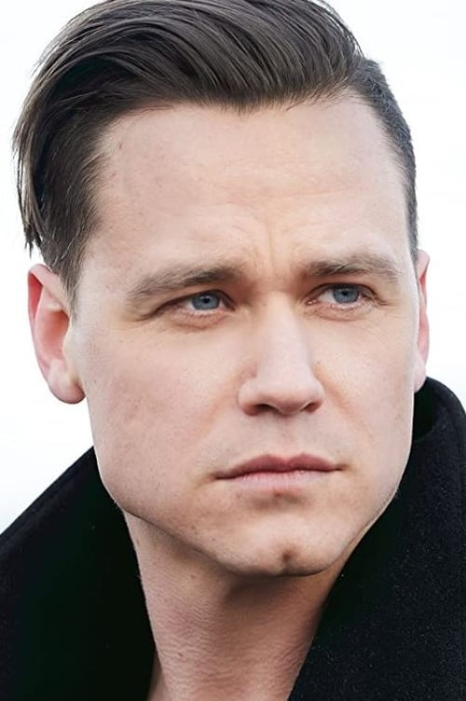
Luke Humphrey is an American-born Canadian actor. The son of Canadian actors Mark Humphrey and Wendel Meldrum, he was born in California while his parents were working in Hollywood. He is most noted for his performance as John Wayne Bobbitt in the television film I Was Lorena Bobbitt, for which he won the Canadian Screen Award for Best Actor in a Television Film or Miniseries at the 10th Canadian Screen Awards in 2022.
Humphrey had his first film acting role in the 2005 film Cruel but Necessary, alongside both of his parents even though they were already divorced. His other roles have included the films I Don't Want to Kill Myself and Trench 11, the television series Frankie Drake Mysteries and Tiny Pretty Things, and the web series Chateau Laurier, as well as stage roles in Stratford Festival productions of The Three Musketeers and Shakespeare in Love.

RAVEN DAUDA
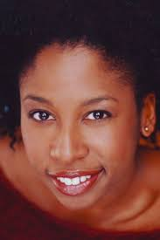
Raven Dauda is a Canadian actress who played the role of Doctor Tracy Pollard in the first, and second, and third season of Star Trek: Discovery.
A veteran of the stage and screen, Dauda appeared in numerous television series, such as Sue Thomas F.B.Eye, Odyssey 5 (starring Peter Weller), The Firm (with Allan G. Royal), Rookie Blue, Orphan Black (with Michelle Forbes), Heroes Reborn (with Nazneen Contractor and Greg Grunberg), Suits (with Neal McDonough), Designated Survivor (with Virginia Madsen), Murdoch Mysteries (with Jason Deline), and The Umbrella Academy. She had recurring roles in Annedroids, Saving Hope (with Dwain Murphy and Brian Markinson), Falling Water (with Sam Asante and Krista Jang), and Utopia Falls (with Milton Barnes and Dwain Murphy). She provided her voice for the revival animated series Clifford: The Big Red Dog, along with Bahia Watson. She also appeared in a few feature films, such as Gossip, Beware of the Midwife, and Bulletproof Monk.

JOHN KOENSGEN
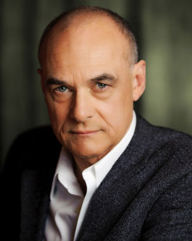
Canadian theatre and television actor and director, John Koensgen has acted in more than 100 plays, including David Young's Glenn (Great Canadian Theatre Company and Necessary Angel); Pauline and Turgenev; Our Country's Good; Summer of the Aliens; Bonjour, là, bonjour and, in February, 2002, Saint Nicholas) (National Arts Centre); The Secret Garden, Hard Times; Goodnight Desdemona (Good Morning Juliet)) (Centaur Theatre); and Facts (New Theatre of Ottawa and GCTC, 2010). In 2014, he appeared in the title role of Butcher by Nicolas Billon at its premiere at Alberta Theatre Projects; and again in the Great Canadian Theatre Company production with his son, Jonathan, in 2016.
He has also performed in film and directed the National Arts Centre production of Blood on the Moon.
Since 2006, he has been the Artistic Director of New Theatre of Ottawa and in 2001 he received the Ottawa Critics Circle Award for Contribution to English Theatre.
John had a recurring role in Frankie Drake Mysteries and has appeared in several TV movies including
Stalked by a Madman, Mind Over Murder, A Killer Upstairs, Nixon and Kissinger, Mackenzie King, Dead Zone (Directed by David Cronenberg), Showstoppers, Are You Afraid of the Dark, External Affairs, A Taste of Jupiter, The Truth About Christmas and My Grown-Up Christmas List.

ROTHAFORD GRAY
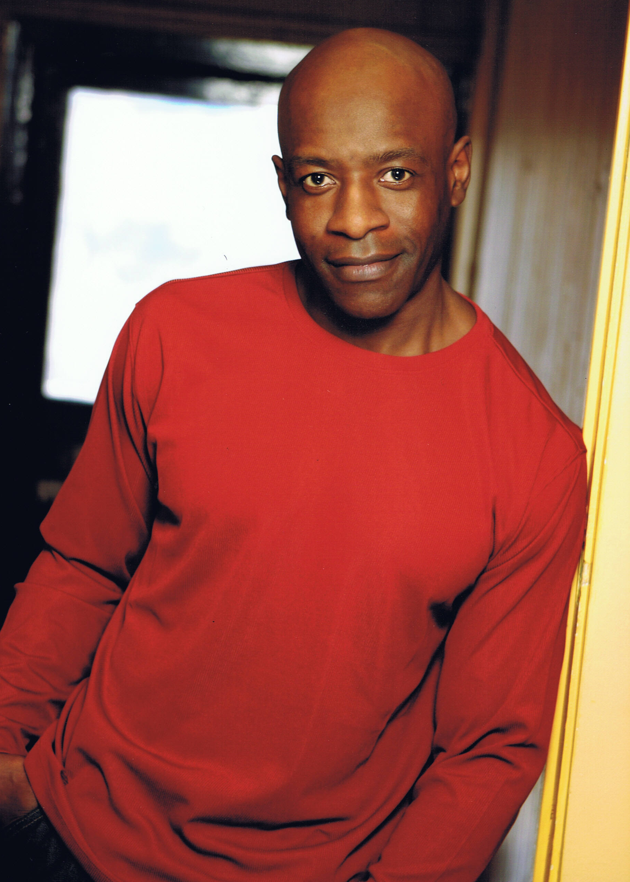
Canadian actor, Rothaford Gray, is known for his work on Max Payne, Exit Wounds and The Cheetah Girls. He attended Bramalea Secondary School in Brampton, Ontario, Canada, graduating in 1983 and Humber College (North Campus) in Toronto, Ontario, Canada.
In 2015, Gray was seen in Degrassi: The Next Generation, The Lizzie Borden Chronicle, 12 Monkeys, and Lost Girl. One role he is noted for by both Canadian and American TV fans is for his reoccurring character Nahum in Slings and Arrows (2003-2006). Gray has also been in the TV series: The Strain, Hemlock Grove, Port Hope, The Listener, The Offering, and The Kennedys. His career in television started back in 1998.
In 2020, Rothaford Gray, as Reverend Smith, appears in the TV Mini-Series Self Made: Inspired by the Life of Madam C.J. Walker along with Mouna Traoré.
His film work has included roles in Marry Me This Christmas, Wendy Williams: The Movie, Dark Web: Cicada 3301, Miracle in Motor City, Kiss the Cook and Giving Hope: The Ni’cola Mitchell Story.
He lives in Mississauga, Ontario, Canada.

BUDDY VALASTRO
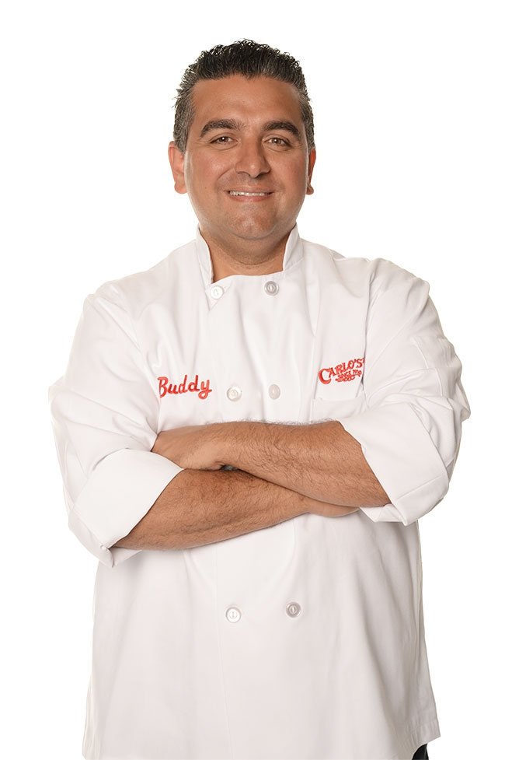
Bartolo "Buddy" Valastro Jr. is an American baker and reality television personality of Italian heritage. He is the owner of Carlo's Bakery, as well as the face of Buddy V's Ristorante. Valastro is best known as the star of the reality television series Cake Boss, which premiered in April 2009. He has also starred in Next Great Baker (2010), Kitchen Boss (2011), Buddy's Bakery Rescue (2013), Bake You Rich (2013), Bakery Boss (2013), Buddy vs. Duff (2019), and Buddy vs. Christmas (2020).

Production Credits

Full Cast
Actors  TIA MOWRY  LUKE HUMPHREY  BUDDY VALASTRO  RAVEN DAUDA  JOHN KOENSGEN  SCOTT GIBSON  ROTHAFORD GRAY  CHRISTOPHER OMARI  MEKDES TESHOME  REBECCA AMZALLAG  SIMON PHILLIPS  ROSEANN CAROL WILSHERE  SEAN MELDRUM  ANAS HASAN  GREGORY WILSON  LINDA BALLANTYNE  NATALIE JANE | Role  Alicia Geller  Logan Forrest  Bobby Gravili  Viola Kringle  Ken Geller  Rick Kringle  William Faison  Michael Kringle  Kemi Kringle  Kate McCartney  Joe Pinkey  Cathy  Waiter  Mike Koy  Club Singer  Voice of Lexy  Voice of Receptionist

Casting
BRIAN LEVY
JASON STROUD

Composer
CATALIN MARIN

Costume Designer
SARAH A. CARROLL

Editor
BEN LAWRENCE

Production Designer
GREGORY PHILIP WILSON

Director of Photography
MICHAEL TIEN

Written by
CARLEY SMALE

Directed by
MAXWELL MCGUIRE

Full Crew
TIM MUDD | Supervising Producer
JOHNNY ROSS | Associate Producers
NAVID SOOFI
LOGAN A. WAGNER
ALEXANDRA WARING
SHARON MCDONELL | Production Manager
BEN HRKACH | First Assistant Director
CIMARRON LANGLOIS | Second Assistant Director
ALEXANDRE BELKE | Third Assistant Director
STEPHEN SANBORN | Fourth Assistant Director
AIDAN MAZEROLLE | Cast Wranglers
DEANNA A. ALSAWEER
SMYTH CASTING | Extras Casting
ILONA SMYTH
BEN BELANGER | SFXSupervisor
MATT SYNEK | SFX Set Supervisor
WARREN MITCHEL BELANGER | SFX Assistants
IZABELLA WALKER
HARRIET CLUNIE | Food Stylist
GORAN POBRIĆ | Production Coordinator
LOGAN A. WAGNER | Production Accountant
JOSHUA LANGE | Assistant Accountant
MATTHEW CARVELL | Post Production Accountant
RYAN WHITEHURST | Accounting Clerk
ALEXANDRA WARING | Post Production Supervisor
RICHARD FRAZIER | Post Production Coordinator
GREGORY PHILIP WILSON | Production Designer
ELIZABETH FITZPATRICK | Art Director
LINDSEY BELANGER | Set Decorators
TOMAS CHOVANEC
ANTHONY RANKIN
GREGORY LOWE | Assistant Set Decorator
NATHALIE GREGOIRE | Property Master
SARAH A. CARROLL | Costume Designer
JULIANNE HJARTARSON | Assistant Costume Designer
SAGINE CAVÉ | Costume Truck Supervisor
VAL HARTRY | Costume Set Supervisors
NICOLE PICARD
ANDY TAIT | Wardrobe Assistant
MICHAEL TIEN | Director of Photography
JOSH HENDERSON | B Camera Operator
ADAM TESTA | A Camera - First Assistant Camera
MUNG HATLANG | A Camera - Second Assistant Camera
MATT CROSSE | B Camera - First Assistant Camera
KUBA GOS | B Camera - Second Assistant Camera
RICHARD FRAZIER | Digital Imaging Technician
RICHARD FRAZIER | Camera Technicians
GEGHANI PANOSIAN
PETR MAUR | Stills Photographer
MARCUS LAUTENBACH | Stills Assistant
STEVEN F. S. BRUNI | Gaffer
NICK LYNCH | Best Electrics
YAN SCHNELL
NICHOLAS HERMIER | Key Grip
RJ NADON | Best Grip
LIAM M. CASASOLA | Grip / Electric Swings
DUSTIN DIGNARD
CONNOR DORZEK
ALEX FORGUES
IAN FRASER
NICK LYNCH
CAMERON MATHESON
JOSEPHINE MURACA
AVERY WILTON
SONIC LIGHTING & SOUND | Sound
FRANCESCO FALSETTO | Sound Mixer
KARLYNE FELIX | Boom Operators
MICHAEL SWATTON
NICK SMITH | Script Supervisor
JESSICA FERGUSON | Location Manager
NATALIE HONSHORST | Assistant Location Manager
KEENE IMBLEAU | Key Location Production Assistant
DEANNA A. ALSAWEER | Location Production Assistants
KEAGAN COOPER
JOSHUA LANGE
AEMON LOPER-GROSS
ALANNA STERLING
EVAN POSNER
ALYSSA "ALY" MORDEN-HAYLEY | Key Makeup Artist
JANELLE CARDINAL | Assistant Makeup Artists
ANTON KHACHATURIAN
GISELE MATTE
NATASHA GABRIELA TREPANIER | Key Hairstylist
MARQUITA LYNCH | Assistant Hairstylists
DARCY RYAN
CAROLINE SCHMITZ
KELSEY DAUPHINEE | Makeup & Hair Assistants
CHRISTINA MCGUIRE
STEFANE GREGOIRE | Transport Coordinator
GREG LEWIS | Transport Captain
MICHAEL DICKSON | Drivers
MIRIAM DICKSON
OLMES LEON
BILAL MAHMOUD
KIM RODGER
ROBERT STRONACH
MICHAEL SWATTON
ALEXANDRE GREGOIRE | Transport Production Assistants
PERRY MCCONNELL
LYNN SPRACKLIN
JAY VISNESKIE
KEITH STEFFENSEN | Move Crew
CORNELIA VILLENEUVE
DAN VILLENEUVE
ERIC VILLENEUVE
SEAN VILLENEUVE
TOM WARRELL | Head Chef
GERRY WHALEN | Chef
MATTHEW DUBUC | Caterer
RONDA MACKINNON | Craft Service
THE NO CONFLICT CLEARANCE COMPANY | Script Clearances
HALL WEBER LLP | Legal Services
DANNY WEBBER
ABOVE THE LINE MEDIA SERVICES | Business Affairs
BRENDAN MCNEILL
ARTHUR J. GALLAGHER CANADA LTD. | Insurance
URBAN POST PRODUCTION | Post Production Services
JOSEPH FACCIUOLO | Dialogue & ADR Editor
EHREN PFEIFER | ADR Recordist
KIRSTY SMITH | Sound FX Editors
LUKA TOMA
MATT THIBIDEAU | Foley Artists
DAWN LEWIS
JESSICA SEVIER | Foley Recordists
DAWN LEWIS
BRAD TIGWELL | Re-Recording Mixer
LUCAS CECCHETTI | Re-Recording Assistant
SOROOSH RAFIEI
KENT MCCORMICK | Colorists
KYLE BROCK
EVAN GRAVES | VFX Artist
KYLE BROCK | Online Editor
PETER TOKARSKY | Project Manager
BRUCE REES | Picture Operations Manager
ROBERTA BRATTI | V.P. of Operations
POND5/AERIAL_VIEWS | Stock Footage
POND5/BLACKBOXGUILD
POND5/BLVDONEPRIME
POND5/OPERATOR1975
POND5/PRO_STUDIO
ISTOCK/GARRETTDESPAIN
ISTOCK/GIANLORENZOFERRETTIPHOTOGRAPHY
ISTOCK/MZABAROVSKY
"FIVE LIZARDS"
By Igor Dvorkin, Duncan Pittock And Ellie Kidd
Courtesy Of Audio Network Rights Limited
"I AM IN LOVE WITH CHRISTMAS"
By David Wesley Ayers
Courtesy Of West One Music Limited
"CHRISTMAS CUPCAKES"
By Mike Reed And Tom Howe
Courtesy Of West One Music Limited
"ALL THE TRIMMINGS"
By Igor Dvorkin, Duncan Pittock And Ellie Kidd
"MERRY AND BRIGHT"
By Mike Reed And Tom Howe
Courtesy Of West One Music Limited
"A BAROQUE CHRISTMAS"
By Bill Connor
Courtesy Of The Scoring House
"A CHRISTMAS FEAST"
by Bill Connor
courtesy of The Scoring House
"CHRISTMAS MEDLEY"
By Patrick Thomas Hawes
Courtesy Of West One Music Limited
"SUSPICIOUS SANTA"
by Bill Connor and Philip Hochstrate
courtesy of West One Music Limited
"A CHRISTMAS WISH"
by Jason Howland and Yasmeen Sulieman
courtesy of Strikingly Beautiful Music, Strange Cranium Productions and Pretty People Publishing
"FINAL LAP"
courtesy of Extreme Production Music USA, Artfully Entertaining Music Library,
Bayham Music Library and Biographically Entertaining Music Library

Producer Biographies

TIMOTHY O. JOHNSON – Executive Producer
Timothy O. Johnson is among the most active and reliable producers in the business thanks to top rate productions and global distribution appeal. He is the managing partner of Johnson Production Group, a Canadian based operation that produces over 100 hours of dramatic television annually with hundreds of programs running internationally. The company is the leader supplier to Lifetime, Hallmark and other international outlets.
A graduate of the Marshall School of Business at the University of Southern California, he served as President of the USC Entertainment Management Association and a member of the Advisory Committee of the Center for Entrepreneurial Studies.
Johnson is also responsible for producing the international hit series, DR. QUINN, MEDICINE WOMAN for CBS for over 5 seasons. During his 100-episode tenure, he also developed and produced the original docu-drama COLD CASE for CBS network, which was the very first program to integrate television with the Internet.
Most recently, Johnson has produced the THE NOEL DIARY, being the #1 Film on Netflix’s Top 10 list in December of 2022. He was also at the helm of the successful GIRL IN THE SHED: THE KIDNAPPING OF ABBY HERNANDEZ, as well as the V.C. Andrews series of films, to date including TWILIGHT’S CHILD, MIDNIGHT WHISPERS, and DAWN, all produced for Lifetime..
Johnson has produced over 400 movies and 15 globally released series for every major US network - including Netflix, Lifetime, Hallmark, ABC, Disney, CBS, NBC, Netfly, FOX and Sony.

JOHNSON PRODUCTION GROUP
The Johnson Production Group contracts globally to produce television content for international networks, studios and distributors. Based in Los Angeles and Vancouver, British Columbia, the company manages production, facilitates development and financing, procures distribution and guarantees quality and timely execution of its programs. While costs have gone up, so has the demand for quality. No longer is good enough, good enough. Johnson Production Group serves that segment when a show needs to be "A" quality, but produced efficiently enough to meet a locked budget. JPG specializes in value, protection of creative elements, and delivery of a quality finished product.
ANDREW C. ERIN – Executive Producer
Andrew Erin is a Canadian Writer/Director making a big splash in the US, and has produced, written and directed numerous commercially successful films. His directorial debut, SAM’S LAKE, was an official selection at the Tribeca Film Festival and did an excellent theatrical run in select theaters around the country; distributed by Lionsgate Films. Andrew also wrote the script for the film. Andrew’s directorial credits include, SIMPLE THINGS, produced for Screen Media Ventures and Universal Studios. Besides winning The Bob Clark Award for Best Director at the California Independent Film Festival, the film was commercially received. Andrew has worked continuously as a writer/director, building a strong library of films in the Thriller/Horror genres with: Embrace of The Vampire, The Clinic, Final Sale, Confined and Toxic Skies.
OLIVER DE CAIGNY – Executive Producer
Oliver De Caigny is a Canadian producer originally from Belgium, his background in financing, production, and post production makes him a well-rounded producer for any type of production. His experience in financing and production agreements (film and TV series and movies-of-the week), distribution agreements (both domestic and foreign) as well as international co-productions, Canadian tax credit, Telefilm Canada and Canada Media Fund incentives provides him with a well-rounded background in development, production and distribution for motion pictures, television series and productions.

LISA ALFORD –Co-Executive Producer
Lisa Alford is a development executive at Johnson Production Group. A Massachusetts native, Lisa has lived and worked in Los Angeles for over a decade, always in support of excellent storytelling. Prior to joining Johnson Production Group, Lisa worked as an executive at TriStar television where she specialized in identifying IP that supported TriStar’s mission to feature diverse, authentic characters and champion underrepresented voices. Lisa came up at Sony Pictures Television where she worked as a production coordinator in the Television Movies and Miniseries department and in the writers room on the WGN hit series OUTSIDERS. In her current role, Lisa shepherds projects from the concept phase through story development, production, and post.

JOSIE FITZGERALD - Producer
Josie Fitzgerald is a Canadian born Producer currently residing and working in Ottawa, Ontario. Josie is also a passionate photographer and writer, with an education in Justice Studies and a professional background in Human Resources and Project Management.

MAXWELL McGUIRE - Director
As a writer and director, Max's projects have been financed or distributed by; Netflix, Bron Studios, Telefilm Canada, Ontario Media Development Corp, Hallmark, Lifetime, CBC TV, UPtv, Canada Council for the Arts, the Harold Greenberg Fund and a number other private international distributors.
Foreverland, his most personal movie, was produced by Bron Studios and Screen Siren Media. It was distributed theatrically by Eone and sold internationally by Vision Films. It stars Max Thieriot (Seal Team/Bates Motel), Laurence Leboeuf (Transplant) and Oscar nominees Juliette Lewis (Cape Fear) and Demian Bichir (The Bridge) along with Sarah Wayne Callies, Matt Frewer and Thomas Dekker.
Max recently directed, Midnight at the Magnolia starring Natalie Hall and Evan Williams for Marvista Entertainment which can currently be seen on Netflix where it was TOP 5 worldwide most watched movie.
Love at Look Lodge, starring Clark Backo and Jonathan Keltz recently premiered on Hallmark to over 2 million viewers this past fall while Mistletoe and Menorahs starring Kelley Jakle and Jake Epstein continues to air on Lifetime TV and around the world.
He's directed numerous thrillers such as The Narcissist, starring Amber Goldfarb, Damon Runyon and Sam Ashe Arnold for Lifetime along with multiple movies for Johnson Production Group, Fireside Pictures, Reel World Management, Neshama Entertainment and Marvista Entertainment.

Billing Block
Lifetime Presents in association with Johnson Production Group and produced in association with GroupM Motion Enertainment “YES, CHEF! CHRISTMAS”
starring TIA MOWRY LUKE HUMPHREY RAVEN DAUDA JOHN KOENSGEN ROTHAFORD GRAY CHRISTOPHER OMARI MEKDES TESHOME REBECCA AMZALLAG SIMON PHILLIPS SEAN MELDRUM ANAS HASAN GREGORY WILSON and BUDDY VALASTRO Casting BRIAN LEVY JASON STROUD Composer CATALIN MARIN Costume Designer SARAH A. CARROLL Editor BEN LAWRENCE Production Designer GREGORY PHILIP WILSON Director of Photography MICHAEL TIEN Co-Executive Producer LISA ALFORD Executive Producers ANDREW C. ERIN OLIVER DE CAIGNY TIA MOWRY ADAM GRIFFIN RICHARD FOSTER CHET FENSTER BUDDY VALASTRO TIMOTHY O. JOHNSON Producer JOSIE FITZGERALD Written by CARLEY SMALE Directed by MAXWELL MCGUIRE
The Canadian Film or Video Production Tax Credit
© MMXXIII Fireside (Chef) Films Inc. All Rights Reserved

Meta Data
LONG (max 3000 characters) synopsis
Aspiring chef, Alicia Gellar, gets accepted into Chicago's coveted "Kringle Cook-Off" competition and must work alongside, revered chef, Logan Forester in order to come up with a three-course dish to present to esteemed restaurateurs Viola and Rick Kringle on Christmas Eve. The two cannot agree on anything, as Alicia wants the meal to feel festive and home-cooked, while Logan wants it to be sophisticated and high-end. Meanwhile, filled with curiosity, Alicia decides to take a DNA test and finally find out about the origins of her birth family. Having been adopted as a baby, Alicia has always wanted to know more about her heritage, and this Christmas she is determined to find out once and for all. However, things get complicated as Alicia and Logan grow closer and Alicia learns that she just might be related to the Kringles. As Christmas Eve approaches, Alicia's journey is filled with self-discovery, romance, complicated family dynamics and a dash of Christmas magic as she chops, steams, bakes and boils her way to the finish line. (1046)
MEDIUM (max 500) synopsis
When an aspiring chef gets accepted into Chicago's coveted "Kringle Cook-Off" competition, she is in for a vigorous Christmas season as she gets partnered with a stern, but handsome, cooking mentor who is determined to win. Although the two butt heads at every turn, it doesn't take long for the sparks to fly, not only in the kitchen, but between them too. (358)
SHORT (max 100 characters) synopsis
An aspiring chef butts heads with her handsome mentor as they partner for a cooking competition. (97)
5 KEY WORDS
Cooking show, Family, Adoption, Romance

